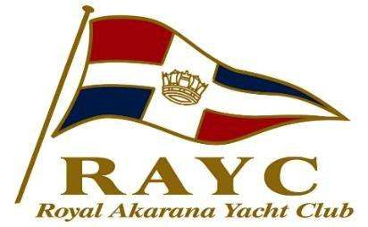

JOB DESCRIPTION
Date | July 2018
Position Title: | Head Coach
Reports To: | Akarana Academy and Pathways Manager
Positions reporting to: | Sailing Coaches and Assistant Coaches
Communications to: | Akarana Academy and Pathways Manager  Director of Sailing and Managing Director
Job Purpose
To manage and supervise daily operations of the Akarana sailing academy activities, coaching staff and assets.
Key Responsibilities
- Working closely with Academy manager to deliver excellence and consistency within our Learn to Sail, Outreach and Adult programs
- Assisting with development of race and fun on the water programs
- Daily supervision and briefing of coaches to ensure Akarana Academy processes are followed including coordinating and preparing structured lesson plans
- Induction training and professional development of RAYC coaches and assistant coaches in line with RAYC course requirements
- Management of assets and equipment for the days planned activities
- Development of coaches to ensure that programs are conducted professionally as per YNZ syllabus and RAYC requirements
- Coach learn to sail and race programs when required in Optimist, Feva, Open BIC, 420 and Laser
- Regatta coaching
- Assist with coach scheduling and manage any changes to the daily roster
- Manage the RAYC academy Health and Safety requirements during academy session times, including preparing accident and incident reports, management of RAYC safety plan
- Actively manage and provide accurate weather, tide and sailing instructions to coaches in line with RAYC academy standard operating procedures. Cancel on water sessions where required due to weather conditions
- Maintain the RAYC asset register and maintenance plan, liaise with service provider and maintenance people and repair equipment where required
- Manage and coordinate storage of boats and maintenance to ensure they are ready for the days scheduled programs
- Customer service, act as the first point of contact for daily academy enquiries and liaise with parents at each sailing session

This job description is intended to outline the principal duties and responsibilities of this role however it is the expectation that the incumbent may be required to take on tasks outside of the scope of this role time to time to ensure the smooth running of operations at RAYC.

Competencies required

Customer Service and Communication | Recognises and ensures that high quality service is delivered to our customers – Always.
Energy and Enthusiasm | Consistently able to work to deadlines and have the self-motivation, drive and determination to take ownership within this role.
Work Attitude | Works as part of a team towards achieving our lofty goals. Is self-motivated, professional and capable to take responsibility.
Initiative & Problem Solving: | Thinks outside the box and works to implement change and enhance processes.
Time Management/ Flexibility & multitasking: | Able to work under pressure, manage a busy work load and remain calm.
Ownership | Takes ownership and responsibility for delivery of assigned tasks.
Relevant Skills, Training and Experience
Qualifications:
- Dinghy and keelboat sailing proficiency to a very high standard
- Senior Yachting Instructor Qualifications YNZ or RYA
- Marine Radio Operators Licence
- First Aid Certificate
- Rescue Boat Drivers Certificate

Experience:
- Personal experience in dinghy sailing / racing in Opti/BIC/Feva/420 and Laser
- Boat repair and maintenance for training fleet and sailing support craft
- Race Management experience
- 5 years previous coaching experience

