


TASMAN BAY CRUISING CLUB
  - NELSON MARINA | TE AHU MOANA O WHAKATŪ

2027 Nelson Marina Regatta
for
Keelboats, Trailer Yachts & Sport Boats
&
Elliott 5.9 Southern Circuit

Friday 22 to Tuesday 26 January 2027

NOTICE OF RACE (NoR)

The Organising Authority is the Tasman Bay Cruising Club Inc. (TBCC)
PO Box 5062, Port Nelson, Nelson 7043 | http://tasmanbaycc.co.nz/nelson-regatta/

​
2027 Nelson Marina Regatta 1
PART 1: TRAILER YACHT & SPORT BOAT FLEET RACING 2
PART 2: KEELBOAT FLEET RACING & RALLY 6
Entry Type 11
Marina Berth 12
Declarations 12
Payment 12

​

PART 1: TRAILER YACHT & SPORT BOAT FLEET RACING
(Incorporating the Elliott 5.9 Southern Circuit)
Friday 22 – Sunday 24 January 2027

1. RULES
1.1 The event will be governed by the 'rules' as defined in The Racing Rules of Sailing (RRS).
1.2 The Yachting New Zealand Safety Regulations (YNZSR) Part V Category C shall apply to all trailer yachts, upgraded so that all boats competing must carry a VHF radio transceiver capable of receiving and transmitting on VHF channel 77, and a minimum of 5 litres of fuel per day of the event.
(a) ALL Elliott 5.9s shall carry an outboard engine of not less than 4.8hp.
1.3 The Yachting New Zealand Safety Regulations (YNZSR) Part VI Category A shall apply to all sport boats, upgraded so that all boats competing must carry a VHF radio transceiver capable of receiving and transmitting on VHF channel 77, and a minimum of 5 litres of fuel per day of the event.
1.4 For protests where only a rule of Part 2 or RRS 31 is alleged to have been broken, an arbitration hearing will be offered prior to any formal hearing.
1.5 Competitors shall wear an approved personal flotation device (PFD) at all times while afloat. [DP] [NP]

2. ADVERTISING
2.1 Boats may be required to display advertising chosen and supplied by the Organising Authority. [DP] [NP]

3. ELIGIBILITY AND ENTRY
3.1 The event is open to all trailer yachts and sport boats recognised by the New Zealand Trailer Yacht Association (NZTYA). NZTYA Ratings will apply. The Organising Authority reserves the right to alter or assign ratings at its discretion.
3.2 Eligible skippers may enter online at http://tasmanbaycc.co.nz/nelson-regatta/.
3.3 Late entries accompanied by the late entry fee may be accepted at the Race Committee's discretion until 1600 hours on Friday 22 January 2027.
3.4 To be eligible to compete, each entrant and crew member shall be a financial member of a yacht club recognised by Yachting New Zealand or their national authority.

4. FEES
4.1 Entry fees are as follows:
Class / Entry Type | Early Bird Fee  (Before 5pm, 13 Jan 2027) | Standard Fee  (After 13 Jan 2027)
TY / Sport Boat / Elliott 5.9 | $100.00 | $115.00
TY / Sport Boat (Including Mon/Tue) | $190.00 | $220.00

5. SCHEDULE
5.1 Registration:
- Friday 22 January 2027: 1500–1630 hours at the TBCC Clubhouse.
5.2 Briefings:
- Friday 22 January 2027: Invitation Race briefing at 1630 hours (TBCC).
- Saturday 23 January 2027: Event briefing at 0930 hours (TBCC).
5.3 Dates of Racing & Warning Signals:
- Friday 22 January 2027: Invitation Race | Warning Signal: 1755 hours
- Saturday 23 January 2027: Race Day 1 | First Warning Signal: 1155 hours
- Sunday 24 January 2027: Race Day 2 | First Warning Signal: 1155 hours
5.4 Number of Races:
(a) 7 races are scheduled for the series (4 races scheduled Saturday, 3 races Sunday).
(b) Up to 4 races per day may be sailed.
(c) On Sunday 24 January 2027, no warning signal will be made after 1500 hours.

6. MEASUREMENT & SAFETY CHECKS
6.1 All boats shall comply with YNZSR and class rules.
6.2 A Safety Declaration shall be completed at Registration. Safety checks may be conducted at any time.

7. SAILING INSTRUCTIONS
7.1 The Sailing Instructions will be available at Registration and online prior to the event.

8. VENUE & RACING AREA
8.1 Venue: Tasman Bay Cruising Club (TBCC), Port Nelson.
8.2 Racing Area: Waters of Tasman Bay.

9. COURSES
9.1 Courses will be windward/leeward or trapezoid courses. Target time per race is 45 minutes.

10. PENALTY SYSTEM
10.1 RRS 44.1 is changed so that the Two-Turns Penalty is replaced by the One-Turn Penalty.

11. SCORING & FLEET ALLOCATION
11.1 Separate scoring will be provided for the Elliott 5.9 class.
11.2 One (1) race is required to be completed to constitute a series.
11.3 (a) When fewer than 7 races are completed, a boat's series score will be the total of her race scores.
(b) When 7 races are completed, a boat's series score will exclude her worst score.

12. RADIO COMMUNICATION
12.1 Except in an emergency, a boat shall neither make nor receive radio or data transmissions while racing that are not available to all boats. Primary operational channel is VHF 77. [DP]

13. PRIZES & SOCIAL EVENTS
13.1 Social Program:
- Friday 22 Jan: Bar open & food available; Invitation Race Prizegiving (2000 hours).
- Saturday 23 Jan: Bar open & food available with Live Music.
- Sunday 24 Jan: Bar open & food available; Fleet Prizegiving as close to 1800 hours as practicable.
13.2 Prizes will be awarded at the discretion of the Organising Authority.

14. DISCLAIMER OF LIABILITY & INSURANCE
14.1 Competitors participate entirely at their own risk. Refer to RRS 3. The Organising Authority will not accept any liability for damage, injury, or death.
14.2 Each boat shall hold valid third-party liability insurance with minimum cover of $1,000,000.

---

PART 2: KEELBOAT FLEET RACING & RALLY
Friday 22 – Tuesday 26 January 2027

1. RULES
1.1 The event will be governed by the 'rules' as defined in The Racing Rules of Sailing (RRS).
1.2 All keelboats shall comply with YNZSR Part II Category 5 for the Invitation Race and Race Days 1 & 2 (Fri–Sun). For Races 4–7 (Mon–Tue), YNZSR Part II Category 4 shall apply, modified as follows:
(a) One safety harness and double-clip tether per crew member.
(b) Registered 406 MHz PLB or EPIRB.
(c) Jackstays in accordance with YNZSR 17.23K.
(d) Mounted or handheld GPS.
(e) Abel Tasman Chart NZ 6144 (Tasman Bay Chart NZ 614 is recommended).
(f) Grab bag.
1.3 All keelboats shall carry an operational VHF radio capable of transmitting/receiving on VHF 77, 16, and 12.
1.4 Crew numbers may change daily but shall be declared to the Race Committee prior to racing.
1.5 Arbitration will be offered for RRS Part 2 / RRS 31 protests prior to formal hearings.

2. ADVERTISING
2.1 Boats may be required to display advertising chosen and supplied by the Organising Authority. [DP] [NP]

3. ELIGIBILITY AND ENTRY
3.1 Open to self-righting monohull yachts registered with Yachting New Zealand.
3.2 Entries shall be submitted online at http://tasmanbaycc.co.nz/nelson-regatta/.
3.3 Late entries may be accepted at the discretion of the Organising Authority up to Registration.

4. FEES
4.1 Entry fees are as follows:
Class / Entry Type | Early Bird Fee  (Before 5pm, 13 Jan 2027) | Standard Fee  (After 13 Jan 2027)
Full Regatta (Friday – Tuesday) | $190.00 | $220.00
Inshore Only (Friday – Sunday) | $100.00 | $115.00

5. SCHEDULE
5.1 Registration:
- Fri 22 Jan 2027: 1500–1630 hours (TBCC)
- Sun 24 Jan 2027: 0830–0930 hours (TBCC - for Sun–Tue entrants)
5.2 Briefings:
- Fri 22 Jan: Invitation Race Briefing at 1630 hours (TBCC).
- Sat 23 Jan: Inshore Racing Briefing at 0930 hours (TBCC).
- Sun 24 Jan: Regatta Briefing at 0930 hours (TBCC).
- Mon 25 Jan: Coastal/Passage Races Briefing at 0830 hours (TBCC).
5.3 Dates of Racing & Warning Signals:
Date | Race Day / Event | First Warning Signal | Races
Fri 22 Jan 2027 | Invitation Race | 1800 hours | 1
Sat 23 Jan 2027 | Race Day 1 (Inshore/Coastal) | 1155 hours | 3 / 1*
Sun 24 Jan 2027 | Race Day 2 (Inshore/Coastal) | 1155 hours | 3 / 1*
Mon 25 Jan 2027 | Race Day 3 (Passage Race) | 0955 hours | 1
Tue 26 Jan 2027 | Race Day 4 (Coastal Return) | 0955 hours | 2 / 1*

*Cruising Divisions race 1 race per day.

6. MEASUREMENT & SAFETY CHECKS
6.1 A Safety Declaration must be completed prior to racing. Safety inspections may occur at any time.

7. SAILING INSTRUCTIONS
7.1 Available at Registration and published on the TBCC website prior to the event.

8. VENUE & RACING AREAS
8.1 Venue: Tasman Bay Cruising Club (TBCC), Port Nelson.
8.2 Racing Areas:
(a) Fri–Sun: Waters of Tasman Bay.
(b) Mon 25 Jan: Tasman Bay to Torrent Bay (Abel Tasman National Park).
(c) Tue 26 Jan: Abel Tasman National Park back to Nelson Haven.

9. COURSES
9.1 Inshore Racing (Romeo/Juliet): Trapezoid, Windward/Leeward, or Triangular courses.
9.2 Cruising Divisions: Coastal courses within Tasman Bay.
9.3 Coastal/Passage Races (Mon–Tue): Passage courses as detailed in the Sailing Instructions/Briefing.

10. PENALTY SYSTEM
10.1 RRS 44.1 is changed so that the Two-Turns Penalty is replaced by the One-Turn Penalty.

11. FLEET ALLOCATION & SCORING
11.1 Fleets will be allocated into Racing (Romeo and Juliet divisions) and Cruising Divisions (up to two divisions depending on entries).
11.2 Scoring:
(a) Races from Sunday 24 Jan to Tuesday 26 Jan count toward the overall Regatta score.
(b) Separate results will be calculated for the Invitation Race and Saturday 23 Jan racing.
(c) Two (2) races are required to constitute a series.
11.3 Any boat wanting to be scored on PHRF must produce a valid PHRF certificate at Registration that remains valid for the entire duration of the regatta
11.4 A minimum of three (3) boats must come to the starting area to constitute a valid race for any division.

12. RADIO COMMUNICATION
12.1 Primary race management channel is VHF 77. Safety/listening watch channel is VHF 16 and Nelson Port Operations is VHF 12. [DP]

13. PRIZES & SOCIAL PROGRAM
- Breakfasts will be available Saturday, Sunday and Monday.
- Fri 22 Jan: Bar open & food available; Invitation Race Prizegiving.
- Sat 23 Jan: Bar open & food available with Live Music; Inshore Prizegiving.
- Sun 24 Jan: Bar open & food available; Inshore Fleet Prizegiving.
- Mon 25 Jan: Beach BBQ and social evening at Anchorage (Abel Tasman).
- Tue 26 Jan: Meals & Bar open at TBCC; Overall Regatta Final Prizegiving (1800 hours).

14. DISCLAIMER OF LIABILITY & INSURANCE
14.1 Competitors participate entirely at their own risk (RRS 3). The Organising Authority accepts no liability for damage, injury, or death.
14.2 Each participating keelboat shall hold valid third-party liability insurance with a minimum cover of $5,000,000 per incident.

15. FURTHER INFORMATION
Website: http://tasmanbaycc.co.nz/nelson-regatta/
Organising Authority: Tasman Bay Cruising Club | Email: TBCC@xtra.co.nz

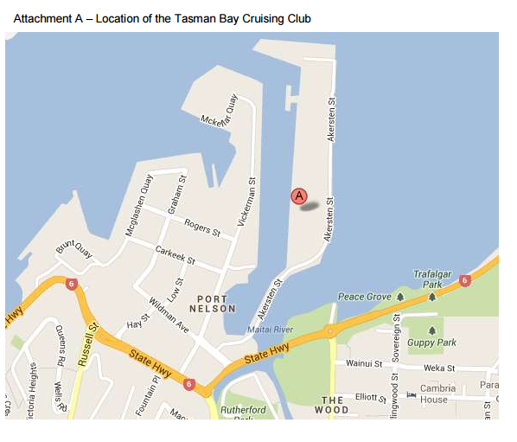
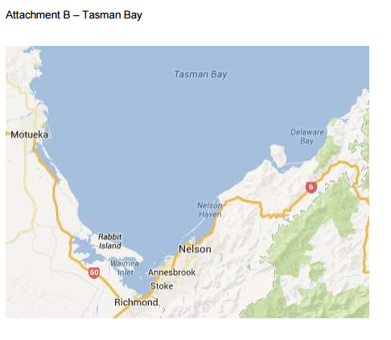

2027 Nelson Regatta Entry Form
Please enter on line at https://tasmanbaycc.co.nz/nelson-regatta/2027-nelson-regatta-entry/ or complete all required fields marked with an asterisk, select one entry type, confirm whether a marina berth is required, and sign both declarations before submitting this form. Submit completed form and payment confirmation to Tasman Bay Cruising Club before the entry deadline.

First Name * | ______________________________
Last Name * | ______________________________
Date * | ______________________________
Email Address * | ______________________________
Phone * | ______________________________
Yacht Club * | ______________________________

Sail Number * | ______________________________
Boat Name * | ______________________________
Design * | ______________________________
Length (m) * | ______________________________
Draft (m) * | ______________________________
VHF Call Sign | ______________________________
Number of crew including helm * | ______________________________

Entry Type
Select one | Entry type | Fee
☐ | Elliot 5.9 South Island Circuit | $100
☐ | Flying 15 Nationals | $150
☐ | Trailer Yacht / Sports Boat Regatta | $100
☐ | Trailer Yacht / Sports Boat Regatta plus Monday and Tuesday | $190
☐ | Keel Boat Regatta Romeo Division (1) | $190
☐ | Keel Boat Regatta Juliette Division (2) | $190
☐ | Keel Boat Regatta - Cruising Division | $190
☐ | Keel Boat - Friday to Sunday | $100

Marina Berth
Marina berth required: ☐ Yes ☐ No

Declarations
Insurance *
☐ I confirm the boat is insured with $5,000,000 third party cover.
Rules *
☐ I agree to be bound by the Racing Rules of Sailing and all other rules that govern this event. I understand that yacht racing has inherent risks and dangers that are beyond the control of the organising authority. I understand that neither the organising authority and its officers, members and servants nor other persons assisting with the conduct of the regatta accept any responsibility in respect of any injury or loss to person or property that may be sustained by reason of participation in the regatta or howsoever arising in connection with the regatta. I agree to the use of my photograph(s) and other relevant information in any event publicity and in the ongoing promotion of Tasman Bay Cruising Club Inc. (TBCC). I agree to the Organising Authority holding the above information for the general administration and well-being of the sport, and for them to retain, use and disclose the information to affiliated organisations and any other persons or organisations that TBCC believes will further the interests and objectives of sailing. I acknowledge my right to access to and correction of this information. The consent is given in accordance with the Privacy Act 2020.
Class Association Membership
☐ If applicable, all sailors are current financial members of their National Class Association.
Skipper/owner name: ______________________________ Signature: ______________________________ Date: ______________________________

Payment
Entry Fee - Payment to TBCC Account: 03-1354-0204881-000
Amount paid: $ ____________

