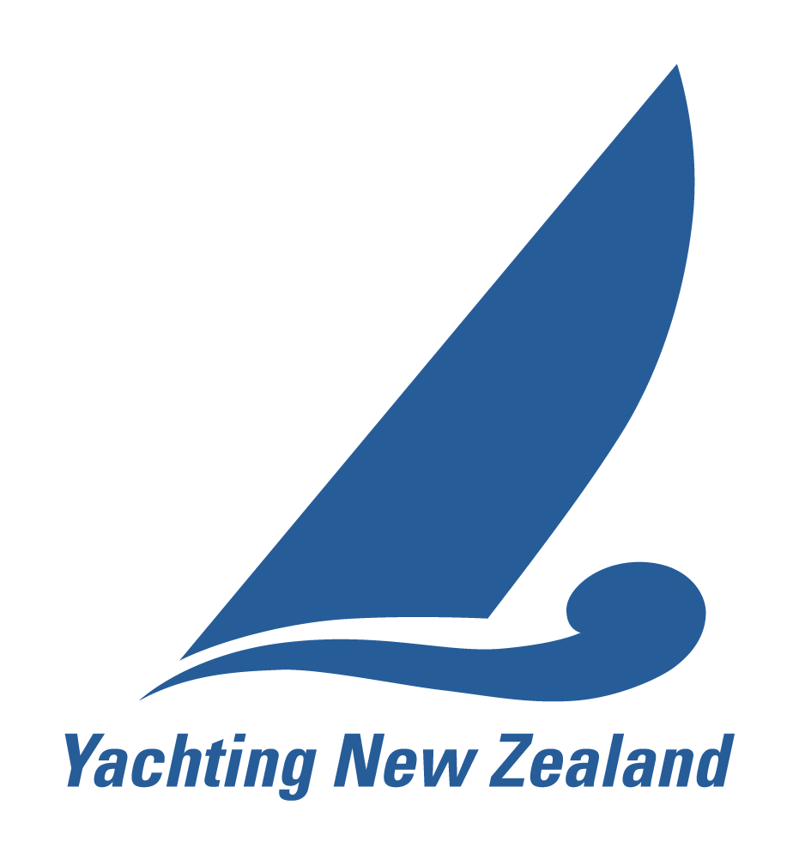 | YACHTING NEW ZEALAND  NATIONAL RACE OFFICER  Application & Revalidation Form

This form covers both initial appointment and revalidation. Please indicate which applies:
☐ Initial appointment (new application) ☐ Revalidation
Sections marked "new applications only" need not be completed by revalidating officers.
The National Race Officer Role
A National Race Officer has the experience and qualification to serve as Race Officer for National Championships and large events, running both single-class and multi-class regattas at a range of venues and for a range of Organising Authorities. The role requires in-depth knowledge of the racing rules pertaining to race management, the World Sailing Race Management Manual and race management policies, sound health and safety practice, the ability to manage a large team of volunteers, and the ability to represent the race committee in a protest.
Yachting New Zealand Regulation 4.3.2. Appointments run for four years, terminating on the 30 June nearest the fourth anniversary of appointment.
Eligibility
All applicants
- Demonstrated ability and experience running club, national and/or regional events, and knowledge of the rules pertaining to race management.
- Attended a Yachting New Zealand Race Management Seminar and passed the test at 80% or better within the last two years.
- Demonstrated management of more than one class of boat and format of racing: preparing or reviewing a Notice of Race and Sailing Instructions, setting at least two course types, an on-water start line and gate marks, across at least two classes.
- Knowledge of health and safety practice sufficient to run safe racing.
- Agreement to the Yachting New Zealand Race Official Code of Conduct.
Initial appointment – additional requirements
- Eight events in an official capacity in the past four years: at least five as Race Officer, no more than three as supervising race officer, and at least three significant events. Significant events are all National Championships, and regional events where your course area had 20 or more boats over more than one day with more than one race scheduled per day.
- A significant event conducted under the supervision of a National or International Race Officer.
- Two referee reports from different events: the first from the NRO or IRO who supervised your significant event; the second from a different NRO or IRO, an Organising Authority, or an umpire (IU or NU) or protest committee member (IJ or NJ) from an event you ran.
- A Club Race Officer qualification with demonstrated experience. Involvement in other sailing disciplines, such as competing or coaching, is also taken into account.
Revalidation – additional requirements
- Active service as a Race Officer over the previous four years, maintaining the knowledge, skill and behaviour expected of a National Race Officer (Regulation 4.3.3).
- Attendance at a National Race Officer Seminar, and a pass at 80% or better, within the past two years.

Part A – Applicant Details
Personal Details
Full name (first, last)
Yacht club
Postal address
Mobile
Email
Country of residence
Current / previous certification | ☐ CRO ☐ NRO ☐ IRO
Date of previous certification

Referees - new applications only
Referee 1 must be the National or International Race Officer who supervised your significant event.
Your referees will be asked to complete Yachting New Zealand’s NRO and CRO Referees Questionnaire. Please confirm with each referee that they are willing to act before submitting this form.
Referee 1 – Supervising Race Officer
Name | Contact email | Qualification (NRO / IRO) | Supervised event | Event date
Referee 2 – Supervising Race Officer, Organising Authority, Umpire or Judge
Name | Contact email | Position / qualification | Event | Event date

Training and Qualifications
Please list Race Management Seminars attended within the last two years. A test score of at least 80% is required.
Venue | Date | Test score (%)
Event Experience
Events over the last four years at which you acted as a Race Official. Include different class types and formats where possible. Initial appointment: eight events, as set out under Eligibility. Revalidation: list the events you have run to demonstrate active service.
If you use the Yachting NZ Race Officer Event Log online, your logged events may be used in place of the Event Experience table – please say so when you submit.
Event name | Format | Class/es | Level (Club / Reg. / Nat. / Int’l) | Role | Key learnings | Supervising RO?
Significant event under supervision – new applications only
Event name
Event format
Class/es
Level | ☐ Regional ☐ National
Role | ☐ Race Officer ☐ Principal Race Officer
Key learnings
Supervising Race Officer & qualification
Race Management Scenarios
The event need not be the same for each scenario.
Scenario | Event | Learnings
Setting an on-water start line
Setting a course which includes windward / leeward legs
Setting gate marks
Writing, reviewing or changing Sailing Instructions
Writing, reviewing or changing a Notice of Race

Declaration and Code of Conduct
☐ I agree to abide by the Yachting New Zealand Race Official Code of Conduct and acknowledge that disciplinary action may be taken against me for a proven or established breach of the Code of Conduct.
☐ I consent to Yachting New Zealand holding the information in this form for the general administration and well-being of the sport, and to Yachting New Zealand retaining, using and disclosing that information to affiliated organisations and to any other person or organisation that Yachting New Zealand believes will further the interests and objectives of Yachting New Zealand. I acknowledge my right to access and correct this information. This consent is given in accordance with the Privacy Act 2020.
☐ I hereby apply for appointment or revalidation as a Yachting New Zealand National Race Officer and confirm that the information given in this form is true and complete.
The Race Official Code of Conduct is available at yachtingnz.org.nz/resources/race-official-code-conduct.
Applicant acknowledgement
Applicant signature
Name (please print)
Date
Submitting This Form
Send the completed form, with any supporting documents, to Yachting New Zealand:

Email: ciorc@yachtingnz.org.nz

If you use the Yachting NZ Race Officer Event Log online, your logged events may be used in place of the Event Experience table – please say so when you submit.
Part B – Other Ability and Experience (optional)
Optional. Complete as much or as little as you wish. This helps Yachting New Zealand understand the wider experience held across the race officer community – for example match racing and team racing – and match officials to events.
Mentoring and Development
Any mentoring, training or development roles you have undertaken.
Other Formats of Racing
Any other formats of racing, at any level, in which you have acted in an official capacity.
Other Race Management Scenarios
Scenario | Event | Role | Learnings
Setting a triangle course
Setting a trapezoid course
Setting a fixed mark or harbour course
Setting a slalom course
Conducting team racing
Conducting match racing
Signalling an individual recall
Signalling a general recall
Signalling abandonment
Shortening course
Changing the course

