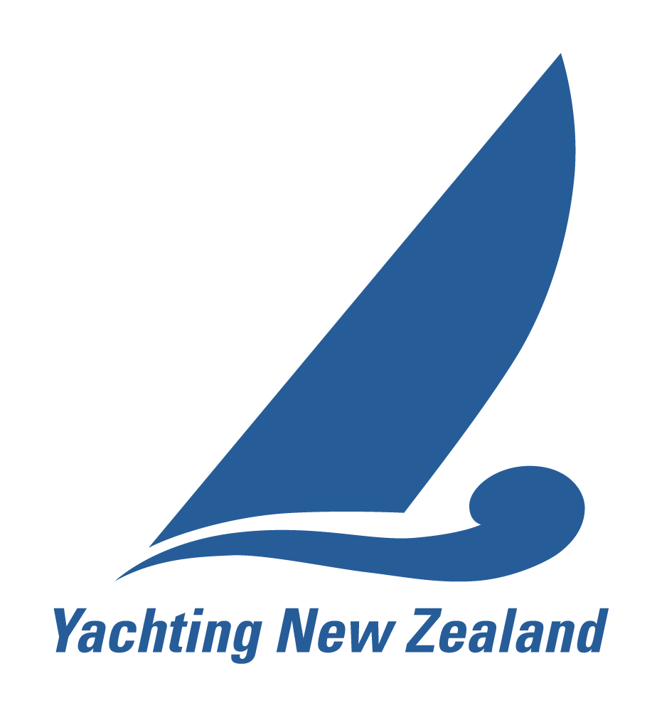 | YACHTING NEW ZEALAND  CLUB RACE OFFICER  Application & Revalidation Form

This form covers both initial appointment and revalidation. Please indicate which applies:
☐ Initial appointment (new application) ☐ Revalidation
The Club Race Officer Role
A Club Race Officer is the person in charge of running races at their club: setting the course, administering the racing and scoring the results, normally from the committee boat or the start tower ashore. A Club Race Officer has the training, knowledge and skills to perform race officer duties to their club’s satisfaction and is able to lead a race management team safely and competently at club racing and local and regional regattas.
Yachting New Zealand Regulation 4.3.1. Appointments run for four years, terminating on the 30 June nearest the fourth anniversary of appointment.
Eligibility
The criteria are the same for initial appointment and for revalidation (Regulation 4.3.1).
- Demonstrated experience in competently running club and/or regional events.
- Completed the Yachting New Zealand online Club Race Officer course on Sport Tutor/Embark.
- Received satisfactory endorsement by a flag officer of your club.
- Agreement to the Yachting New Zealand Race Official Code of Conduct.
Part A – Applicant Details
Personal Details
Full name (first, last)
Yacht club
Postal address
Phone
Mobile
Email
Current / previous certification | ☐ None ☐ CRO ☐ NRO
Date of previous certification

Training
☐ I have completed the Yachting New Zealand online Club Race Officer course on Embark.
Date completed

Flag Officer Endorsement
To be completed by a flag officer of a yacht club affiliated to Yachting New Zealand, confirming the club’s satisfaction with this race officer’s work and supporting this application.
I acknowledge that the applicant has demonstrated, to our club’s required standard, the following:
☐ Good knowledge of the club’s health and safety practices and specific club hazards, sufficient to ensure racing is conducted safely, including decision-to-race responsibilities.
☐ Sets reasonable courses for the classes and level of sailors involved.
☐ Good understanding of flags, starting procedures and the race committee actions that can occur during a race.
☐ Completes end-of-day procedures as required by the role.
☐ Good knowledge of radio procedures.
☐ Can competently lead a race management team.

Flag officer name
Yacht club
Title / position
Email
Signature
Date

Declaration and Code of Conduct
☐ I agree to abide by the Yachting New Zealand Race Official Code of Conduct and acknowledge that disciplinary action may be taken against me for a proven or established breach of the Code of Conduct.
☐ I consent to Yachting New Zealand holding the information in this form for the general administration and well-being of the sport, and to Yachting New Zealand retaining, using and disclosing that information to affiliated organisations and to any other person or organisation that Yachting New Zealand believes will further the interests and objectives of Yachting New Zealand. I acknowledge my right to access and correct this information. This consent is given in accordance with the Privacy Act 2020.
☐ I agree to Yachting New Zealand publishing my contact details on the Find a Race Official page of the Yachting New Zealand website.
☐ I hereby apply for appointment or revalidation as a Yachting New Zealand Club Race Officer and confirm that the information given in this form is true and complete.
The Race Official Code of Conduct is available at yachtingnz.org.nz/resources/race-official-code-conduct.
Applicant acknowledgement
Applicant signature
Name (please print)
Date
Part B – Ability and Experience
The Race Officer is the person in charge of a race course, with other personnel assisting under their direction.
Days as Race Officer
List the eight most significant days of racing for which you were the Race Officer in the past four years.
No. | Date | Event | Club | Races | Boats | Personnel under you | RM boats | Format (fleet / match / teams)
1
2
3
4
5
6
7
8
Other race management duties
List up to eight days on which you undertook other race management duties. Roles include flag officer, timekeeper, recorder, line sighter (start or finish), mark layer skipper or crew, duty officer, results, and safety boat skipper or crew.
Date | Event | Club | Races | Boats | Your role
Race Officer Event Log
If you log your events on the Yachting NZ Race Officer Event Log, you may attach your log instead of completing the tables above. To obtain your log, email services@yachtingnz.org.nz with the subject line Race Officer Event Log (the subject is case sensitive), sending from the address you use to log in to the Yachting New Zealand website. A spreadsheet of your entries will be returned to you – check your spam folder if it does not arrive.
Submitting This Form
Send the completed form, with any supporting documents, to Yachting New Zealand:
Email: ciorc@yachtingnz.org.nz

