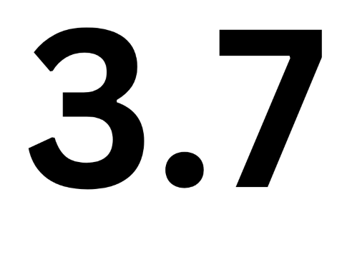

**J14, 3.7,470 & Cherub National Championship**

**28th, 29th & 30th of March 2025**

The Organising Authority is Maraetai Sailing Club

# NOTICE OF RACE

NB: The notation ‘[DP]’ in a rule in the Notice of Race means that the penalty for a breach of that rule may, at the discretion of the protest committee, be less than disqualification*.*

## 1. RULES

**1.1.** The regatta will be governed by the rules as defined in *The Racing Rules of Sailing*.

**1.2.** The Yachting New Zealand Safety Regulations part 1 shall apply.

**1.2.1.** For the J14, Farr 3.7 and Cherub, Yachting New Zealand has granted Dispensation from Regulation 3,4,5 & 6.

**1.3.** The J14, Farr 3.7 and Cherub National Class rules will apply for their appropriate class. The Cherub class will also comply with “Cherub National Council of Australia Rules and Restriction (2014 update)”

**1.4.** Under rule 86, Changes to the Racing Rules, the following rule will be changed as follows:

The race committee may award a finishing score to a boat that is still racing by displaying to her from a committee vessel (which may be in motion) flag W with one sound signal. A boat so notified is no longer required to sail the course (changing rule 28), shall stop racing and shall return to the starting area, or return to shore if there is no more racing. A finish score under this (Sailing Instruction) will be the score she would have received had she sailed the course and finished within any time limits, without gaining or losing any place. However, when two or more boats that are overlapped are notified, they will be scored as if they were tied.

**1.5.** Appendix T, Arbitration, will apply.

**1.6.** Penalty System: RRS 44.1 is changed so that a two-turn penalty is replaced by a one turn penalty for all classes.

The sailing instructions may also change other racing rules.

**2. SAILING INSTRUCTIONS**

Sailing instructions will be available after 1700 7th March online.

## 3. COMMUNICATIONS

**3.1.** The online official noticeboard is www.maraetaisailingclub.org.nz

**3.2.** The Regatta Notice Board is located inside the boat shed of MSC.

**3.3.** Except in an emergency, a boat that is racing shall not make voice or data transmissions and shall not receive voice or data communication that is not available to all boats. This restriction also applies to mobile telephones. [DP].

**3.4.** Communication to competitors will be via the noticeboard.

## 4. ELIGIBILITY AND ENTRY

**4.1.** The regatta is open to all boats of the **J14, Farr 3.7 and Cherub Classes** that comply with their appropriate class rules and whose crews are current financial members of their National Class Association**.**

**4.2.** Eligible boats may enter by completing the entry form online at www.maraetaisailingclub.org.nz

**4.3.** Entry registrations will **close at 2000hrs Monday 24th March 2025**

**4.4.** Late entries accompanied by the contest entry fee plus the late entry fee may be accepted at the race committee’s discretion until 20:00 Thursday 27th March 2025.

## 5. FEES

Required fees are as follows

|  |  |
| --- | --- |
| **CLASS** | **FEE** |
| J14 | $130.00 or $160 with Tee |
| 3.7 | $130.00 or $160 with Tee |
| Cherub | $130.00 or $190 with Tees |

***5.1.*** Late Entry Fee $50.00

**5.2.** Payment is to be made electronically via the entry form at www.maraetaisailingclub.org.nz

## 6. SCHEDULE

**6.1. Registration: MSC Club Rooms**

|  |  |  |
| --- | --- | --- |
| DATE | From | To |
| Friday 28th March | 0800 | 1000 |
|  |  |  |

***6.2.* Equipment inspection and event measurement: MSC car park**

|  |  |  |
| --- | --- | --- |
| Date | From | To |
| Friday 28th March | 0800 | 1000 |

***6.3.* Schedule of Event:**

|  |  |  |
| --- | --- | --- |
| ***Date*** | ***Times*** | ***Class*** |
| Briefing-Friday 28th March | 1030 hrs. | Briefing |
| Friday 28th March | Time of first warning Signal 1227 hrs. | Racing up to 4 Races Back-to-Back |
| Saturday 29th March | Time of first warning Signal 1027 hrs. | Racing up to 4 Races Back-to-Back |
| Sunday 30th March | Time of first warning Signal 1027 hrs. | Racing up to 4 Races Back-to-Back |

Cherubs may have up to 5 races back-to-back each day.

***6.4.* Number of races**.

|  |  |  |
| --- | --- | --- |
| ***Class*** | ***Total number Schedule*** | ***Target Time*** |
| J14 | 9 Races | 30 Min |
| 3.7 | 9 Races | 30 Min |
| Cherubs | 12 Races | 30 Min |

N.B; Target times are only a race “target” - race times may vary in length depending on conditions.

On the last scheduled day of racing no warning signal will be made after 1530 hrs.

## 7. EQUIPMENT INSPECTION & MEASUREMENT

**7.1.** All entrants must comply with respective class measurement rules and hold/display a current valid measurement certificate prior to the start of the event.

**7.2.** Spot check for measurement at Class Measurers discretion before and during the event.

**7.3.** All beach trolleys/trailers must have boat sail numbers clearly marked on them.

**7.4.** All boatsmust have boat sail numbers clearly marked on them.

**7.4.** A boat shall comply with RRS 78.1 throughout the contest and may be checked at any time during the event.

**7.5.** A safety declaration is to be completed at registration. NB; a safety check may be made on any boat at any time during the event.

## 8. VENUE

**8.1.** Attachment A; shows the location of the regatta venue.

**8.2.** Attachment B; shows the location of the racing area.

## 9. THE COURSES

**9.1.** The courses to be sailed will consist of:

J14 - Windward / Leewards, Triangles

Cherubs - Windward / Leewards

3.7 - Windward / Leewards, Triangles

470- Windward/ Leewards, Triangles

## 10. SCORING

**10.1.** 5 races are required to be completed to constitute a series.

1. When fewer than 6 races have been completed, a boat’s series score will be the total of her race scores.
2. When 6 or more races have been completed, a boat’s series score will be the total of her race scores excluding her worst score.
3. **SUPPORT BOATS**

Support boats shall Register with the Organising Authority. [DP].

1. **BERTHING**

Boats shall be kept in their assigned places while they are in the boat park. [DP]

## 13. LAUNCHING & RETRIEVAL RESTRICTIONS

Competitors shall launch and retrieve vessels from MSC ramps during the regatta except with, and according to the terms of, prior written permission of the race committee. [DP].

## 14. PRIZES

A prizegiving will be held after racing on the last day for all classes - time to be confirmed.

## 15. INSURANCE

It is **highly recommended** that each participating boat shall be insured with valid marine third-party liability insurance with a minimum cover of $1,000,000 per incident or the equivalent.

## 16. RISK STATEMENT

Competitors participate in the regatta entirely at their own risk. See RRS 4, Decision to Race. The organising authority will not accept any liability for material damage or personal injury, or death sustained in conjunction with or prior to, during, or after the regatta.

## 17. AFTER MATCH FUNCTIONS

MSC’s fully licensed bar (In the Boating Club building) will be open at the end of each day's sailing.

Bacon Butties and coffee will be available each morning.

## 18. FURTHER INFORMATION

For further information please contact:

|  |  |
| --- | --- |
| **Maraetai Sailing Committee Representative**  Chris Currell: | [chriscurrell1@gmail.com](mailto:chriscurrell1@gmail.com) |
| **J14 Association**  Jim Molloy: | [jim.molloy@xtra.co.nz](mailto:jim.molloy@xtra.co.nz)  021-346507 |
| **3.7 Class**  Chris Mitchell: | chris@aes.net.nz  021492006 |
| **Cherub**  Chris Marsh: | [chrismarshnz@outlook.com](mailto:chrismarshnz@outlook.com)  021746129 |
|  |  |

**Attachment 1 - Venue Map**

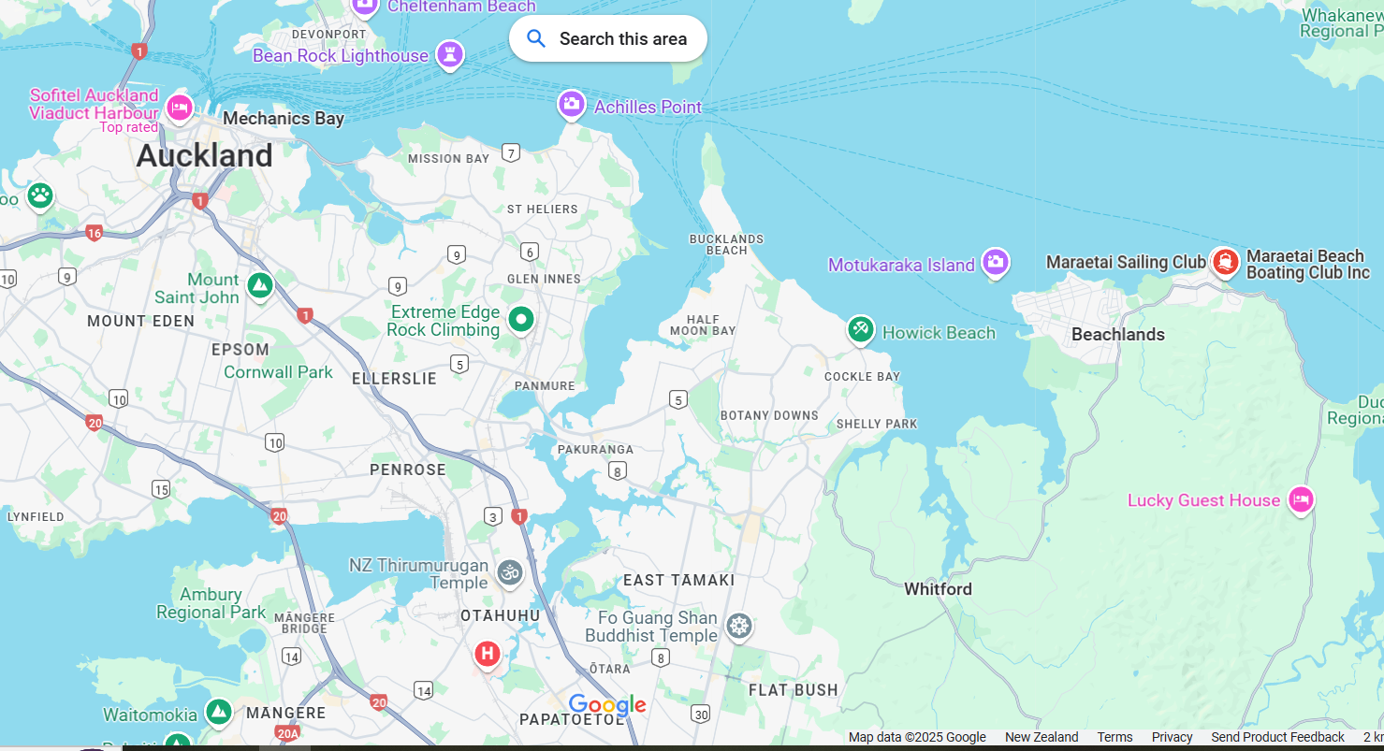

**Attachment 2 - Course Area**

