2024 NEW ZEALAND O’PEN SKIFF NATIONAL CHAMPIONSHIPS
17-21 April 2024

The Organising Authority is:
Manly Sailing Club,

Notice of Race (NoR)
NB: The notation ‘[NP]’ in a rule means that a boat may not protest another boat for breaking that rule. This changes RRS 60.1(a).
The notation ‘[DP]’ in a rule in the Sailing Instructions means that the penalty for a breach of that rule may, at the discretion of the protest committee, be less than disqualification.
1 RULES
1.1 The event will be governed by the rules as defined in The Racing Rules of Sailing. This includes the Class Rules of the OSCA.
1.2 The Yachting New Zealand Safety Regulations Part 1 shall apply. In addition, all competitors shall wear water sports safety helmets whilst on the water.
1.3 The OSCA Addendum Q, ‘Appendix UF’ Umpired Fleet Racing, Open Skiff Edition, Version: May 17, 2021, allowing umpiring on the water for races may apply. The Sailing Instructions will state if they apply.
1.4 U12 competitors (Gold/Silver) or Development Feet competitors may elect to use the 3.5 sqm sail or the deprecated 3.8 sqm sail. All other competitors are required to use the 4.5 sqm sail.
1.5 Coaching assistance from the official coach vessel(s) is permissible for competitors in the Development Fleets that are obviously struggling near the back of the fleet and any such communication shall not be considered outside help. This changes rule 41.
1.6 Appendix T, Arbitration, will apply.
2 SAILING INSTRUCTIONS
2.1. The sailing instructions will be available on the NZOSA website after 1200 on Friday 12th April 2024. Printed copies will NOT be distributed.
3 COMMUNICATION
3.1 The online official notice board is located at www.manlysailingclub.org.nz.
3.2 [DP] While racing, except in an emergency, a boat shall not make voice or data transmissions and shall not receive voice or data communication that is not available to all boats.
4 ELIGIBILITY AND ENTRY
4.1 The regatta is open to all boats of the O’pen Skiff class.
4.2 To be eligible to compete in this event each competitor shall be:
(a) a financial member of a club recognised by the competitor’s National authority;
(b) a member of the New Zealand O’pen Skiff Association, or their country’s association.
(c) under the age of 17 on 17th April 2024. Competitors under the age of 19 on 17th April 2024 will be allowed to compete on an informal basis but will not be eligible for the Class National titles or trophies.
4.3 The fleets are as follows:
(a) Gold Fleet
(b) Silver Fleet
(c) Development Fleet
Please see Attachment 1 for guidelines on Fleet criteria.
4.4 Eligible competitors may enter online at:
https://www.manlysailingclub.org.nz/events.html
Credit/Debit Card payment is required.
4.5 The closing date for entries is 1700hrs on Monday 15th April 2024. Late entries may be accepted by the Organising Authority up to 12noon on Wednesday 17th April 2024.
5 FEES
5.1 The entry fees are as follows, and must be paid online at the time of Entry:
a) Gold and Silver Fleet: $175.00 per boat
b) Subsequent siblings: $120.00 per boat
c) Development Fleet: $120.00 per boat
5.2 The late entry fee is an additional $50.00 per boat.
6 ADVERTISING
6.1 [DP] Boats may be required to display advertising chosen and supplied by the organising authority.

7 SCHEDULE
7.1 Schedule & Dates of racing:

Date | Time | Event/Races Scheduled | Races per day maximum
Wed 17th April | 1000-1200 | Charter Boat Allocation, Registration and Equipment Inspection
 | 1300-1530 | Russell Coutts Sailing Foundation Coaching (RCSF) Clinic
Thurs 18th April | 0900-1000 | Charter Boat Allocation, Registration, and Equipment Inspection
 | 1000-1200 | Morning RCSF Coaching Clinic
 | 1200-1300 | Lunch (Not Provided)
 | 1300-1500 | Afternoon RCSF Coaching Clinic / Fun Sail
 | 1600-1700 | Welcome Social (Drinks and appetizers) at the Bowling Club
Fri19th April | 0800 - 0900 | Charter Boat Allocation, Registration and Equipment Inspection
 | 0900 | Welcome & PRO/RO/PC Briefings
 | 1055 | First Warning Signal (4 races scheduled) | 4
Sat 20th April | 1000 | Daily PRO Briefing
 | 1055 | First Warning Signal (3 races scheduled) | 4
 | TBA | Joint Fleet Fun Event
Sun 21st April | 1000 | Daily PRO Briefing
 | 1055 | First Warning Signal (3 races scheduled) | 4
 | After Racing | Prize giving at the Manly Bowling Club

7.2 The target time for Gold fleet races will be 25 minutes.

7.3 The programme of events for the Development Fleet will be advised each day at the morning briefing. Please refer to Addendum 1.
7.4 On the last scheduled day of racing no warning signal will be made after 1500hours
8 EQUIPMENT INSPECTION
8.1 [DP] A boat shall comply with RRS 78.1 when presented for inspection and at all times while racing.
8.2 [DP] All competitors and boats will comply with the O’pen Skiff Safety Checklist (Addendum 2). All competitors and boats will be checked during equipment inspection prior to racing commencing.
9 VENUE
9.1 Manly Sailing Club is located at 65 Laurence Street, Manly, Whangaparaoa, Auckland 0930. Addendum 3 shows the site plan for the event.
9.2 Racing will take place in Polkinhornes, Waiau and Whangapararoa bays. Addendum 4 shows the location of racing.
10 COURSES
10.1 The courses to be sailed will be as follows:
(a) For the Gold and Silver Fleets a variety of courses will be used including Windward/Leeward, Triangular, Reaching, Trapezoid or special courses.
(b) For the Development Fleet, the daily briefing will detail the types of racing and sailing scheduled.
(c) Special Courses will be used for Joint Fleet Events.
11 PENALTY SYSTEM
11.1 RRS 44.1 is changed so that the Two-Turns Penalty is replaced by the One-Turn Penalty.
11.2 Umpires may impose one or more penalties for an incident as described in Attachment Q.
12 SCORING
12.1 Five races are required to be completed to constitute a series.
12.2 When from five to eight races have been completed, a boat’s series score will be the total of her race scores excluding her worst score.
12.3 When nine or more races have been completed, a boat’s series score will be the total of her race scores excluding her two worst scores.

13 SUPPORT PERSON VESSELS
13.1 [DP] Support person vessels shall be deemed to be “Event Support Vessels” and shall have an operative VHF radio and follow all instructions of the Race Officer. In addition, all support vessels shall comply with local safety regulations and bylaws.
13.2 [DP] All support person vessels shall always have an engine safety cut out switch (kill cord) attached to the driver while the engine is running, unless prior written exemption has been provided by the Organising Authority.
14 CHARTERED OR LOANED BOATS
14.1 A limited number of charter boats will be available. Please contact bevan@glideindustries.com for more information and pricing.
14.2 [NP] A chartered or loaned boat may carry national letters or a sail number in contravention of her class rules, provided that the race committee has approved her sail identification before the first race.
15 BERTHING
15.1 [DP] [NP] Boats are to be parked in the area indicated on Addendum 3.
16 RISK STATEMENT
16.1 RRS 3 states: ‘The responsibility for a boat’s decision to participate in a race or to continue to race is hers alone.’ By participating in this event each competitor agrees and acknowledges that sailing is a potentially dangerous activity with inherent risks. These risks include strong winds and rough seas, sudden changes in weather, failure of equipment, boat handling errors, poor seamanship by other boats, loss of balance on an unstable platform and fatigue resulting in increased risk of injury. Inherent in the sport of sailing is the risk of permanent, catastrophic injury or death by drowning, trauma, hypothermia or other causes.
17 INSURANCE
17.1 Each participating boat shall be insured with valid marine third party liability insurance with a minimum cover of NZ$1,000,000 per event or the equivalent. A certificate of insurance is to be presented at registration.
17.2 [DP] [NP] Each participating support boat shall be insured with valid marine third party liability insurance with a minimum cover of NZ$1,000,000 per event or the equivalent.
18 PRIZES
18.1 Prizes will be given as follows:
Sportsmanship Award. Awarded in recognition of qualities such as sportsmanship, perseverance, assistance to others, positive attitude.
Medals and Trophies will also be awarded to the following divisions:
Gold Fleet
1st Place Overall: NZ O’pen Skiff National Champion
1st Female: NZ O’pen Skiff Female National Champion
Plus overall: 2nd, 3rd
And overall Female: 2nd, 3rd
U12 (age 11 or under as at 1st day of regatta): 1st, 2nd, 3rd
U15 (age 14 or under as at 1st day of regatta): 1st, 2nd, 3rd
U17 (age 16 or under as at 1st day or regatta): 1st, 2nd, 3rd
Silver Fleet
Overall: 1st, 2nd, 3rd
Female: 1st, 2nd, 3rd
U12 (age 11 or under as at 1st day of regatta): 1st, 2nd, 3rd
U15 (age 14 or under as at 1st day of regatta): 1st, 2nd, 3rd
Development Fleet
Overall: 1st, 2nd, 3rd (if points racing is conducted & as appropriate to entry numbers)
Female: 1st, 2nd, 3rd (if points racing is conducted & as appropriate to entry numbers)
Prizes may be awarded for ‘encouragement’ and ‘taking part’.
18.2 Other prizes may be awarded at the discretion of the Organising Authority.
19 FURTHER INFORMATION
19.1 For further information please contact:
Manly Sailing Club
Email: secretary@manlysailingclub.org.nz
Phone: 021 905 979 or 021 088 66075

List of Addenda:

Addendum 1 – Fleet Guidelines

Addendum 2 – Equipment Check List

Addendum 3 Manly Sailing Club – Location and Site Plan

Addendum 4 Racing Areas

Addendum 1 - Fleet Guidelines

Prior to the event, parents are encouraged to seek the guidance of their club coaches and other parents when deciding which fleet in which to register. Event coaches will make recommendations to competitors and parents during or after the coaching clinic if they feel a sailor is better suited to a different fleet than entered. Parents are welcome to approach event coaches to discuss fleet allocation.
DEVELOPMENT FLEET GUIDELINES
The Development Fleet is for kids that don't have previous race experience or limited experience and are still learning the basic fundamentals of racing. This fleet offers a great opportunity to learn to race with an emphasis on fun!
Sailing will be a mixture of adventure sailing, racing, freestyle and any other form of sailing that the organisers deem fit.
Competitors will benefit from a high level of coaching throughout the event.
Development Fleet racing is intended to be run dependent on weather forecasts and prevailing winds. Should the conditions be such that racing is an option, this will be conducted on a separate course.
The Development Fleet programme will consist of a variety of activities, led by appropriately qualified activity leader/coach. These activities may include shore and on-water based skills, coaching and on-water games.

SILVER FLEET GUIDELINES
Participation in Silver Fleet helps competitors develop their confidence and experience on their journey to Gold Fleet. The Silver fleet suits competitors that have completed learn to race training and have fundamental skills for racing, including navigating race starts and standard race courses. Silver fleet courses are typically shorter than Gold fleet courses and also fewer races may be sailed.
Additionally, race management may decide to abandon Silver fleet racing if conditions exceed the fleet’s ability. This gives competitors the opportunity to experience new challenges in racing when they still may not be quite ready for the physical and mental challenges of Gold fleet racing. Generally speaking, competitors who have reached the overall and/or female podium in Silver Fleet at previous major regattas are encouraged to enter Gold fleet.

GOLD FLEET GUIDELINES
The Gold fleet is for experienced and confident competitors who have competed in Silver Fleet in at least one to two prior regatta seasons. Competitors in Gold fleet are confident racers with the ability to tackle long courses (target times of 25 minutes to 30 minutes) and can perform in a range of conditions including heavy wave state and average wind ranging from 4 to 25 knots.
Addendum 2 - O’pen Skiff Safety Checklist

O’PEN SKIFF SAFETY CHECK LIST

EVENT |  |  | DATE |  | PASS
COMPETITOR |  |  | SAIL NO |  | FAIL
CLUB |  |  | COUNTRY
SAFETY CHECKS
1.Buoyancy Aid (not inflatable) (YNZ Safety Part 1 Rule 1) CR C 3.1(a)
2.Hull condition (no cracks, damage, and bung in place)
3.Tow rope, buoyant, 8mm diameter 7m long shall be securely fixed to the mast or bow handle at all times (YNZ Safety Part 1 Rule 4) CR C5.1(a)
4.Mast attachment to hull, can be removed in emergency. (YNZ Safety Part 1 Rule 5)
5.Spars float, check end plugs. (YNZ Safety Part 1 Rule 6)
6.Rudder Clip working as expected to prevent rudder from detaching) (YNZ Safety Part 1 Rules 8)
7.Rudder Leash (Leash securely attached) (YNZ Safety Part 1 Rules 9) CR C7.3a(2)

8.Centreboard retaining loop (shock cord) in place (YNZ Safety Part 1 Rule 7) CR C7.3.a(1)

9.Sail number on each side of the hull (50mm high). (YNZ Safety Part 1 Rule 11)
10.Beach trolley clearly marked with sail number (YNZ Safety Part 1 Rule 12}
11.Mainsheet boom attachment secure but able to be released in emergency.
12.Mainsheet, figure 8 or stopper knot in place.
13.Sail number clearly readable CR C9.3
14.Helmet must be worn while afloat (no cracks with chin strap)) NZCR
Safety Officer |  | Comments
Date

It is the responsibility of all competitors to ensure they remain compliant with YNZ Safety Regulations Part 1, the O’pen Skiff Safety Check List and the O’pen Skiff Class Rules at all times during the regatta.

Addendum 3 - Manly Sailing Club Location and Site Plan

Location:
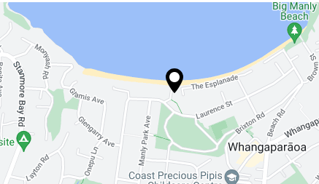

Boat and trailer parking:
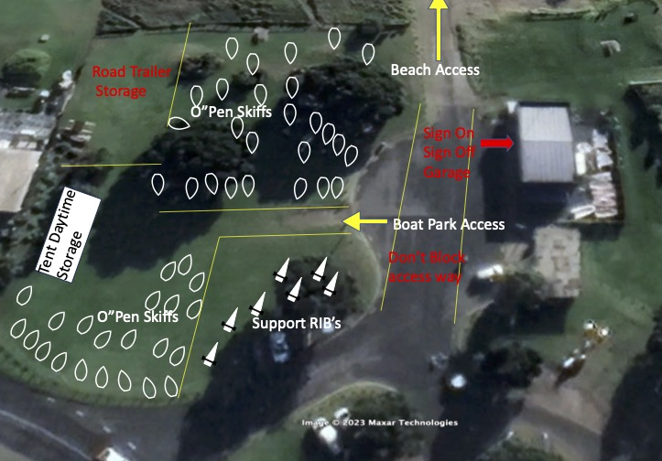
Addendum 4 - Racing Areas

Gold/Silver

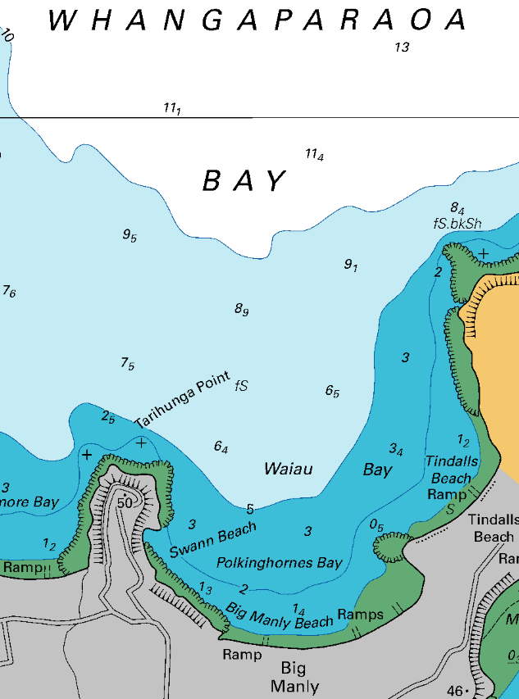
Development

