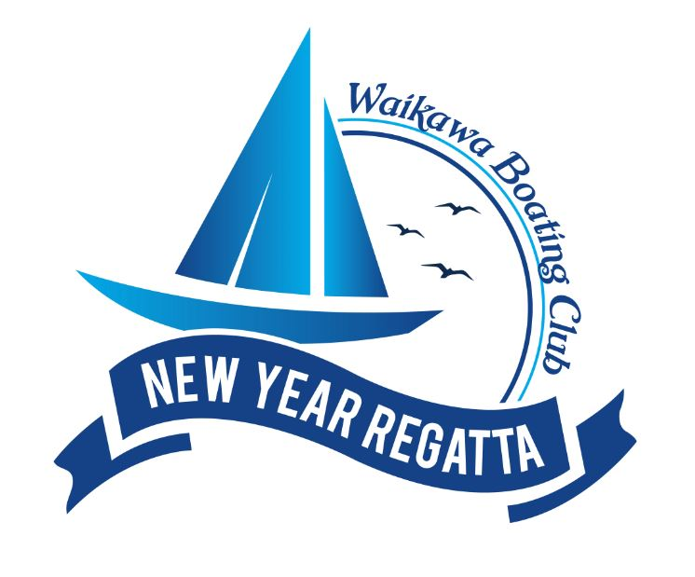

NOTICE OF RACE

New Year Regatta
12th to 14th January 2024

in conjunction with the

Race 1 sponsored by Ray White

Totaranui/Queen Charlotte Sound

The Organising Authority is the Waikawa Boating Club (Inc)
PO Box 52, PICTON 7250
+64 3 573 6798

For further information please contact the Regatta Organiser
events@waikawaboatingclub.co.nz



1 RULES
1.1 The regatta will be governed under the current Racing Rules of Sailing (RRS).
1.2 The Yachting New Zealand (YNZ) Safety regulations part II category 5 shall apply to all keel boats.
1.3 The YNZ safety regulations part V category B shall apply to all trailer yachts.
1.4 The YNZ safety regulations part VI Category B shall apply to all sports boats.
1.5 Should there be any conflict between the Notice of Race (NOR) and the Sailing Instructions (SIs) the SIs shall prevail. This changes RRS 63.7.
1.6 The racing Rules:
- Yachts with movable ballast, in the form of canting keel or water ballast may move that ballast to increase or decrease weight, or to change trim and stability. This changes RRS 51. RRS 52 shall not apply to the adjustment of canting keel or water ballast.
- Powered winches either electric or hydraulic are permitted. This changes RRS 52.
- Sports Boats and Trailer yachts – Category B Rule 12 will be changed to read, Outboard motors must be carried and stowed so that they can be used within a maximum of 5 minutes.
1.7 Marlborough district Bylaws dictating the proximity to vessels over 500 Tonnes

2 ELIGIBILITY AND ENTRY
2.1 The regatta is open to all keel boats, sports boats, trailer yachts and sports trailer yachts.
2.2 Divisions:
- Division 1 racing division for yachts with spinnakers
- Division 2 racing division for yachts with spinnakers (Number of divisions may be dependant on boat entries)
- Division 3 long harbour courses for yachts without spinnakers (as per 2.6).
- Division 4 long harbour courses for yachts with spinnakers
- The organising authority reserves the right to re-allocate an entrant into a more suitable division to ensure fair competition in a division. Four yachts will constitute a division.
- Divisions 1, 2 inc Trailer Yachts are referred to as Racing Divisions.
- Division 3 and 4 are referred to as Harbour Racing Divisions.
2.3 Entries and payment of entry fees will be accepted on-line through the regatta webpage https://waikawaboatingclub.co.nz/new-year-regatta/. Hard forms available on request. Fees listed include G.S.T.
2.4 Boat & Skipper $120 early bird
Crew $30 early bird
Early Bird rates close on Friday 22nd December 2023 .
Entries received after the 22nd December2023 will be at the rate of $150 for boat & skipper. Crew entries stay at $30 per crew member.
All entries close on Friday 22nd Dec 2023. Any entries after this date are accepted at the race committees discretion.

2.5 To be eligible to compete in this event, all competitors shall be a current financial member of a club affiliated to Yachting New Zealand. When paid, the entry fee covers temporary membership of Waikawa Boating Club for all competitors for the duration of the regatta.
2.6 DIVISION 3: The only sails that are permitted are normal upwind sails that shall be attached in the same manner as if the yacht were sailing to windward. Headsails must be attached to a permanent load bearing forestay with only one headsail per forestay. Headsails may be held out with a spinnaker or jockey pole as long as the pole is attached to the mast.

3 SCHEDULE OF EVENTS
3.1 Friday 12th January 2024 (Regatta Day 1)
Registration for regatta from 1200hrs at Waikawa Boating Club
Regatta Briefing at the wardroom 16.00.
Race 1, Start 1800 Sponsored by Ray White Marlborough.
First warning signal 17.55hrs
Regatta Day 1 Prize giving to be held at approx. 2030hrs at Waikawa Boating Club

Saturday 13th January 2024 (Regatta Day 2)
First warning signal 1020hrs
Racing Divisions have 3 races scheduled.
Harbour Racing Divisions have 2 races scheduled
Regatta Day 2 prize giving 1800hrs at Waikawa Boating Club
Entertainment and BBQ at the club

Sunday 14th January 2024 (Regatta Day 3)
First race start will be at 10.20hrs
Racing Divisions have 2 races scheduled.
Harbour racing Divisions have 2 races scheduled
Regatta Day 3 prize giving 17.30hrs at Waikawa Boating Club.
Refreshments and food available at the club.

3.2 No race shall start after 1500hrs on Sunday 14 January 2024.

4 SAILING INSTRUCTIONS
4.1 The sailing instructions will be available at registration from 1200hrs Friday 12th January 2024 as well as on the Waikawa Boating Club notice board and website https://waikawaboatingclub.co.nz/new-year-regatta/

5 RACING AREA & COURSES
5.1 The courses for the Racing Divisions will be held in the inner Queen Charlotte Sound. The courses for the Racing Divisions will be a variety of trapezoidal or windward/leeward courses, and may include 1 harbour course, per day, if time permits.
5.2 The Harbour Division courses may be throughout Queen Charlotte Sound.
5.3 The Race Officer has absolute discretion to alter courses, finish line and divisional start sequence. The course card provided is an indication only, other marks may be laid or used if more suitable to conditions. Any changes will be broadcast over VHF Channel 77 either prior to or during the race. It is the responsibility of the competitor to ensure their radio is in good working order.

6 SCORING SYSTEM
6.1 The Low-points scoring system of Appendix A of the RRS will apply, Sailwave will be used for scoring and results.
6.2 Racing Divisions, where 5 races or more have been completed a yacht score will be the total of her race scores excluding her worst score. Less than 5 completed all races to count
6.3 Harbour Division, where 5 races have been completed a yachts score will be the total of her race scores excluding her worst score. 4 or less completed, all races to count.

7 HANDICAPPING
7.1 All yachts shall race in the same condition and carry the same equipment on-board as at the time her club handicap was established.
7.2 All yachts will be handicapped by the Waikawa Boating Club official handicappers and these handicaps will be available at the Waikawa Boating Club on Wednesday 10th January 2024 or during registration, or for late entrants, prior to the warning signal for Race 1.
7.3 A boats handicap may be reviewed at any time during the regatta.
7.4 The handicapper’s decision will be final.

8 PRIZES
8.1 There will be prizes awarded for every race in the regatta.
8.2 Prizes will be awarded on handicap and line honours for each division in the Waikawa Boating Club Wardroom at the end of each day’s racing.
8.3 Spot prizes may be awarded on the Friday and Saturday evenings following prize giving in the clubhouse.
8.4 An overall prize giving for the New Year Regatta will be held in the Wardroom at the completion of racing on Sunday 14th January 2024.

9 PROTESTS
9.1 For protests where only a rule of Part 2 is alleged to have been broken, Appendix T will apply.

10 TEAM SUPPORT BOATS
10.1 Team support boats will be allowed.
10.2 Support boats must be registered with the Organising Authority at registration.

11 BERTHING
In the first instance competitors should contact Marlborough Sounds Marinas for a berth.

12 RADIO COMMUNICATIONS
12.1 All competing yachts and support boats must have a marine VHF transceiver with enough battery capacity to be still fully operational at the end of each day.

13 INSURANCE
13.1 All competing vessels are required to carry a minimum of 3rd party insurance for racing of $2 million. Insurance is a requirement if berthing in the Waikawa or Picton Marinas.

14 DISCLAIMER
14.1 Although the Waikawa Boating Club and its volunteers do everything they can to ensure the safety of the competitors, all competitors participate entirely at their own risk and responsibility. See Rule 3, Decision to Race in the RRS.
14.2 The Waikawa Boating Club is not responsible for the seaworthiness of a yacht whose entry is accepted and/or the sufficiency and/or adequacy of its equipment, or the competence of its skipper or crew.
14.3 The organising authority will not accept any liability for material damage or personal injury or death sustained in conjunction with or prior to, during or after the series.
14.4 Skippers and crew are reminded about their responsibilities on the water when it comes to the consumption of alcohol and the disposal of rubbish.

Your invitation to
2024 New Year Regatta
The New Year Regatta could be considered to be the foundation event for the Waikawa Boating Club, with the event first held in 1948. The event has grown from those days to be the biggest event on the club’s calendar and a major draw for boats from around New Zealand.

Friday 12th 12.00pm Registration open for Regatta.
16.00 Briefing for Regatta
18.00 Racing starts, Race 1 sponsored by Ray White
19.30pm Dinner available; bookings recommended
20.30pm Prize giving for Regatta Race 1

Saturday 13th
08.00 Breakfast at the club; bookings recommended
10.20 Racing starts
18.00 Prize Giving for the Regatta Day 2 Racing
18.45 BBQ and Entertainment at the club.

Sunday 14th 8.00am Breakfast at the club; bookings recommended
10.20am Racing starts
17.30pm Prize Giving For the Regatta and Overall Regatta Results at the clubhouse and farewell
Bar Open with light snacks available

Note; all times are approximate to allow for late winds.
Waikawa Accommodation Options

Walking distance to the Waikawa Boating Club

Parklands Marina Holiday Park
Beach Road, Waikawa
https://www.parktostay.co.nz/

Waikawa Bay Holiday Park
Waimarama Street, Waikawa
http://waikawabayholidaypark.co.nz/

Bay Vista Waterfront Motel
303-307 Waikawa Road, Picton 7220
http://www.bayvistapicton.co.nz/

For other nearby accommodation options, we recommend contacting:

Picton i-SITE Visitor Centre
https://marlboroughnz.com/about/isite

Waikawa/Picton Shuttle Options

Waikawa Shuttle
0800 9 245 292

Pharmacy Picton

Picton Health Care Pharmacy
6 High Street, Picton
+64 3 573 6420
Mon-Fri 8.30am-5.30pm
Sat 9.00am-2.00pm
CLOSED Sundays

Picton Supermarket

FreshChoice Picton ( can deliver )
100 High Street, Picton
+64 3 573 6463
Mon-Sun 7.00am-9.00pm

