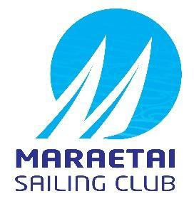
2023 RS Winter Champs
19th and 20th August 2023
Notice of Race
The Organising Authority is Maraetai Sailing Club (MSC),
Maraetai , Auckland

- Rules
  - The regatta will be governed by the ‘rules’ as defined in the Racing Rules of Sailing (RRS).
  - The Yachting New Zealand Safety Regulations Part 1 shall apply.
  - Under rule 86, Changes to the Racing Rules, the following rules will be changed as follows:
- RRS 35, A4 and A5 will be changed to state that boats still racing but failing to finish within 15 minutes after the first boat starts, sails the course and finishes may be given a finishing position based on the last mark they rounded and/or their position on the course. Their score will be greater than any boat who rounded further marks or who finished.
- RRS 44.1 will be changed so that the Two-Turns Penalty is replaced with the One-Turn penalty
- RRS 60.1 (a) will be changed to state that a competitor cannot protest another boat or competitor for breaches of some specific parts of Sailing Instructions or Supplementary Sailing Instructions
- RRS A4 and A5 will be changed to state that a boat starting later than 4 minutes after her starting signal will be scored Did Not Start.
The changes will appear in full in the Supplementary Sailing instructions.
  - Appendix T, Arbitration shall apply.

- Sailing Instructions
  - The sailing instructions will consist of the instructions in RRS Appendix S, Standard Sailing Instructions, and supplementary sailing instructions that will be on the official notice board located at MSC.
Paper copies will not be issued to competitors.
- Communication
  - The online official notice board is located at MSC
  - [DP] Except in an emergency, a boat that is racing shall not make voice or data transmissions and shall not receive voice or data communication that is not available to all boats. This restriction also applies to mobile telephones.
- Eligibility
  - The event is open to all boats of the RS Feva, RS Aero, RS Quest that comply with the Class Rules.
  - Eligible entrants may enter by completing the online Entry Form along with entry payment on the MSC website: by 2200hrs on Thursday 17th August 2023.
  - Late entries may be accepted up until 1700hrs on Friday 18th August, 2023, at the discretion of the Organising Authority.
  - A minimum of (10) Ten entries are required by the 14th August 2023, to constitute a regatta.
  - To be eligible to compete in this event each entrant and crew shall be a financial member of a yacht club recognised by the entrant’s and crew’s national authority.
Proof of affiliated club membership shall be presented at registration.
- Entry Fee
  - The entry fee for the event is NZD$100.00 per boat (Feva,Quest) $50.00 per boat for RS Aero.
  - Late entries, if accepted, shall be accompanied by an additional late entry surcharge of $50.00 per boat.
  - In the event of cancellation due to any causes outside of the Organising Authority’s control, all efforts will be made to reimburse Entry fees.
- Advertising
  - [DP] Boats may be required to display advertising chosen and supplied by the Organising Authority.
- Schedule
  - Registration: Saturday 19th August at 0900hrs – 1000hrs at MSC.
  - Equipment inspection and measurement: Saturday 19th August 0900hrs – 1030hrs.
  - Briefing: The briefing is scheduled for 10.30hrs on Saturday 19th August at the Maraetai Sailing Club.
  - Dates of racing and number of races:
Day: | Date: | Number of Races | Target Time for Each Race
Saturday | 19th August 2023 | Four (4) races back to back | 30 minutes
Sunday | 20th August 2023 | Four (4) races back to back | 30 minutes
  - All boats will start and race in class fleets (Providing minimum of 5 boats per class)
  - The schedule time of the first warning signal is 1130 hrs Saturday and 1100hrs Sunday.
  - On the last scheduled day of racing no warning signal will be made after 1530 hrs.
  - Up to five (5) races may be sailed per day, but only if forecast weather conditions allow. This decision will only be made with the approval of the race committee.
- Measurement and Inspection
  - Each boat shall be presented for measurement and inspection prior to racing on the first day (NoR 7.2 above).
  - Only RS Class legal sails may be used. Dispensation may be given at the discretion of the race committee to club boats using club sails which do not comply with Class Rules.
  - In addition, spot measurement and safety checks may be conducted at any time throughout the regatta.
- Venue
  - The host club is Maraetai Sailing Club (MSC), Maraetai Auckland. Appendix A shows the location of the Club and event venue.
  - The racing will take place in the waters off Maraetai. Appendix B shows the approximate location of the Racing Area.
- Courses
  - The courses to be sailed will be outlined in the Supplementary Sailing instructions, but will consist of W/L and/or triangle course using laid inflatable marks.
- Penalty System
  - Appendix P, Special Procedures for RRS 42 may apply as amended by the Supplementary Sailing Instructions.
  - RRS 44.1 is changed so that the Two-Turns Penalty is replaced by the One-Turn Penalty.
- Scoring
  - Eight (8) races are scheduled.
  - Three (3) races are required to be completed to constitute a regatta.
  - When fewer than five (5) races have been completed, a boat’s series score will the total of her race scores.
  - When 5 or more races have been completed, a boat’s series score will be the total of her race scores excluding her worst score.
- Launching
  - [DP] All competing boats shall be launched and retrieved from Maraetai Beach in the compound of the MSC, unless instructed otherwise by the Organising Authority
  - [DP] Beach trolleys shall be clearly marked with the boat’s sail number.
- Support Boats
  - [DP] All support vessels are required to register on the day.
  - [DP] All support vessels and coach boats must have VHF communications and be available to assist the race committee if required.
  - [DP] All support person vessels shall always have an engine safety cut out switch (kill cord) attached to the driver while the engine is running, unless prior written exemption has been provided by the OA.

- Risk Statement
  - RRS 3 states: ‘The responsibility for a boat’s decision to participate in a race or to continue to race is hers alone.’ By participating in this event each competitor agrees and acknowledges that sailing is a potentially dangerous activity with inherent risks. These risks include strong winds and rough seas, sudden changes in weather, failure of equipment, boat handling errors, poor seamanship by other boats, loss of balance on an unstable platform and fatigue resulting in increased risk of injury. Inherent in the sport of sailing is the risk of permanent, catastrophic injury or death by drowning, hypothermia or other causes.
- Insurance
  - Each participating boat shall be insured with valid marine third-party liability insurance with a minimum cover of $1,000,000 per incident or the equivalent.
- Rights to Use Name & Likeness
  - By participating in the event, a competitor automatically grants to the Organising Authority and the sponsors of the event, the right in perpetuity, to make, use and show, from time to time and at the discretion, any motion pictures, still pictures and live, taped or film television and other reproductions of him/her during the period of the competition for said event in which the competitor participated and in all material related to the said event without compensation.
- Use of Drone for Media
  - All those who take part in the regatta as competitors as well as support crew or spectators agree to be overflown by a drone during the duration of the event, this includes your person and your property (boats).
- Prizes
  - Prizes will be given based on the following divisions:
- Youth : helm and crew aged 18 or under.
- Women’s: All girl boat, both helm and crew aged 18 or under.
- Junior: Both helm and crew aged 13 or under.
- Open: One or both sailors shall be over 18 years.

  - For age divisions the skipper / crew shall both be under or on the age-group as at 31st December, 2023
  - A minimum of three (3) entries are required to constitute a division.
  - Division prizes will be awarded based on a boats place in the overall rankings. Divisions will not be rescored separately.
- Further Information
For further information, please contact:
Geoff Rasmussen
027 2222555 Email: admin@maraetaiboatclub.org.nz
APPENDIX A LOCATION OF MARAETAI SAILING CLUB

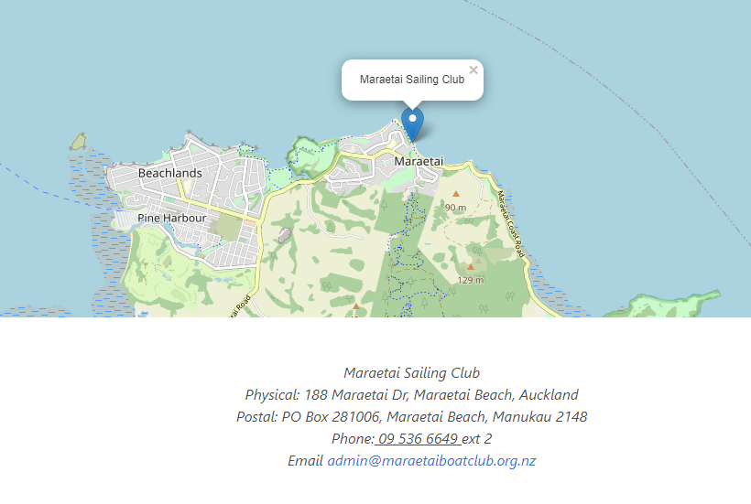

APPENDIX B APPROXIMATE LOCATION OF THE RACING AREA
