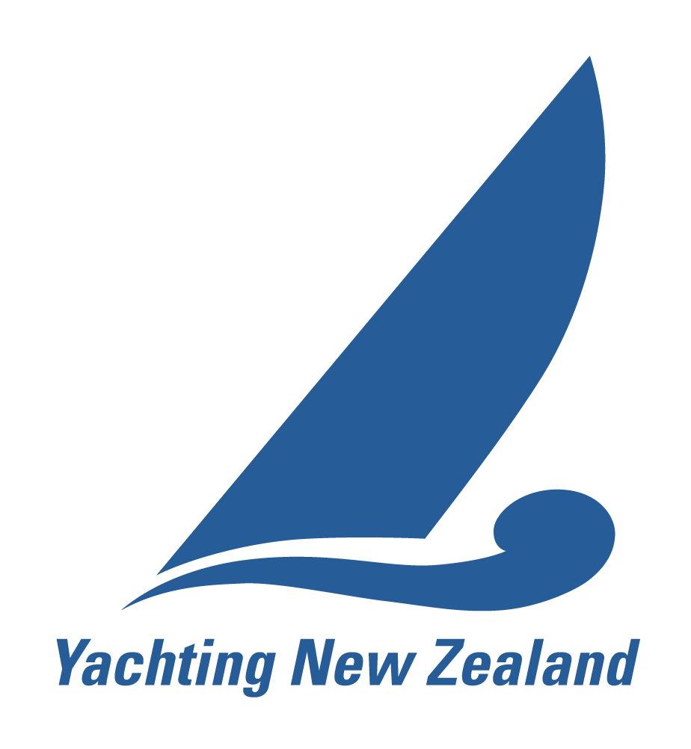
YACHTING NEW ZEALAND

NATIONAL RACE OFFICER – APPLICATION FORM

Please note: this form is for an initial appointment as a National Race Officer.
There is an alternate form for revalidation.

Criteria for initial appointment:
During the last four years the applicant must have:
- Demonstrated ability and experience in:
- running club and / or regional events
- knowledge of the rules pertaining to Race Management
- Attended a Yachting New Zealand Race Management Seminar and achieved a score of at least 80% in the Race Officers written test within two years of application.
- Conducted an event under the supervision of a National Race Officer.

PART A
Surname:
First Names:
Yacht Club:
Postal Address:
Phone (Home): |  | Mobile:
Email:

Last Race Management Seminar Attended | Venue | Date | Test Score (must be over 80%)

List one event for which you have had supervision by a National Race Officer.
Name of the Event:
Name of the NRO:

List two referees who can vouch for your competence as a Race Officer: One of the referees must be the NRO who supervised the event nominated above.
Name:
Email:
Phone:

Name:
Email:
Phone:

Recommendation from a Flag Officer of a Yacht Club affiliated to Yachting New Zealand, acknowledging the club’s satisfaction of this race officer’s work and supporting this application.

Yacht Club:
Name:
Signature:
Title:

I hereby apply for appointment as a Yachting New Zealand National Race Officer. I agree to Yachting New Zealand holding the above information for the general administration and well-being of the sport, and for them to retain, use and disclose the information to affiliated organisations and any other persons or organisations that Yachting New Zealand believes will further the interests and objectives of Yachting New Zealand. I acknowledge my right to access to and correction of this information. The consent is given in accordance with the Privacy Act 1993.

I agree to abide by the Yachting New Zealand Race Official Code of Conduct and acknowledge that disciplinary action may be taken against me for a proven or established breach of the Code of Conduct.

Signature:
Date:

Please send the completed form to:

Email: ciorc@yachtingnz.org.nz
Fax: (09) 360 2246

YACHTING NEW ZEALAND
NATIONAL RACE OFFICER – APPLICATION FORM

Part B (Demonstrating Ability and Experience):

B1: List the 3 most significant events for which you were the Race Officer in the last 4 years

If you have been submitting a record of the regattas you have acted as a Race Officer for using the Yachting NZ Race Officer Event Log online, there is no need to complete Part B, as the information should be in your file at YNZ.

Check here if you have your 3 most significant events for which you were the Race Officer in the last 4 years are logged with YNZ

Or List here
Event Name(1):
Organising Authority:
Number of Races:
Number of Yachts competing:
Number of personnel under your direction:
Number of committee/rescue boats under your direction:
A brief description of your Task:
Event Name (2):
Organising Authority:
Number of Races:
Number of Yachts competing:
Number of personnel under your direction:
Number of committee/rescue boats under your direction:
A brief description of your Task:
Event Name (3)
Organising Authority:
Number of Races:
Number of Yachts competing:
Number of personnel under your direction:
Number of committee/rescue boats under your direction:
A brief description of your Task:
B2: Please detail an event for which you have been responsible for (need not be the same event for each category and it is not necessary to have items in every box)
 | Event | Copy Enclosed
Writing the Notice of Race |  | Yes No
Writing the Sailing Instructions |  | Yes No

Setting the following course configurations | Event |  |  | No of Races | Date
Trapezoid
Triangle
Windward / Leeward
Gates
Fixed marks
Harbour Course
 |  | Event | Reason for implementation
Setting on the water start line
Signaling Individual Recall
Signaling General Recall
Signaling Abandonment
Shortening the course
Changing the course

B3: Give the number of events where you were a Race Official during each of the last four years:

Level 1 International Event
Level 2 National Event including Championship or Selection Trial
Level 3 Regional or Local Event including Club Racing
Year | Number | Your Role (see RO definitions below)- indicate all that apply
Ending | of Events of each Level | Race Committee Chairman | PRO | RO | Other Race Official
30 June
20
30 June
20
30 June
20
30 June
20

RO Definitions:
- Principal Race Officer (PRO)- Responsible for overall on water management when there are multiple courses
- Race Officer (RO)- on the water manager/decision maker/ responsible person for his/her race course

Please send the completed form to:

Email: ciorc@yachtingnz.org.nz
Fax: (09) 360 2246

