New Zealand 29er National
Championships 2023
Thursday 1st of June to Monday 5th June 2023
The Organising Authority is Kohimarama Yacht Club
Notice of Race (NOR)

The notation ‘[NP]’ in a rule means that a boat may not protest another boat for breaking that rule. This changes RRS 60.1(a).
1 RULES
The event is governed by the rules as defined in The Racing Rules of Sailing.
1.1 The Yachting New Zealand Safety Regulations Part 1 shall apply.
1.2 Under rule 86, Changes to the Racing Rules, the following rules will be changed as follows:
• The race committee may award a finishing score to a boat that is still racing by displaying to her from a committee vessel (which may be in motion) flag W with one sound signal. A boat so notified is no longer required to sail the course (changing rule 28), shall stop racing and shall return to the starting area, or return ashore if there is no more racing. A finishing score under this (Sailing Instruction) will be the score she would have received had she sailed the course and finished within any time limit, without gaining or losing any place. However, when two or more boats that are overlapped are notified, they will be scored as if they were tied.
• RRS 44.1 will be changed so that the Two-Turns Penalty is replaced with the One- Turn penalty.
• RRS 60.1 (a) will be changed to state that a competitor cannot protest another boat or competitor for breaches of some specific parts of Sailing Instructions or Supplementary Sailing Instructions
1.3 The 29er One Design class rules will apply.
1.4 Appendix T, Arbitration will apply.

2 SAILING INSTRUCTIONS
2.1 The sailing instructions will be posted on the official noticeboard at the Kohimarama Yacht Club no later than 29 May 2023 and on the KYC website.
2.2 The sailing instructions will consist of the instructions in RRS Appendix S, Standard Sailing Instructions, and supplementary sailing instructions that will be on the official notice board at the club rooms located at Kohimarama Yacht Club.
3 COMMUNICATION
3.1 The Official Noticeboard is located in the office window of the Kohimarama Yacht Club.
3.2 The online notice board is located at https://www.kyc.org.nz/29er-nationals-2023 or join Team App on:
iOS: https://www.teamapp.com/ios-app
Android: https://www.teamapp.com/android-app
3.3 [DP] From the first warning signal until the end of the last race of the day, except in an emergency, a boat shall not make voice or data transmissions and shall not receive voice or data communication that is not available to all boats.
4 ELIGIBILITY AND ENTRY
4.1 The event is open to all boats of the 29er class that comply with the class rules.
4.2 Eligible boats may enter by completing the entry form and submitting it, together with the required fee, online at https://dsfasdfasdsdf.org.nz by Sunday 28th May 2023.
4.3 To be considered an entry in the event, a boat shall complete all registration requirements and pay all fees.
4.4 Late entries will be accepted at the discretion of the Organising Authority. No entries will be accepted after Thursday 1 June 2023.
4.10 To be eligible to compete in this event each entrant and crew member shall be a financial member of a club recognised by the entrant’s and crew members’ national authority. Proof of affiliated club membership to be presented at registration.
4.11 Each competitor, entrant and crew member shall be a financial member of the New Zealand 29er Class Association or another 29er Class Association affiliated to the International 29er Association.
Register for NZ 29er Class association here:
https://kyc.webentry.co.nz/regatta.php?regattaid=195

5 FEES
5.1 Entry fees are as follows:
Class | Entry fee until 28th May 2023 | Late Entry fee
29er Class | $200 | $280

TBC with kyc committee
6 ADVERTISING
6.1 Boats may be required to display advertising chosen and supplied by the organizing authority.
7 SCHEDULE
7.1 Registration:
Date | From | To
1 June 2023 | 1200 hrs | 1600 hrs
2 June 2023 | 1000 hrs | 1100 hrs

7.2 Equipment inspection and event measurement:
Date | From | To
1 June 2023 | 1200 hrs | 1600 hrs
2 June 2023  (by appointment only) | 1000 hrs | 1100 hrs

7.3 Welcome and briefing: 1100hrs Friday 2nd June 2023.
7.4 Dates of racing:
Date | Fleet | Maximum races per day | Time of first warning signal
Friday 2nd June 2023 | 29er | Up to 5 | 1255 hrs
Saturday 3rd June 2023 | 29er | Up to 5 | 1055 hrs
Sunday 4th June 2023 | 29er | Up to 5 | 1055 hrs
Monday 5th June 2023 | 29er | Up to 5 | 1055 hrs

7.5 The series will consist of not more than 12 races.
7.6 On the last scheduled day of racing no warning signal will be made after 1500 hrs.
8 EQUIPMENT INSPECTION
8.1 Each boat shall comply with the 29er class rules at all times during the regatta. No equipment that is subject to measurement under the 29er class rules may be changed during the regatta without the approval of the Race Committee.
8.2 Boats may be inspected at any time.
8.3 [DP] Boats shall also comply with RRS 78.1 at all times
9 VENUE
9.1 The Regatta will be based from Kohimarama Yacht Club.
9.2 Addendum A - location of Kohimarama Yacht Club.
9.3 Addendum B – location of the racing area.
10 COURSES
10.1 The courses to be sailed will be Windward/Leeward.
11 PENALTY SYSTEM
11.1 RRS 44.1 is changed so that the Two-Turns Penalty is replaced by the One-Turn Penalty.
12 SCORING
12.1 5 races are required to be completed to constitute a series.
12.2 A boat’s series score shall be:
(a) When fewer than 5 races have been completed, a boat’s series score will be the total of her race scores.
(b) When from 5 to 8 races have been completed, a boat’s series score will be the total of her race scores excluding her worst score.
(c) When 9 or more races have been completed, a boat’s series score will be the total of her race scores excluding her two worst scores.
13 SUPPORT PERSON VESSELS
13.1 [DP] All support boats are required to register via the online form on the website
https://kyc.org.nz/nz29ernationals2023/
13.2 All support and coach boats are asked to have VHF communications and be available to assist the race committee if required.
13.3 Registered Support Boats may launch from the boat ramp on Kohimarama Beach.
13.4 All support person vessels shall always have an engine safety cut out switch (kill cord) attached to the driver while the engine is running, unless prior written exemption has been provided by the Organising Authority. [DP]
14. RISK STATEMENT
14.1 RRS 3 states: ‘The responsibility for a boat’s decision to participate in a race or to continue to race is hers alone.’ By participating in this event each competitor agrees and acknowledges that sailing is a potentially dangerous activity with inherent risks. These risks include strong winds and rough seas, sudden changes in weather, failure of equipment, boat handling errors, poor seamanship by other boats, loss of balance on an unstable platform and fatigue resulting in increased risk of injury. Inherent in the sport of sailing is the risk of permanent, catastrophic injury or death by drowning, trauma, hypothermia or other causes.
15 INSURANCE
15.1 Each participating boat shall be insured with valid third-party liability insurance with a minimum cover of $1,000,000 NZD per incident or the equivalent. Certificate of insurance is to be presented at registration.
16 PRIZES
16.1 Prizes will be given as follows:
● Prizes will be awarded to the first three boats in the Regatta, the first girls team and first mixed crew. There may be other prizes awards by the Organising Authority.
● The top New Zealand entrant will be the New Zealand Champion for 2023 and will be awarded the 29er Association championship trophy.
18 FURTHER INFORMATION
18.1 For further information please contact:
Andy Kensington
Organising Chair, KYC
andy@pde.co.nz
021842639

Addendum A

Location of Regatta Venue
Kohimarama Yacht Club
80 Tamaki Drive Kohimarama

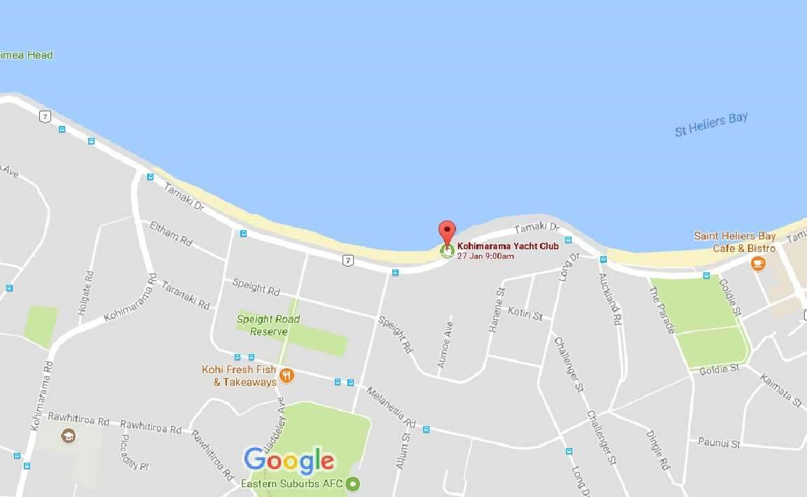

Addendum B

Racing Area

