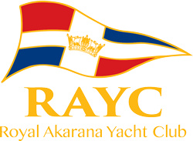
2023 RS Feva National Championship
29-30 April 2023
Notice of Race
The Organising Authority is Royal Akarana Yacht Club,
8-10 Tamaki Drive, Okahu Bay, Auckland.
Ammendments :
11.2. Five (5) races are required to be completed to constitute a series.
11.4 When six (6) or more races have been completed

1. Rules
1.1. The regatta will be governed by the ‘rules’ as defined in the Racing Rules of Sailing (RRS)
1.2. The Yachting New Zealand Safety Regulations Part 1 shall apply.
1.3 Under rule 86, Changes to the Racing Rules, the following rules will be changed as follows:
- RRS 35, A4 and A5 will be changed to state that boats still racing but failing to finish within 15 minutes after the first boat sails the course and finishes may be given a finishing position based on the last mark they rounded and/or their position on the course. Their score will be greater than any boat who rounded further marks or who finished.
- RRS 44.1 will be changed so that the Two-Turns Penalty is replaced with the One-Turn penalty
- RRS A4 and A5 will be changed to state that a boat starting later than 4 minutes after her starting signal will be scored Did Not Start.
The changes will appear in full in the Supplementary Sailing instructions.

2. Sailing Instructions
2.1 The sailing instructions will consist of the instructions in RRS Appendix @, Standard Sailing Instructions, and supplementary sailing instructions that will be on the regatta microsite – www.rayc.co.nz/rsfeva
Paper copies will not be issued to competitors.
3. Communication
3.1 Official communications will be available through the 2023 RS Feva Nationals WhatsApp Group
https://chat.whatsapp.com/BGcJeFUSUjx7FXK0yu8ph3
3.2 Except in an emergency, a boat that is racing shall not make voice or data transmissions and shall not receive voice or data communication that is not available to all boats. This restriction also applies to mobile telephones. [DP]
4. Eligibility
4.1 The regatta is open to all boats of the RS Feva Class that comply with the Class Rules.
4.2 Eligible entrants may enter by completing the online entry form via www.rayc.co.nz/rsfeva by 2200hrs on Sunday 23 April 2023.
4.3 Late entries may be accepted up until 2200hrs on Wednesday 26th April 2023, at the discretion of the Organising Authority, and will incur an additional fee – no exceptions.
4.4 A minimum of (6) six entries are required by the entry closing date of 23rd April, 2023 to constitute a regatta.
4.5 To be eligible to compete in this event each entrant and crew shall be a financial member of a yacht club recognised by the skipper and crew’s national authority.
Proof of affiliated club membership shall be presented at registration.
4.6 To be eligible to compete in this event each sailor shall be a financial member of the NZ RS Feva Association. This can be completed at the time of entry.

5. Entry Fee
5.1 The entry fee for the regatta is NZD$250.00 per boat.
5.2 Membership of the NZ RS Feva Association is an additional $20.00 per sailor and is included in the entry fee.
5.2. Appendix A: Includes two NZ RS FEVA Association memberships @ $20 per sailor, plus two regatta t-shirts.
5.3 Late entries, if accepted, shall be accompanied by an additional late entry surcharge of $50.00 per boat
5.5 In the event of cancellation due to any causes outside of the Organising Authority’s control, 50% of the entry fee may be refunded upon request.
6. Advertising
6.1. Boats may be required to display advertising chosen and supplied by the Organising Authority. [DP]
7. Schedule
7.1 Registration: Saturday 29 April at 0800hrs – 0900hrs at RAYC
7.2 Equipment inspection and measurement: Saturday 29 April 0800hrs – 0900hrs
7.3 Briefing: The briefing is scheduled for 0930 hrs on Saturday 29 April in the Joyce Fischer room at the main RAYC Building (Hyundai Marine Sports Centre).
7.4 Dates of racing and number of races:
Day: | Date: | Number of Races | Target Time for each race:
Saturday | 29 April | Four (4) races back to back | 30 minutes
Sunday | 30 April | Three (3) races back to back | 30 minutes

7.5 All boats will start and race together as one fleet
7.6 The schedule time of the first warning signal each day is 1055 hours.
7.7 On the last scheduled day of racing no warning signal will be made after 1530 hours.
7.8 Up to five (5) races may be sailed per day, but only if forecast weather conditions require it or to constitute a National Championship.
8. Measurement and Inspection
8.1. Each boat shall be presented for measurement and inspection prior to racing on the first day (NoR 5.2 above).
8.2 Only RS Feva Class legal sails may be used. Dispensation will be given to club boats using club sails which do not comply with Class Rules, but these boats are not eligible for National prizes if using non class compliant sails
8.3 In addition, spot measurement and safety checks may be conducted at any time throughout the regatta.
8. Venue
8.1 Addendum A: The host club is Royal Akarana Yacht Club, 8-10 Tamaki Drive, Okahu Bay. Attachment A shows the location of the Club and regatta venue.
8.2. Addendum B: The racing area will be the inner Waitemata Harbour, in an area approximately described as stretching from Rough Rock, Northern Leading Beacon and Bean Rock.
9. Courses
9.1 The courses to be sailed will be outlined in the Supplementary Sailing instructions,
10. Penalty System
10.1 Appendix P, Special Procedures for RRS 42 may apply as amended by the Supplementary Sailing Instructions
10.2 RRS 44.1 is changed so that the Two-Turns Penalty is replaced by the One-Turn Penalty.
11. Scoring
11..1. Seven (7) races are scheduled.
11.2. Five (5) races are required to be completed to constitute a series.
11.3 When fewer than four (4) races have been completed, a boat’s series score will be the total of her race scores.
11.4 When six (6) or more races have been completed, a boat’s series score will be the total of her race scores excluding her worst score.
11.5 All boats in all divisions will be scored together as a single fleet.
12. Launching
12.1 All competing boats shall be launched and retrieved from Royal Akarana Yacht Club boat ramps, unless instructed otherwise by the Organising Authority. [DP]
12.2 Beach trolleys shall be clearly marked with the boat’s sail number. [DP]
13. Support Boats
13.1 All support vessels are required to register via the online form on the website. [DP]
13.2 All support vessels and coach boats must have VHF communications and be available to assist the race committee if required. [DP]
13.3 All support person vessels shall always have an engine safety cut out switch (kill cord) attached to the driver while the engine is running, unless prior written exemption has been provided by the OA and be wearing a PFD.
14. Radio Communications
14.1 Except in an emergency, a boat that is racing shall not make voice or data transmissions and shall not receive voice or data communication that is not available to all boats. This restriction also applies to mobile telephones. [DP]
15. Prizes
15.1 Prizes will be given based on the following divisions:
a) Youth Championship: helm and crew aged 18 or under 1st, 2nd, 3rd boat.
b) Women’s Championship: All girl boat, both helm and crew aged 18 or under, 1st
c) Junior Championship: Both helm and crew aged 13 or under, 1st
d) Open Championship: One or both sailors shall be over 18 years, 1st.
e) National Championship: 1st boat, helm and crew aged 18 or under
15.2 For age divisions the skipper / crew shall both be under or on the age-group as at 31st December, 2023
15.3 A minimum of three (3) entries are required to constitute a division.
15.4 Division prizes will be awarded based on a boats place in the overall rankings. Divisions will not be rescored separately.
16. Insurance
16.1 Each participating boat shall be insured with valid marine third-party liability insurance with a minimum cover of $1,000,000 per incident or the equivalent.
17. Disclaimer of Liability
17.1 RRS 3 states: ‘The responsibility for a boat’s decision to participate in a race or to continue to race is hers alone.’ By participating in this event each competitor agrees and acknowledges that sailing is a potentially dangerous activity with inherent risks. These risks include strong winds and rough seas, sudden changes in weather, failure of equipment, boat handling errors, poor seamanship by other boats, loss of balance on an unstable platform and fatigue resulting in increased risk of injury. Inherent in the sport of sailing is the risk of permanent, catastrophic injury or death by drowning, hypothermia or other causes.
17.2. Competitors participate in all races entirely at their own risk. Refer to RRS rule 4. The Organising Authority will not accept any liability for material damage or personal injury or death sustained in conjunction with, prior to, during, or after the regatta.
18. Rights to Use Name & Likeness
By participating in the event, a competitor automatically grants to the Organising Authority and the sponsors of the event, the right in perpetuity, to make, use and show, from time to time and at the discretion, any motion pictures, still pictures and live, taped or film television and other reproductions of him/her during the period of the competition for said event in which the competitor participated and in all material related to the said event without compensation.
19. Use of Drone for Media
All those who take part in the regatta as competitors as well as support crew or spectators agree to be overflown by a drone during the duration of the event, this includes your person and your property (boats).
22. Further Information
For further information, please contact:
Shelley Liefting
shelley@rayc.co.nz

Addendum A
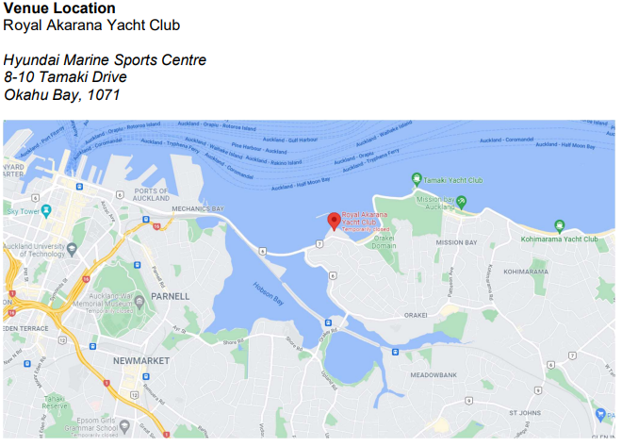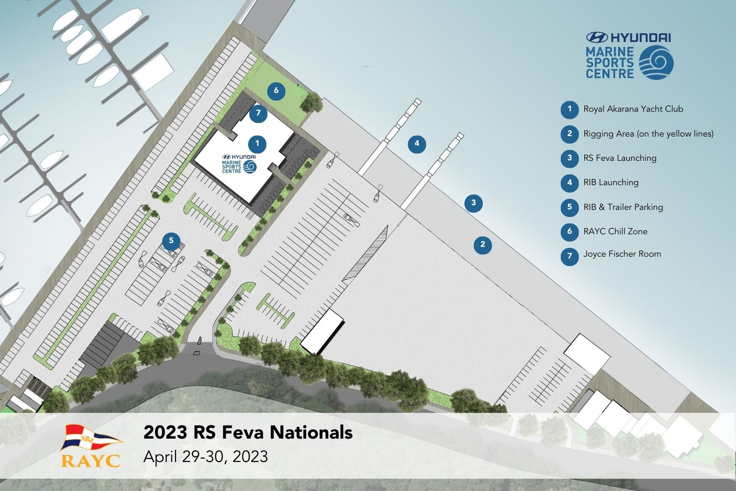
Addendum B
Racing Area
The racing area will be the inner Waitemata Harbour, in an area approximately described as stretching from Rough Rock, Bean Rock, St Heliers Beach.

