



2023 New Zealand WASZP National Championships

11th – 13th March 2023

Sailing Instructions

The Organising Authority is the Naval Point Club Lyttleton (NPCL)
Naval Point | Lyttelton

NB: The notation ‘[DP]’ in a rule in the Sailing Instructions means that the penalty for a breach of that rule may, at the discretion of the protest committee, be less than disqualification. The notation [NP] in a rule in the Sailing Instructions means that a boat may not protest another boat for breaking that rule. This changes RRS 60.1(a).

- Rules
  - The event will be governed by the ‘rules’ as defined in the Racing Rules of Sailing (“RRS”) and WASZP Class rules.
  - The Yachting New Zealand Safety Regulations Part 1 shall apply.
  - Appendix T shall apply.
  - This is a WASZP Class Tier 3 event.
- Code of Conduct:
  - Competitors shall comply with any reasonable request from a regatta official.
- Notices to Competitors
  - Notices to competitors will be posted on the official notice board located inside the NPCL clubhouse.
- Changes to Sailing Instructions
  - Any change to the Sailing Instructions will be posted before 0900 hours on the day it will take effect, except that any change to the schedule of races will be posted by 1800hrs, or at the end of protest time, whichever is earlier on the day before it will take effect.
- Signals Made Ashore
  - Signals made ashore will be displayed on the flagstaff on the front deck of NPCL.
  - When flag AP is displayed ashore, ‘1 minute’ is replaced with ‘not less than 30 minutes’.
  - A boat shall not leave the shore until flag D is displayed. The warning signal will be made not less than 30 minutes after flag D is displayed or not before the scheduled time, whichever is the later. [DP]
- Schedule of Races
  - Registration & Briefing
Registration Saturday 11th March 2023 between 0930 – 1100 in the NPCL Clubhouse.
The briefing for the National Championship is scheduled for 1100 on Saturday 11th March 2023 in the NPCL Clubhouse.
  - Race Schedule:
Day: | Date: | Racing: | Time of First Warning Signal:
Saturday | 11 March 2023 | 3 Races | 1300
Sunday | 12 March 2023 | 4 Races | 1200
Monday | 13 March 2023 | 4 Races | 1200

  - One extra race may be sailed.
  - The Race Committee may race up to two extra races per day. Refer to SI 4.1 above.
  - On Monday 13th March no warning signal will be made after 1600hrs.
6.6 To alert boats that a race or sequence of races will begin soon, an orange flag will be displayed with one sound signal at least five minutes before a warning signal is displayed.

- Class Flags
  - The class flag will be the class insignia on a coloured background.
- Venue & Racing Area
  - Refer to the Notice of Race for the location of the event venue and the approximate location of the preferred racing area. Note that other sailing areas in the general proximity of the NPCL may be used.
- The Course and Marks
  - The course to be sailed for races comprising the National Championship will be windward/leeward.
  - Addendum A illustrates the courses to be sailed including the approximate course length. A description of the Race Committee Vessels and marks will be posted on the official notice board before the regatta briefing.
  - No later than the warning signal the Race Committee will designate the course, and it may also display the approximate bearing of the first leg.
- Areas that are Obstructions
  - There are no areas designated as obstructions.
- The Start
  - Races will be started using RRS26.
  - The starting line will be between a staff displaying an orange flag on the Race Committee vessel at the starboard end and the start mark at the port end of the line.
  - A boat starting later than 5 minutes after her starting signal will be scored Did Not Start without a hearing. This changes RRS A4 and A5.
- Change of the Next Leg of the Course
  - Not applicable.
- The Finish
  - The finishing line will be between a staff displaying a blue flag on the Race Committee vessel and the finishing mark.
  - Grand Prix Finishing:
In order to keep racing prompt and reduce the time between the first finisher and the last finisher, a Grand Prix finish system will be in place.

After the first boat sails the course and finishes, a Pink flag will be displayed from the Race Committee Vessel. Any boat not on a leg to windward shall proceed directly to the finish. Any boat on a leg to windward shall first sail through the windward gate and then proceed to the finish.

The number of laps completed by each sailor will be recorded and the results will be corrected accordingly.

Addendum B provides further information on Grand Prix Finishing

- Equipment and Measurement
  - Measurement is not required but each boat must comply with the Waszp class rules at all times of the regatta.
  - Competitors are required to complete a declaration at the time of signing on stating that their boat complies with class rules, including any exemptions published by the Waszp Association of NZ for the 2023 Nationals.
  - Competitors may choose to sail with either a 6.9m2 or an 8.2m2 rig. The rig to be used for the regatta shall be declared at the time of signing on. No swapping of rig sizes during the National Championships will be permitted.
  - Spot equipment and safety checks may be conducted at any time throughout the event.
- Penalty System
  - Rule 44.1 and 44.2 are changed so that the ‘Two-Turns’ penalty is replaced by a 270° degree turn. On a windward leg the turn must comprise of a gybe, and on a downwind leg, the turn shall comprise a tack.
- Time Limits and Target Times
  - The target time for the first boat to sail the course is 20 minutes.
  - The time limit for the first boat to sail the course is 40 minutes.
  - The Finish Time Window for the Grand Prix Finish is 10 minutes.
  - Boats failing to finish within 10 minutes after the first boat sails the course and finishes and who have not completed one lap will be scored Did Not Finish without a hearing. This changes Rules 35, A4, and A5. Refer to Addendum B for further information on Grand Prix Finishing.
- Protests and Requests for Redress.
  - Hearing request forms are available at the race office. Protests and requests for redress or reopening shall be delivered to the Race Officer within the appropriate time limit.
  - The protest time is 90 minutes after the last boat has finished the last race of the day.
  - Notices will be posted no later than 30 minutes after the protest time limit to inform competitors of hearings in which they are parties or named as witnesses. Hearings will be held in the NPCL clubhouse, beginning at the time advised to both parties.
  - Notices of protests by the race committee will be posted to inform boats under RRS 61.1(b).
  - Breaches of instructions 19, 23, 24, 25, 27 and 30 will not be grounds for protest by a boat. This changes RRS 60.1 (a). In accordance with RRS 64.1(a), the protest committee may make any determination in respect of penalties for a breach of a rule other than Part 2.
17.6 On the last scheduled day of racing a request for redress shall be delivered no later than 30 minutes after the decision was posted. This changes RRS 62.2.
- Scoring
  - 5 races are required to be completed to constitute a series.
  - When fewer than 6 races have been completed, a boat’s series score will the total of her race scores.
  - When from 6 to 8 races have been completed, a boat’s series score will be the total of her race scores excluding her worst score.
  - When 9 or more races have been completed, a boat’s series score will be the total of her races scores excluding her two worst scores.
- Safety Regulations [DP] [NP]
  - Competitors shall wear personal floatation devices when afloat. Wet suits and dry suits are not personal floatation devices.
  - Competitors shall, within 30 minutes of departing or coming ashore, sign-on each time they leave the shore to enter the course and shall sign-off each time they come ashore from the course.
  - A boat that retires from a race shall notify the race committee as soon as possible.
- Replacement of Crew or Equipment
  - Substitution of competitors will not be allowed.
  - Substitution of damaged or lost equipment will not be allowed unless authorised by the Race Officer. Requests for substitution shall be made at the first reasonable opportunity.
  - Replacement sail numbers will not be allowed without prior written approval of the Race Officer.
- Advertising [NP]
  - Boats may be required to display advertising chosen and supplied by the Organising Authority.
- Official Vessels [NP]
  - Official vessels may display a white flag with RC insignia.
- Support Vessels [DP] [NP]
  - Support Vessels are allowed. All support boat must register with the OA and must adhere to all local bylaws. Support Vesselss must carry a VHF capable of making and receiving transmissions on the VHF channel designated by the OA. All official and support vessels shall always have an engine safety cut out switch (kill cord) attached to the driver while the engine is running unless prior written exemption has been provided by the Organising Authority.
- Trash Disposal [DP] [NP]
  - Boats shall not put trash in the water. Trash may be placed on a race committee boat when not racing.
- Risk Statement
The responsibility for a boat’s decision to participate in a race or to continue to race is hers alone.
By participating in this event each competitor agrees and acknowledges that sailing is a potentially dangerous activity with inherent risks. These risks include strong winds and rough seas, sudden changes in weather, failure of equipment, boat handling errors, poor seamanship by other boats, loss of balance on an unstable platform and fatigue resulting in increased risk of injury. Inherent in the sport of sailing is the risk of permanent, catastrophic injury or death by drowning, trauma, hypothermia or other causes.

ADDENDUM A - Courses

National Championship Course

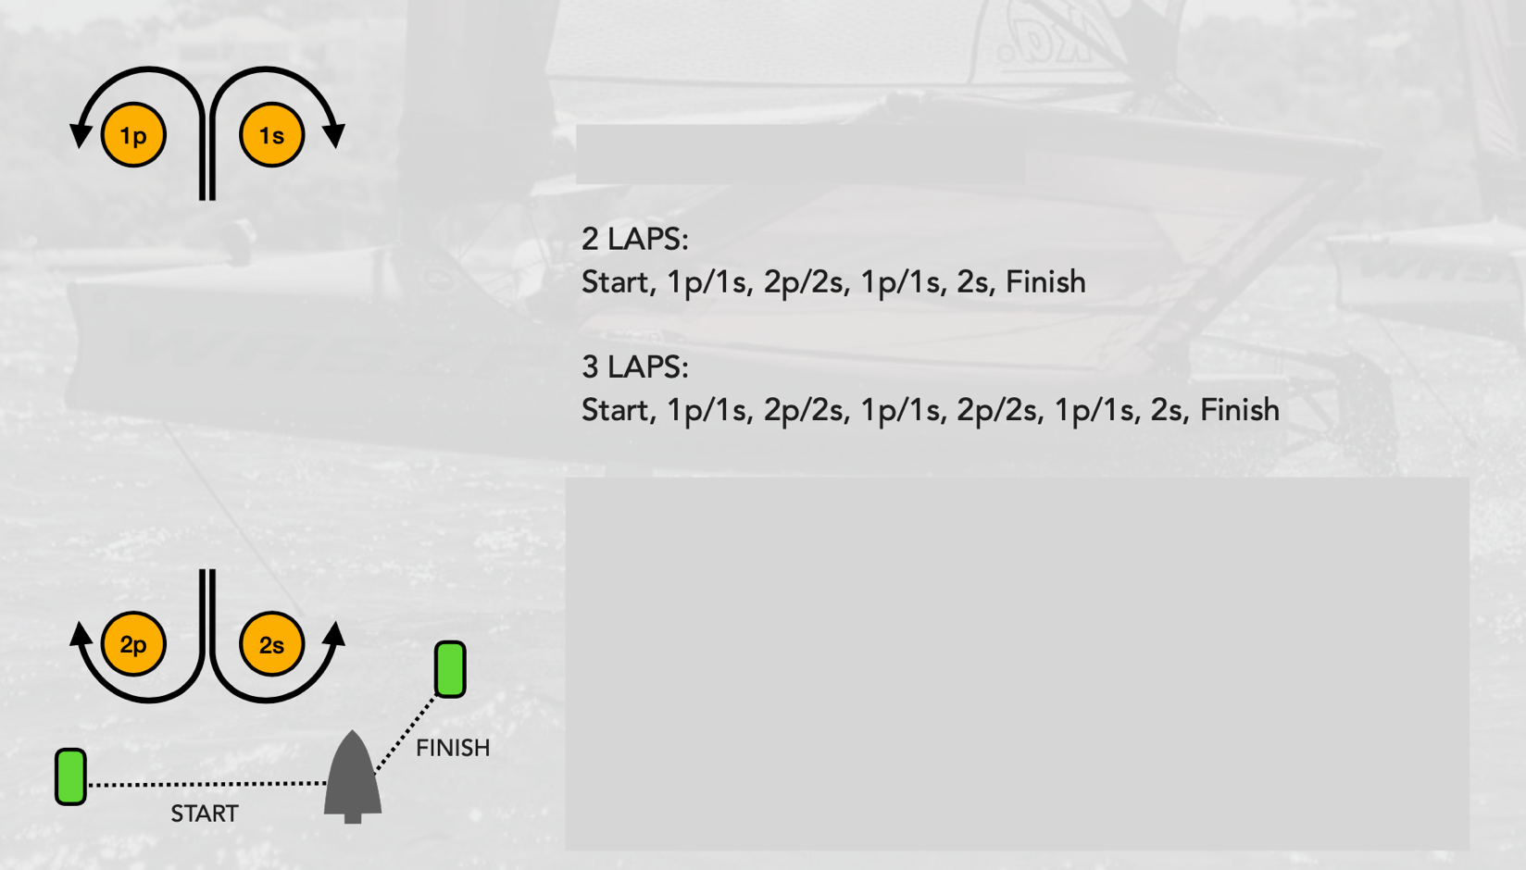

ADDENDUM B – Grand Prix Finishing

Each race will consist of the number of laps designated by the course signal displayed at the start.

A lap consists of sailing from the start (or from Gate 2 in subsequent laps) through Gate 1 and back through Gate 2.

When the first boat completes the course and finishes, the Race Committee vessel will immediately display a pink flag with a sound signal. This indicates that the Finishing Time Window is open.

From this time, all boats shall continue sailing the course but when on a downwind leg shall sail through the finish line regardless of the number of laps completed. All boats which cross the finish line whilst the Finish Time Window is open shall be deemed to have finished irrespective of the number of laps they have completed.

Their position in the race will be determined from their finishing order and number of completed laps, with those have completed the most laps being recorded ahead of those with less completed laps. Boats which have completed 1 lap will be ranked behind those that have completed 2 laps. Boats which have completed 2 laps will be ranked behind those that have completed 3 laps.

To assist the Race Committee, when crossing the finish line, boats should indicate how many laps they have completed

Lowering of the pink flag shall indicate that the Finishing Time Window has closed.

Boats failing to cross the finish line within the Finishing Time Window, will be scored after those finishing as described above. These boats will be scored according to their relative positions and number of laps completed at their last passing through gate 2 (before the Finish Time Window closed).

Boats who have not completed one lap by the time the Finishing Window closes shall be scored Did Not Finish without a hearing. This changes RRS 35, A4 and A5.

