2023 New Zealand Finn Class
National Championships
13th April 2023 – 16th April 2023
Organising Authority
Plimmerton Boating Club, 66 Moana Road, Plimmerton, Karehana Bay 5026

In association with the New Zealand Finn Class Association

AMMENDED Notice of Race as at 28th February 2023

- RULES
  - The event is governed by the rules as defined in The Racing Rules of Sailing.
  - The Yachting New Zealand Safety Regulations Part One shall apply
  - The International Finn Class (IFA) event manual, available at https://www.finnclass.org/technical/rules apply.
  - Appendix T, Arbitration will apply.

- SAILING INSTRUCTIONS
  - The sailing instructions will be available after 1200 hours on 12th April 2023 at https://www.plimmertonboatingclub.org.nz/

  - The sailing instructions will consist of the instructions in RRS Appendix S, Standard Sailing Instructions, and supplementary sailing instructions that will be on the official notice board located at the Plimmerton Boating Club.

- ELIGIBILITY AND ENTRY
  - The event is open to all boats of the Finn Class that holds a valid measuring certificate.
  - Eligible boats may enter by completing the entry form and submitting it, together with the required fee to manager@plimmertonboatingclub.org.nz
  - Entries close on Monday 10th April 2023 at 1700 hours. Late entries will be accepted up until 13th April 2023 however will incur a late entry fee of $25
  - To be eligible to compete in this event each competitor shall be a financial member of a club recognised by the competitor’s national authority. Proof of affiliated club membership to be presented at registration
  - Each competitor shall be a financial member of their national Finn Class association.

- FEES
Entry fees are as follows:
Entry Fee: $175 per sailor
Late entry fee including late payment fee: $200 per sailor

- ADVERTISING
  - Boats may be required to display advertising chosen and supplied by the organizing authority.
  - The organizing authority may provide bibs that competitors are required to wear as permitted by the World Sailing Advertising Code.

- SCHEDULE
  - Registration:
Date | From | To
13/04/2023 | 1500hrs | 1700hrs
14/04/2023 | 0800hrs | 0900hrs

  - Equipment inspection and event measurement:
Thursday 13th April 2023 from 1500hrs to 1700hrs

  - Dates of racing:
Date | Finn
14/04/2023 | Racing
15/04/2023 | Racing
16/04/2023 | Racing

  - Number of races:

Total Number Scheduled | Races per Day Scheduled | Races per day maximum | Target time  Minutes
9 | 3 | 4 | 50

  - The scheduled time of the warning signal each day is 1100hrs.
  - On the last scheduled day of racing the scheduled time of the warning signal is 1000hrs.
  - On the last scheduled day of racing no warning signal will be made after 1500hrs.

- EQUIPMENT INSPECTION
  - Each boat shall produce or verify the existence of a valid measurement certificate.
  - Boats may be inspected at any time.

- VENUE
  - NoR Addendum A shows the plan of the event venue.
  - NoR Addendum B shows the location of the racing areas.

- COURSES
The course will be a windward/leeward race with an offset mark at the top and a gate at the bottom with a downwind finish.

- PENALTY SYSTEM
For the Finn Class RRS 44.1 is changed so that the Two-Turns Penalty is replaced by the One-Turn Penalty.

- SCORING
  - Five races are required to be completed to constitute a series.
  - (a) When fewer than Six races have been completed, a boat’s series score will be the total of her race scores.
(b) When from Six to Nine races have been completed, a boat’s series score will be the total of her race scores excluding her worst score.

- SUPPORT PERSON VESSELS
  - Support person vessels shall be marked with the Sail number(s) of the competitor(s).
  - All support person vessels shall always have an engine safety cut out switch (kill cord) attached to the driver while the engine is running, unless prior written exemption has been provided by the Organising Authority.

- CHARTERED OR LOANED BOATS
A chartered or loaned boat may carry national letters or a sail number in contravention of her class rules, provided that the race committee has approved her sail identification before the first race.

- RISK STATEMENT
RRS 3 states: ‘The responsibility for a boat’s decision to participate in a race or to continue to race is hers alone.’ By participating in this event each competitor agrees and acknowledges that sailing is a potentially dangerous activity with inherent risks. These risks include strong winds and rough seas, sudden changes in weather, failure of equipment, boat handling errors, poor seamanship by other boats, loss of balance on an unstable platform and fatigue resulting in increased risk of injury. Inherent in the sport of sailing is the risk of permanent, catastrophic injury or death by drowning, trauma, hypothermia or other causes.

- INSURANCE
Each participating boat shall be insured with valid third-party liability insurance with a minimum cover of $1,000,000 per incident or the equivalent. Certificate of insurance is to be presented at registration.

- PRIZES
Prizes will be given as follows:
1st Place New Zealand National Finn Class Championships
2nd Place New Zealand National Finn Class Championships
3rd Place New Zealand National Finn Class Championships
1st Master
1st Grand Master
1st Great Grand Master
1st Legend
1st Junior
1st Handicap

- RIGHTS TO USE NAME AND LIKENESS
By participating in the event, a competitor automatically grants to the Organising
Authority and the sponsors of the event, the right in perpetuity, to make, use and
show, from time to time and at their discretion, any motion pictures, still pictures
and live, taped or film television and other reproductions of him/her during the
period of the competition for said event in which the competitor participated and, in all material, related to the said event without compensation.

- USE OF DRONE FOR MEDIA
All those who take part in the race as competitors as well as support crew or
spectators agree to be overflown by a drone during the duration of the event, this includes your person and your property (boats).

- FURTHER INFORMATION
For further information please contact:
New Zealand Finn Association
Ray Hall
secretary@finnclass.org.nz

Addendum A

Venue Location
Plimmerton Boating Club

66 Moana Road, Plimmerton, Karehana Bay 5026

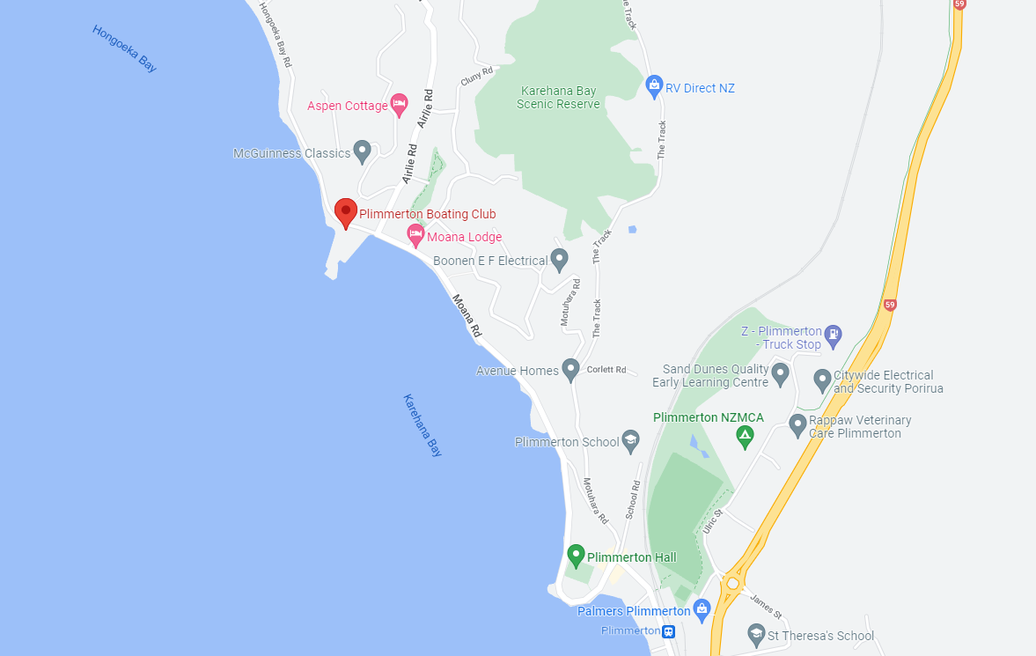

Addendum B

Racing Area
The racing area will be the outer Mana/Plimmerton Harbour, in an area approximately described as stretching from Titahi Bay to Hongoeka Bay.

