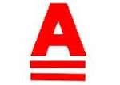

New Zealand A Class & Tornado
National Championships 2023
Thursday 9th March – Sunday 12th March 2023
The Organising Authority is the NZ Multihull Yacht Club
The Hosting Venue is Turangi Yacht & Power Boat Club
Stump Bay, Southern Lake Taupo, New Zealand
SAILING INSTRUCTIONS (SIs)
Version 1.05
The notation ‘[NP]’ in a rule of the sailing instructions (SIs) means that a boat may not protest another boat for breaking that rule. This changes RRS 60.1(a).
1 RULES
- The event is governed by the rules as defined in The Racing Rules of Sailing.

- The Yachting New Zealand Safety Regulations Part 1 shall apply.

- Appendix T, Arbitration will apply.
2 CHANGES TO SAILING INSTRUCTIONS
2.1 Any change to the sailing instructions will be posted before 0900 on the day it will take effect, except that any change to the schedule of races will be posted by 2000 on the day before it will take effect.
3 COMMUNICATIONS WITH COMPETITORS
3.1 Notices to competitors will be posted on the official notice board located at Turangi Yacht Club.
3.2 The race office is located at Turangi Yacht Club.

4 CODE OF CONDUCT
4.1 [DP] Competitors and support persons shall comply with reasonable requests from race officials.
5 SIGNALS MADE ASHORE
5.1 Signals made ashore will be displayed at Turangi Yacht Club.
5.2 When flag AP is displayed ashore, ‘1 minute’ is replaced with ‘not less than 30 minutes’ in Race Signals AP.
5.3 [DP] Flag D with one sound means Boats are required to not leave the shore until this signal is made. The warning signal will not be made before the scheduled time or less than 30 minutes after flag D is displayed.’
6 SCHEDULE OF RACES
6.1 Dates and Numbers of Races:

Day/Date | Class | Number of races | Time of First Warning Signal
Thursday 9th | A Class | Three (3) | 10.55
 | Tornado | Three (3) | 11.00
Friday 10th | A Class | Three (3) | 10.55
 | Tornado | Three (3) | 11.00
Saturday 11th | A Class | Three (3) | 10.55
 | Tornado | Three (3) | 11.00
Sunday 12th | A Class | Three (3) | 10.55
 | Tornado | Three (3) | 11.00
6.2 One extra race per day may be sailed, provided that no class becomes more than two races ahead of schedule and the change is made according to SI 2.1.
6.3 To alert boats that a race or sequence of races will begin soon, the orange starting line flag will be displayed with one sound at least five minutes before a warning signal is made.
6.4 On the last scheduled day of racing no warning signal will be made after 14.25.
7 CLASS FLAGS
7.1 The A Class flag is the A Class Emblem on a White Background.
The Tornado flag is the Tornado Emblem on a White Background.

8 RACING AREA
8.1 The racing area is in the greater area of Stump Bay.
SI Addendum A shows the location of the racing area.
9 COURSES
9.1 The diagram in SI Addendum B shows the course, including the approximate angles between legs, the order in which marks are to be passed and the side on which each mark is to be left.
9.2 No later than the warning signal, the race committee signal vessel will display the approximate compass bearing of the first leg.
9.3 Legs of the course will not be changed after the preparatory signal. This changes RRS 33.
10 MARKS
10.1 Mark descriptions are shown in Addendum B - courses
10.2 In the event that a gate mark is missing and has not been replaced with an object displaying flag M, the remaining mark shall be rounded to port.
11 THE START
11.1 The starting line is between a staff displaying an orange flag on the signal vessel at the starboard end and the course side of the port-end starting mark.
11.2 [DP][NP] Boats whose warning signal has not been made shall avoid the starting area during the starting sequence for other races.
11.3 A boat that does not start within 3 minutes after her starting signal will be scored Did Not Start without a hearing. This changes RRS A5.1 and A5.2.
12 CHANGE OF THE NEXT LEG OF THE COURSE
12.1 To change the next leg of the course, the race committee will move the original mark or the finishing line to a new position.
13 THE FINISH
13.1 The finishing line is between a staff displaying a blue flag on the finishing mark at the starboard end and the course side of the port end finishing mark.
13.2 If the race committee is absent when a boat finishes, she should report her finishing time, and her position in relation to nearby boats, to the race committee at the first reasonable opportunity.
14 PENALTY SYSTEM
14.1 RRS 44.1 is changed so that the Two-Turns Penalty is replaced by the One-Turn Penalty.
15 TIME LIMITS [AND TARGET TIMES]
15.1 The Race Time Limit (see RRS 35), Target Time and the Finishing Window are shown in the table below.
Class | Target Time | Race Time Limit | Finishing Window
A Class | 40 minutes | 60 minutes | 20 minutes
Tornado Class | 40 minutes | 60 minutes | 20 minutes

15.2 Boats failing to finish within the Finish Window after the first boat starts, sails the course and finishes within the race time limit will be scored Did Not Finish without a hearing. This changes RRS 35, A5.1 and A5.2 The Finishing Window is the time for boats to finish after the first boat sails the course and finishes. Boats failing to finish within the Finishing Window, and not subsequently retiring, penalized or given redress, will be scored Time Limit Expired (TLE) without a hearing. A boat scored TLE shall be scored points for the finishing place two more than the points scored by the last boat that finished within the Finishing Window. This changes RRS 35, A5.1, A5.2 and A10.
15.3 Failure to meet the Target Time will not be grounds for redress. This changes RRS 62.1(a).
16 HEARING REQUESTS
16.1 For each class, the protest time limit is 20 minutes after the last boat in that class finishes the last race of the day or the race committee signals no more racing today, whichever is later. The time will be posted on the official notice board.
16.2 Hearing request forms are available from the race office at Turangi Yacht Club.
16.3 Notices will be posted no later than 30 minutes after the protest time limit to inform competitors of hearings in which they are parties or named as witnesses. Hearings will be held in the protest room, located at Turangi Yacht Club, beginning at the time posted.
17 SCORING
17.1 5 races are required to be completed to constitute a series.
17.2 (a) When fewer than 6 races have been completed, a boat’s series score is the total of her race scores.
(b) When from 6 to 9 races have been completed, a boat’s series score is the total of her race scores excluding her worst score.
(c) When 10 or more races have been completed, a boat’s series score is the total of her race scores excluding her two worst scores.
18 [DP][NP] SAFETY REGULATIONS
18.1 Check-in and check-out procedures
- Competitors shall individually check-out before racing by personally signing check out sheets located at the Turangi Yacht Club.
- Competitors shall individually check-in immediately on returning to shore after racing by personally signing check-in sheets located at the Turangi Yacht Club.
18.2 A boat that retires from a race shall notify the race committee at the first reasonable opportunity.
19 REPLACEMENT OF CREW OR EQUIPMENT
19.1 [DP]Substitution of crew is not allowed without prior approval of the Principal Race Officer.
19.2 [DP] Substitution of damaged or lost equipment is not allowed unless authorized by the Principal Race Officer. Requests for substitution shall be made to the committee at the first reasonable opportunity, which may be after the race.
20 EQUIPMENT AND MEASUREMENT CHECKS
20.1 A boat or equipment may be inspected at any time for compliance with the class rules, notice of race and sailing instructions.
21 OFFICIAL VESSELS
21.1 Official vessels will be identified as follows:
The Start and Finish Vessel is a Large White Launch which will be displaying a start pole on it’s Port side and a finish pole on the starboard side
22 [DP][NP] SUPPORT TEAMS
22.1 Except when requested to participate in rescue operations, team leaders, coaches and other support persons shall stay outside areas where boats are racing and are restricted to a 5 knot speed limit, from the time of the preparatory signal for the first start of a sequence of starts until all boats have finished or the race committee signals a postponement or abandonment of all races. The areas the boats are racing in is defined as the area inside the course and within 100 metres of any mark, lay line, starting line, finishing line or any area where any boat that is racing is sailing or may sail.

22.2 All official and support vessels shall always have an engine safety cut out switch (kill cord) attached to the driver while the engine is running, unless prior written exemption has been provided by the Organising Authority.

23 PRIZES
23.1 Prizes will be awarded as follows:

A Class Nationals:
- 1st Open Division Trophy
Open Division medals: 1st, 2nd, 3rd
- 1st Classic Division Trophy
Classics Division medals: 1st, 2nd, 3rd
- 1st Veteran Division (over 55) Trophy
- Youth (under 25) Medal
- Winner of 1st Race - The Murray Philpott Memorial Trophy
- Ken Urquhart Trophy for “Good Sportsmanship”

Tornado Nationals:
- 1st Place – The Moore Trophy
Open Division places: 1st, 2nd, 3rd
- The Pro Marine Tornado Trophy - 1st Tornado with an aluminium mast

23.2 Other prizes may be awarded at the discretion of the Classes or Organising Authority.
24 RISK STATEMENT
24.1 RRS 3 states: ‘The responsibility for a boat’s decision to participate in a race or to continue to race is hers alone.’ By participating in this event each competitor agrees and acknowledges that sailing is a potentially dangerous activity with inherent risks. These risks include strong winds and rough seas, sudden changes in weather, failure of equipment, boat handling errors, poor seamanship by other boats, loss of balance on an unstable platform and fatigue resulting in increased risk of injury. Inherent in the sport of sailing is the risk of permanent, catastrophic injury or death by drowning, trauma, hypothermia or other causes..
25 INSURANCE
25.1 Each participating boat shall be insured with valid third-party liability insurance with a minimum cover of $1,000,000 per incident or the equivalent.

Addendum A Racing Areas

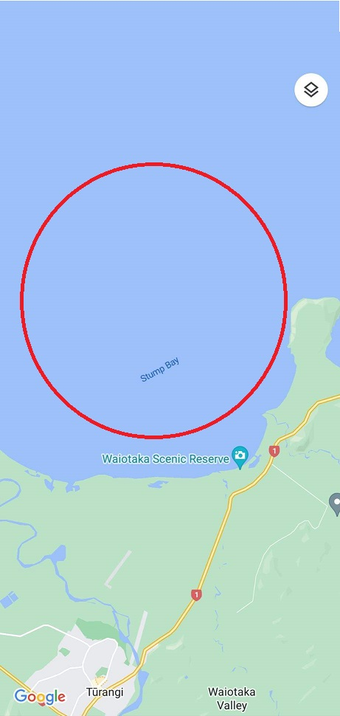

Addendum B Course

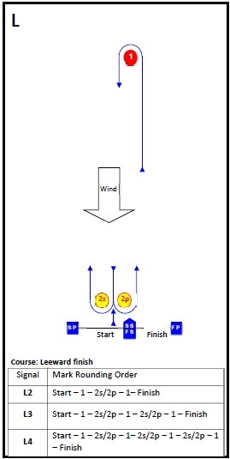

Mark Descriptions:

Mark 1 | Red cylinder buoy
Mark 2s and 2p | Yellow cylinder buoys
Starting mark starboard end | Committee boat
Starting mark port end | Orange teardrop buoy with an ORANGE flag
Finishing mark starboard end | Committee boat
Finishing mark port end | Orange teardrop buoy with a BLUE flag
Replacement mark | Orange conical buoy

