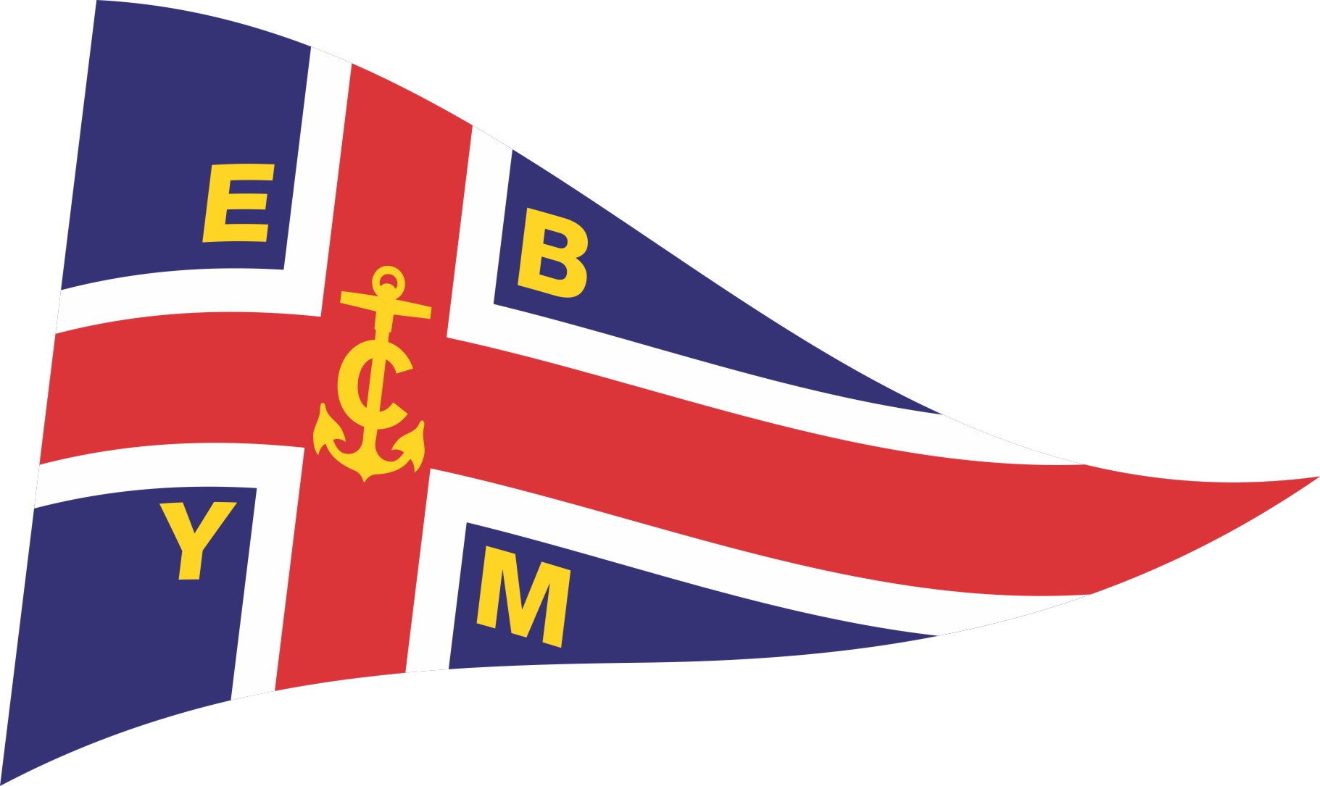
2023 New Zealand 420 Open and National Championships
2023 420 Open World Championship Team Selection Trials

Wednesday 8th – Sunday 12th March 2023
Notice of Race
The Organising Authority is the
Evans Bay Yacht and Motor Boat Club (EBYMBC)
- Evans Bay Parade, Evans Bay, Wellington

The notation ‘[DP]’ in a rule in the Notice of Race means that the penalty for a breach of that rule may, at the discretion of the protest committee, be less than disqualification and the notation [NP] in a rule in the Notice of Race means rules that are not grounds for protest by a boat for breaking that rule. This changes RRS 60.1(a)

- Rules
  - The event will be governed by the rules as defined in the Racing Rules of Sailing (RRS).
  - The YNZ Safety Regulations Part 1 shall apply.
  - Appendix S shall apply.
  - Appendix T shall apply.
- Advertising
  - Boats may be required to display advertising chosen and supplied by the Organising Authority.
- Eligibility and Entry
  - The event is open to all boats of the International 420 Class.
  - Eligible boats may enter by completing the online entry form and paying the required fee by Sunday 5th March 2023.
  - To be eligible to compete in this event each entrant and crew member shall be a financial member of their national 420 class association, and a club recognised by their national authority. Proof of class association and club membership is to be submitted with the entry or presented at the time of registration.
  - Late entries, accompanied by the late entry fee may be accepted at the Race Committee’s discretion until 1000hrs on Thursday 9th March 2023.
- Fees
  - The entry fee is $200.00.
  - The late entry fee is $250.00 ($200.00 + $50.00 late fee) if received after 5th March 2023
- COVID-19
  - [NP] All competitors shall comply with the New Zealand Government COVID-19 requirements in place at any specific time during the event.
  - Refunds will be organised for those who have paid in advance in the event of a COVID related cancellation.
- Schedule
Measuring | Wednesday 8th March 2023 | 0900 – 1600hrs | EBYMBC Clubhouse
Measuring | Thursday 9th March 2023 | 0800 – 0930hrs | EBYMBC Clubhouse
Registration | Thursday 9th March 2023 | 0930 - 1000 hrs | The South-eastern corner of the upstairs lounge of the EBYMBC Clubhouse
Briefing | Thursday 9th March 2023 | 1000 hrs | Upstairs Lounge at EBYMBC
Racing | Thursday 9th March 2023 | 1155 hrs – First warning signal | 3 races
Racing | Friday 10th March 2023 | 1055 hrs – First warning signal | 3 races
Racing | Saturday 11th March 2023 | 1055 hrs – First warning signal | 3 races
Racing | Sunday 12th March 2023 | 1055 hrs – First warning signal | 3 races

  - Twelve (12) races are scheduled for the series.
  - Up to four (4) races may be sailed per day.
  - On Sunday 12th March, no warning signal will be made after 1500hrs
- Measurement
  - Each boat shall provide a valid measurement certificate no later than at the time of measurement. In addition, all boats shall be presented to the Organising Authority for full measurement as per the schedule above.
  - Spot measurements and safety checks may be conducted at any time throughout the event (refer NOR 1.1 and 1.2).
  - All beach trolleys shall have their boat numbers clearly marked on them (refer NOR 1.2).
  - All boats shall ensure that the sail numbers displayed match the hull number (refer NOR 1.2). No dispensation will be approved unless irreparable damage is sustained during the event.
- Sailing Instructions
  - The Supplementary Sailing Instructions will be posted on the EBYMBC website and on the official noticeboard located in the upstairs lounge of the EBYMBC clubhouse. Printed copies will not be provided to competitors.
- Venue
  - The Event Venue is the Evans Bay Yacht & Motor Boat Club (EBYMBC). Refer to Addendum A.
  - The Racing area is the waters known as Evans Bay and Wellington Harbour. Refer to Addendum B.
- Courses to be sailed
  - The courses to be sailed will be Trapezoid and/or Windward/Leeward.
- Scoring
  - The Low Points scoring system of RRS Appendix A will apply.
  - Five (5) races are required to be completed to constitute a series.
  - When fewer than six (6) races have been completed, a boat’s series score will be the total of her race scores.
  - When six (6) or more races have been completed, a boat’s series score will be the total of her race scores excluding her worst score.
- Launching
  - Unless otherwise directed by the Organising Authority, all completing boats and equipment shall be launched and retrieved from the ramps in front of the EBYMBC.
- Coaching and Support Boats
  - All support boats must register with the Organising Authority at the time of Registration (refer to 6 above) and nominate which boat(s) they are supporting. [DP].
  - Kill cords must be fitted and worn at all times while afloat. All local bylaws must also be adhered to.
- Radio Communication
  - Except in an emergency, a boat shall neither make radio transmissions while racing nor receive radio communications not available to all boats. This restriction also applies to mobile telephones [DP].
- Prizes
  - Prizes will be provided by the NZ 420 Class Association and awarded as follows:
- Trophy for First Open/Mixed Team
- Trophy for First Women’s Team
  - Other prizes may be awarded at the discretion of the NZ 420 Class Association or the Organising Authority.
  - For the avoidance of doubt, the NZ National Championship will be awarded to the highest place crew where both sailors are NZ citizens or Permanent Residents.
- Selection
  - This event is the selection event for the 2023 420 Open Worlds at Goztepe Yelkenn Kulubu, Turkey. The selection policy will be posted on the notice board.
- Disclaimer of Liability
  - Competitors participate in all races entirely at their own risk. Refer to RRS rule 4. The Organising Authority will not accept any liability for material damage or personal injury or death sustained in conjunction with, prior to, during, or after the race.
  - Competitors accept that sailing is by its nature an unpredictable sport and therefore inherently involves an element of risk. By taking part in the event, each competitor and the responsible adult agrees and acknowledges that:

- They are aware of the inherent element of risk involved in the sport and accept responsibility for the exposure of themselves and their boat to such inherent risk whilst taking part in the event;
- They are responsible for the safety of themselves, their boat and their other property whether afloat or ashore;
- They accept responsibility for any injury, damage or loss to the extent caused by their own actions or omission;
- Their boat is in good order, equipped to sail in the event and they are fit to participate;
- The provision of a race management team, support boats and other officials and volunteers by the event organiser does not relieve them of their own responsibilities;
- The provision of support boat cover is limited to such assistance, particularly in extreme weather conditions, as can be practically provided in the circumstances.

- Insurance
  - Each participating boat shall be insured with valid marine third-party liability insurance of a minimum of $1,000,000. Proof of insurance shall be provided no later than the close of registration.
- Rights to use name and likeness
  - By participating in the event competitors automatically grant to the Organising Authority, and their sponsors, the right in perpetuity to make, use and show, from time to time at their discretion, any motion pictures and live, taped or filmed television and other reproductions of the athlete during the period of the competition without compensation.
  - No drones will be allowed or permitted unless approved by the NZ Civil Aviation Authority.
- Further Information
For further information please contact:
Ryan Leatham – General Manager
Evans Bay Yacht & Motor Boat Club
generalmanager@ebymbc.org.nz
Phone: (04) 939 4167

Addendum A – Location of Evans Bay Yacht & Motor Boat Club

Addendum B – Indicative Racing Area
