iQ FOIL CLASS NATIONAL CHAMPIONSHIPS 2023
17th to 19th February 2023
Manly Sailing Club, 65 Laurance St, Manly
Whangaparaoa
The Organising Authority is The Manly Sailing Club 65 Laurance St, Manly Whangaparaoa
Notice of Race (NoR) and Sailing Instructions
The notation ‘[NP]’ in a rule means that a boat may not protest another boat for breaking that rule. This changes RRS 60.1(a).
1 RULES
1.1 The event is governed by the rules as defined in The Racing Rules of Sailing.

1.2 The Yachting New Zealand Safety Regulations Part 1 shall apply.

1.3 Appendix B, of the RRS will also apply.

1.4 The iQ Foil Class rules apply.

1.5 If there is a conflict between languages the English text takes precedence.

1.6 Appendix T, Arbitration will apply.

2.0 SAILING INSTRUCTIONS
2.1 Any change to the sailing instructions will be posted before 0900 on the day it will take effect, except that any change to the schedule of races will be posted by 2000 on the day before it will take effect.

3.0 COMMUICATION WITH COMPETITORS

3.1 The online official notice board is located at www.manlysailingclub.org.nz

3.2 A briefing will take place each day at the Manly Sailing Club at 1000hrs

3.3 [DP] A board shall neither make transmissions while racing nor receive communications
not available to all boards, except in an emergency or when using equipment provided by the organising authority.

3.4 In all rule governing the event;
3.4.1 The terms ‘rider’, ‘competitor’, ‘crew’, ‘athlete’ ‘and owner’ mean a person competing, or intending to compete, in the event.

4.0 CODE OF CONDUCT

4.1 [DP] Competitors and support persons shall comply with reasonable requests from race officials.

5.0 SIGNALS MADE ASHORE

5.1 Signals ashore will be displayed on the flagstaff located in the front of the Manly Sailing Club.

5.2 [DP] Flag D with one sound signal means ‘boards shall not leave the shore until this signal is made. The warning Signal will not before the scheduled time or less than 30 minutes after flag D is displayed’

6.0 ELIGIBILITY AND ENTRY
6.1 The event is open to all boards of the iQ Foil class that comply with the class rules.

6.2 Eligible boards may enter by completing the entry form and submitting it, together with the required fee, at www.manlysailingclub.org.nz by Wednesday 15th February 2023.

6.3 To be considered an entry in the event, a competitor shall complete all registration requirements and pay all fees.
6.4 Late entries will be accepted under the following conditions: If Late Entry is received online after to 1800hrs on Friday 10th February 2023 will need to add a further $40 (Late Fee) to their entry fee. No entries will be accepted after 1800hrs on Wednesday 15th February 2023.
6.5 To be eligible to compete in this event each competitor shall be a financial member of a club recognised by the competitor’s national authority.
7.0 FEES
7.1 *Entry fees is as follows:
Class | Entry Fee until 1800hrs 10th Feb 2023 | Late Fee in addition
All fleets | $180 | $40

8.0 ADVERTISING
8.1 Boards may be required to display advertising chosen and supplied by the organizing authority.

9.0 SCHEDULE
9.1 Registration: Manly Sailing Club
Date | From | To
Friday 17th Feb | 0800hrs | 1000hrs

9.2 SCHEDULE OF RACES AND CLASS FLAGS
Day | Fleet | Number of Races | First Time of Warning Signal | Class Flag
Friday 17th Feb | iQ 9.0 Gold | 6 | 1300hrs | Will be described at briefings
Friday 17th Feb | iQ 8.0 Women and Youth | 4 | 1305hrs | Will be described at briefings
Friday 17th Feb | iQ 9.0 Open, Silver and Bronze | 4 | 1310hrs | Will be described at briefings
Saturday 18th Feb | iQ 9.0 Gold | 6 | 1300hrs
Saturday 18th Feb | iQ 8.0 Women and Youth | 4 | 1305hrs
Saturday 18th Feb | iQ 9.0 Open, Silver and Bronze | 4 | 1310hrs
Sunday 19th Feb | iQ 9.0 Gold | 6 | 1300hrs
Sunday 19th Feb | iQ 8.0 Women and Youth | 4 | 1305hrs
Sunday 19th Feb | iQ 9.0 Open, Silver and Bronze | 4 | 1310hrs

9.3 Number of races:
Class | Total Number Scheduled | Races per Day Scheduled | Races per day maximum
IQ 9.0 Gold | 18 | 6 | 6
iQ 8.0 Women and Youth, iQ 9.0 Open, Silver and Bronze | 12 | 4 | 6

9.4 The scheduled time of the warning signal for the first race each day is 1300 hrs.

9.5 On the last scheduled day of racing no warning signal will be made after 1800hrs

10.0 EQUIPMENT INSPECTION
10.1 Boards may be inspected at any time for class compliance.

11 .0 VENUE
11.1 Addendum A shows the plan of the event venue.
11.2 Addendum B shows the location of the racing areas.

12.0 COURSES AND MARKS
12.1 The courses to be sailed, and the description of the marks will be advised at the daily briefings.

13.0 THE START
13.1 Races will be started using RRS App B3, 26.1 or 26.2., depending on the race format.
13.3 The starting line is between a staff displaying an orange flag on the signal vessel and the course side of the starting mark at the other end.
13.6 A board that does not start within two minutes after her starting signal will be scored Did Not Start without a hearing. This changes RRS A5.1 and A5.2.
13.1 When a starting sequence is in progress, boards whose warning signal has not been made shall avoid the starting area. The starting area is defined as the area 50 metres from the starting line in all directions.

14.0 TIME LIMITS
Fleet | Target Time | Time Limit | Finish Window
Course | 18 | 24 | 6
Slalom | 6 | 8 | 4
Marathon | 60 | 90 | 30
Medal | 8 | 12 | 4

15 CHANGE OF COURSE
15.1 There will be no change of course, except described at the daily briefing.
16 THE FINISH
16.1 The finishing line is between a staff displaying a blue flag on the signal vessel and a vessel on the other end.

17.0 PENALTY SYSTEM
17.1 For the iQ Foil class RRS 44.1 is changed so that the Two-Turns Penalty is replaced by the One-Turn Penalty.

18.0 CHECK OUT AND CHECK IN

18.2 Check out and Check in boards will be located outside the doors on the ground level of the Manly Sailing Club.

19.0 SCORING
19.1 Five races are required to be completed to constitute a series.

19.2 A boat’s series score shall be the total of her race scores.
19.3 (a) When fewer than five races have been completed, a boat’s series score will be the total of her race scores.
(b) When from six to nine races have been completed, a boat’s series score will be the total of her race scores excluding her worst score.
(c) When eleven or more races have been completed, a boat’s series score will be the total of her race scores excluding her two worst scores.
20 REPLACEMENT OF CREW OR EQUIPMENT
20.1 [DP] Substitution of competitors is not allowed without prior written approval of the Race Committee.
20.2 [DP] Substitution of damaged or lost equipment is not allowed unless authorized in writing by the Race Committee. Requests for substitution shall be made to the committee at the first reasonable opportunity, which may be after the race.
21 HEARING REQUESTS
21.1 The protest time limit is 60 minutes after the last boat in the fleet finishes the last race of the day or the race committee signals no more racing today, whichever is later. The time will be posted on the official notice board.
21.2 Hearing request forms are available from the race office upstairs in the Manly Sailing Club.
21.3 Notices will be posted no later than 30 minutes after the protest time limit to inform competitors of hearings in which they are parties or named as witnesses. Hearings will be held in the protest room, located upstairs in the Manly Sailing Club, beginning at the time posted.
21.4 RRS 62.2(a) and 66.2(a) do not apply.
22.0 SUPPORT PERSON VESSELS
22.1 [DP] Support person vessels shall be registered with the Organising Authority.
22.2 [DP] All support person vessels shall always have an engine safety cut out switch (kill cord) attached to the driver while the engine is running, unless prior written exemption has been provided by the Organising Authority.

23.0 RISK STATEMENT
23.1 RRS 3 states: ‘The responsibility for a boat’s decision to participate in a race or to continue to race is hers alone.’ By participating in this event each competitor agrees and acknowledges that sailing is a potentially dangerous activity with inherent risks. These risks include strong winds and rough seas, sudden changes in weather, failure of equipment, boat handling errors, poor seamanship by other boats, loss of balance on an unstable platform and fatigue resulting in increased risk of injury. Inherent in the sport of sailing is the risk of permanent, catastrophic injury or death by drowning, trauma, hypothermia or other causes.

24.0. DISCLAIMER OF LIABILITY
24.1 RRS 3 of the Racing Rules of Sailing States: “The responsibility for a boat’s decision
` to participate in a race or continue racing is hers alone”.
Sailing is by its nature an unpredictable sport and therefore inherently involves an element of risk. By taking part in a event, each competitor agrees and acknowledges that:
- They are aware of the inherent element of risk involved in the sport and accept responsibil-
-ity for the exposure of themselves, their crew, and their boat to such inherent risk whilst taking part in the event;
- They are responsible for the safety of themselves, their crew, their boat and their other
property whether afloat or ashore;
- They accept responsibility for any injury, damage or loss to the extent caused by their own
actions or omission;
- Their boat is in good order, equipped to sail in the event and they are fit to participate;
E The provision of a race management team, patrol vessels and other officials and volunteers
by the event organiser does not relieve them of their own responsibilities;
f. The provision of patrol vessel cover is limited to such assistance, particularly in extreme
weather conditions, as can be practically provided in the circumstances;
g. It is their responsibility to familiarise themselves with any risks specific to this venue or this event drawn to their attention in any rules and information produced for this event and to attend any safety meetings held for this event.

24.2 RPAS (Remote Piloted Aircraft Systems) may be used during the event. Participation in
the regatta will be taken as agreement and consent to be flown over and have the RPAS operate within close proximity to competing boats. The RPAS Operators employed by the Organising Authority are Civil Aviation Authority Certified Operators and the RSAP are operated within Civil Aviation Authority Rule 102. The Organising Authority does not accept any liability for actual or perceived interference from any RPAS taking photographs during racing.

25.0 INSURANCE
25.1 Each participating boat shall be insured with valid third-party liability insurance with a minimum cover of $1,000,000 per incident or the equivalent. Certificate of insurance is to be presented at registration.

26.0 PRIZES
26.1 A Prizegiving will be held at the completion of racing on the last day.

27.0 FURTHER INFORMATION
For further information please contact:
Fiona Rist, Secretary Manly Sailing Club secretary@manlysailingclub.org.nz
021 905 979

Addendum A

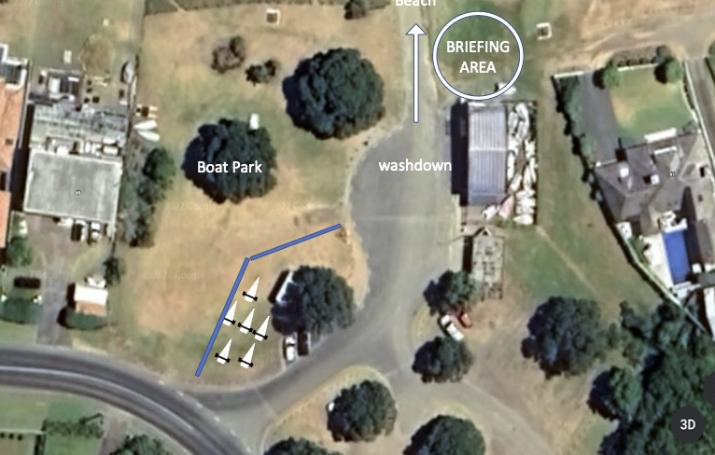

Addendum B

