PORT OTAGO
2023 New Zealand Sunburst National Championships
January 26 to 29 2023
The Organising Authority is Vauxhall Yacht Club (VYC),
153 Portobello Road, Vauxhall, Dunedin 9013
Notice of Race (NoR)
The notation ‘[NP]’ in a rule means that a boat may not protest another boat for breaking that rule. This changes RRS 60.1(a).
1 RULES
1.1 The event is governed by the rules as defined in The Racing Rules of Sailing.

1.2 The Yachting New Zealand Safety Regulations Part 1 shall apply.

1.3 Appendix S, Supplementary Sailing Instructions will apply.

1.4 Appendix T, Arbitration will apply.

2 SAILING INSTRUCTIONS
2.1 The supplementary sailing instructions (SSI) will be available after 2000 hrs on 20th January on the VYC website and available at event registration.

2.2 The sailing instructions will consist of the instructions in RRS Appendix S, Standard Sailing Instructions, and supplementary sailing instructions that will be on the official notice board located at VYC.

3 COMMUNICATIONS

3.1 The official notice board and flagpole are located at the Vauxhall Yacht Club.

4 ELIGIBILITY AND ENTRY
4.1 The event is open to all boats of the Sunburst class.

4.2 Eligible boats may enter by completing the official entry form with the NOR
and paying the required fee to the bank account notified on the entry
form.

4.3 Late entries will be accepted up till close of registrations with payment of registration fee and late payment fee.
4.4 To be eligible to compete in this event each competitor and crew member shall be a financial member of a club recognised by the competitor’s national authority.

5 FEES
5.1 Entry fees
Class | Early Entry Fee until 2000 hrs 12-01-2023 | Additional late entry fee.
Sunburst Class | $50 | $10

6 ADVERTISING
6.1 Boats may be required to display advertising chosen and supplied by the organizing authority.

7 SCHEDULE

7.1 8 Races are scheduled for the series, this applies to the Championship and Taiho (non-spinnaker) fleet.

7.2 Registration:
Date | From | To
26-01-2023 | 1200 | 1800

7.3 Equipment inspection and event measurement:
Date | From | To
26-01-2023 | 1200 | 1800

7.4 Briefing:

Date | Time | Venue
27-01-2023 | 0930 | VYC

7.5 Dates of racing:
Date | 1st Warning Signal | Target Time | Finishing Window
27-01-2023 | 1030 | 40m | 20m
28-01-2023 | 1030 | 40m | 20m
29-01-2023 | 1030 | 40m | 20m

7.6 Number of races:
Date | Races per Day Scheduled | Races per day maximum
27-01-2023 | 3 | 4
28-01-2023 | 3 | 4
29-01-2023 | 2 | 3

7.7 On the last scheduled day of racing no warning signal will be made after 1530.

8 EQUIPMENT INSPECTION
8.1 Each boat shall have a valid measurement certificate and shall display a current registration sticker on its transom.

8.2 All sails shall have been previously measured and stamped by a Sunburst Class Measurer.

8.3 Each competitor shall present their hull for weighing in dry condition with the rudder stock removed.

8.4 There shall be only one set of sails, spars and foils used by each boat. These shall be presented and endorsed at Measurement. (Refer NOR 7.3 above). Any changes must be requested and approved by the Race Officer in writing.

8.5 Each boat shall complete a measurement/safety checklist during the measurement process on Thursday 26th January (Refer NOR 7.3 above).
8.6 There will be no sail, boat or foil measurement at the event unless previously arranged with a Sunburst Class Measurer.
8.7 All beach trailers/trolleys must have boat names and sail numbers clearly marked on them.
8.8 Safety and measurement checks may be made on any boat at any time during the event.

9 VENUE
9.1 NoR Addendum A shows the plan of the event venue.
9.2 NoR Addendum B shows the location of the racing areas.

10 COURSES

10.1 The courses to be sailed will be triangular courses including windward, reaching, and leeward marks or windward, leeward only.

10.2 Courses will be described in the SSI’s and described at briefing.
10.2 The marks that may be used will be described in the SSI’s and described at briefing.

11 PENALTY SYSTEM
11.1 For all classes RRS 44.1 is changed so that the Two-Turns Penalty is replaced by the One-Turn Penalty.

12 SCORING
12.1 5 races are required to be completed to constitute a series.
12.3 When fewer than 6 races have been completed, a boat’s series score will be the total of her race scores.
12.4 When 6 or more races have been completed, a boat’s series score will be the total of her races scored excluding her worst score.

13 SUPPORT PERSON VESSELS
13.1 Support boats are allowed.
13.2 [DP] All support person vessels shall always have an engine safety cut out switch (kill cord) attached to the driver while the engine is running unless prior written exemption has been provided by the Organising Authority.

14 LAUNCING
14.1 [DP] Unless otherwise directed by the Organising Authority, all competing boats and equipment shall be launched and retrieved from VYC ramps.

15 RADIO COMMUNICATIONS
15.1 Except in an emergency, a boat that is racing shall not make voice or data transmissions

and shall not receive voice or data communication that is not available to all boats. This restriction also applies to mobile telephones. [DP].

16 RISK STATEMENT
16.1 RRS 3 states: ‘The responsibility for a boat’s decision to participate in a race or to continue to race is hers alone.’ By participating in this event each competitor agrees and acknowledges that sailing is a potentially dangerous activity with inherent risks. These risks include strong winds and rough seas, sudden changes in weather, failure of equipment, boat handling errors, poor seamanship by other boats, loss of balance on an unstable platform and fatigue resulting in increased risk of injury. Inherent in the sport of sailing is the risk of permanent, catastrophic injury or death by drowning, trauma, hypothermia or other causes.

17 INSURANCE
17.1 It is recommended that each participating boat shall be insured with valid third-party liability insurance with a minimum cover of $1,000,000 per incident or the equivalent.

18 PRIZES
18.1 Prizes will be awarded as follows:
Sunburst.
• Wilson & Horton Cup (Line Honours)
• Brooke Trophy (2nd line)
• Maurice Scott & Life Members’ Trophy (3rd Line)
• Wakatere Trophy (1st Handicap)
• Colin & Peter Kettlewell Cup (1st Helm & Crew under 19 years of age at 1 January 2023
• National Youth Championship Mixed Double Handed Trophy (Helm & Crew under 19 years of age at 1 January 2023
• NZ Sunburst Association Trophy – Secondary Schools Trophy (1st Helm & Crew both pupils from the same school for the 2022-2023 year)
• Muritai One Ton Cup (Highest placed crew with a combined age of 100 years or more).
• Invitation Race Trophy – John Brooke painting
• Tony Bouzaid Trophy

19 FURTHER INFORMATION
19.1 For further information please contact
Roy Roker rokers@xtra.co.nz 027 208 3163
Merv Read merv_read@hotmail.com 022 027 0068
Peter Wood petetheplumber123@gmail.com 03 4535351
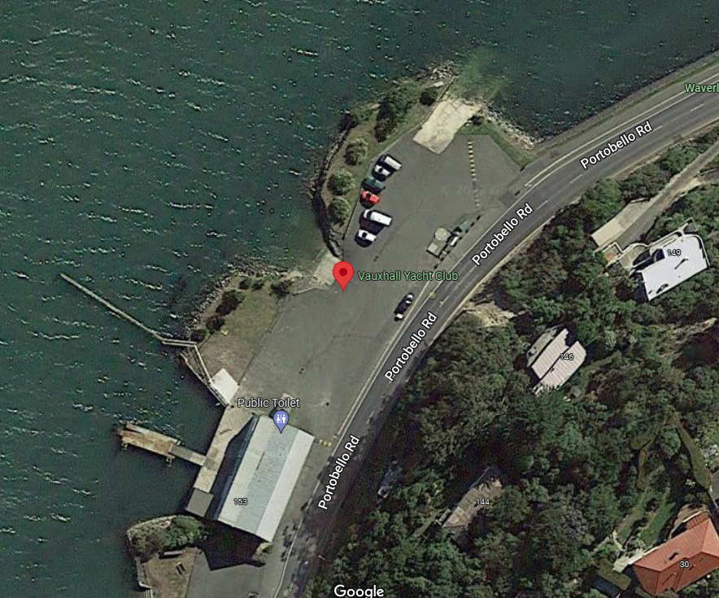
Addendum A

Addendum B

