2023 New Zealand One-Design “P” Class Championship for the Tauranga Cup

5th – 8th January 2023

The Organising Authority is the Plimmerton Boating Club (PLBC)
66 Moana Road, Plimmerton | Porirua, 5026

SUPPLEMENTARY SAILING INSTRUCTIONS (SSI)
This sheet and Addendum A are supplements to Appendix S of the Racing Rules of Sailing.
Note: The notation ‘[DP]’ in a rule in the SSI means that the penalty for a breach of that rule may, at the discretion of the protest committee, be less than disqualification. The notation [NP] in a rule in the SSI means that a boat may not protest another boat for breaking that rule. This changes RRS 60.1(a).

NOTICES TO COMPETITORS (SI 2)
SSI 1 The race office is located at the PLBC Clubrooms.
The official notice board is located at the ground floor at the PLBC clubrooms.
Notices may also be posted online at https://www.plimmertonboatingclub.org.nz/club-updates/p-class-nationals-2023.

SIGNALS MADE ASHORE (SI 4)
SSI 2 Signals ashore will be displayed on the flagstaff located at the PLBC start tower.
SSI 3 When flag AP is displayed ashore, ‘1 minute’ is replaced with ‘not less than 30 minutes’ in Race Signals AP.
SSI 4 Flag D with one sound means ‘Boats shall not leave the shore until this signal is made. The warning signal will not be made before the scheduled time or less than 30 minutes after flag D is displayed.’ (DP)

SCHEDULE OF RACES AND CLASS FLAGS (SI 5 & 6)
Day | Number of Races | Time of first warning signal | Class Flag
Friday  6th January | 3 | 11:00 | Class insignia (Blue P) on a white background.
Saturday  7th January | 3 | 10:00 | Class insignia (Blue P) on a white background.
Sunday  8th January | 3 | 10:00 | Class insignia (Blue P) on a white background.

SSI 5 On Sunday 8th January, no warning signal will be made after 16:30

COURSES (SI 7)
SSI 6 The courses to be sailed, the order in which the marks are to be passed, and the side on which each mark is to be left are shown in Addendum A.

SSI 7 In the event that a gate mark is missing and has not been replaced with an object displaying flag M, the remaining mark shall be rounded to port.
MARKS (SI 8)
SSI 8 The description of the marks is below each course diagram shown in Addendum A.

THE START (SI 9)
SSI 9 To alert boats that a race or sequence of races will begin soon, the orange starting line flag will be displayed with one sound at least five minutes before a warning signal is made.
SSI 10 A boat starting later than four minutes after her starting signal will be scored Did Not Start without a hearing. This changes RRS A5.1and 5.2.

THE FINISH (SI11)
SSI 11 The Race Committee may award a finishing score to a boat that is still racing by displaying to her from a Committee vessel (which may be in motion) flag W with one sound signal. A boat so notified is no longer required to sail the course, shall stop racing and return to the starting area, or return ashore if there is no more racing. A finishing score under this Sailing Instruction will be the score she would have received had she sailed the course and finished within any time limit, without gaining or losing any place. However, when two or more boats that are overlapped are notified, they will be scored as if they were tied.
This changes RRS 28.

TIME LIMITS (SI 12)
Fleet/Class | Target time for first finisher | Finish Window | Race time limit
P-Class | 30 minutes | 15 minutes | 45 minutes
There is no prescribed time limit for the first boat to pass mark 1.

PENALTY SYSTEM
SSI 12 RRS 44.1 is changed so that the two-turns penalty is replaced by the one-turn penalty
SSI 13 Appendix P, parts P1 through P4 will apply

CHECK OUT AND CHECK IN
SSI 14 Boats shall comply with the following check out and check in procedure:
  - Competitors shall individually check out before racing by personally signing the check-out sheets located at the launching ramp.(DP)(NP)
  - Competitors shall individually check-in immediately on returning to shore after racing, by personally signing the check-in sheets located at the launching ramp. (DP)(NP)
  - A boat that retires from a race or returns to the launching area before she finished shall notify the Race Office as soon as possible. (DP)(NP)

REPLACEMENT OF CREW OR EQUIPMENT
SSI 15 Substitution of competitors will not be allowed.
SSI 16 Substitution of damaged or lost equipment is not allowed unless authorized in writing by the Race Officer. Requests for substitution shall be made to the committee at the first reasonable opportunity, which may be after the race. (DP)

SUPPORT VESSELS
SSI 17 All support boats must register with the Organising Authority at registration and nominate the boat(s) they support. (DP)(NP)
SSI 18 All support and coach boats must have VHF communications and be available to assist the race committee if required. (DP)(NP)
SSI 19 All support and coach boats shall have an engine safety cut out switch (kill cord) attached to the driver at all times while the engine is running, unless prior written exemption has been provided by the Organising Authority. (DP)(NP)
SSI 20 All persons on board support vessels must adhere to local bylaws and wear a PFD at all times while afloat (DP)(NP)
SSI 21 Except when requested to participate in rescue operations, team support boats and other support persons shall stay outside areas where boats are racing, from the time of the preparatory signal until all boats have finished or the race committee signals a postponement or abandonment of all races. The areas the boats are racing in is defined as the area inside the course and within 100 metres of any mark, lay line, starting line, finishing line or any area where any boat that is racing, is sailing or may sail. (DP)
SSI 22 When flag V (with a long sound signal) is displayed on a committee boat all support boats are requested to remain afloat and assist all sailors. (DP)(NP)

Addendum A – Approximate Course Area

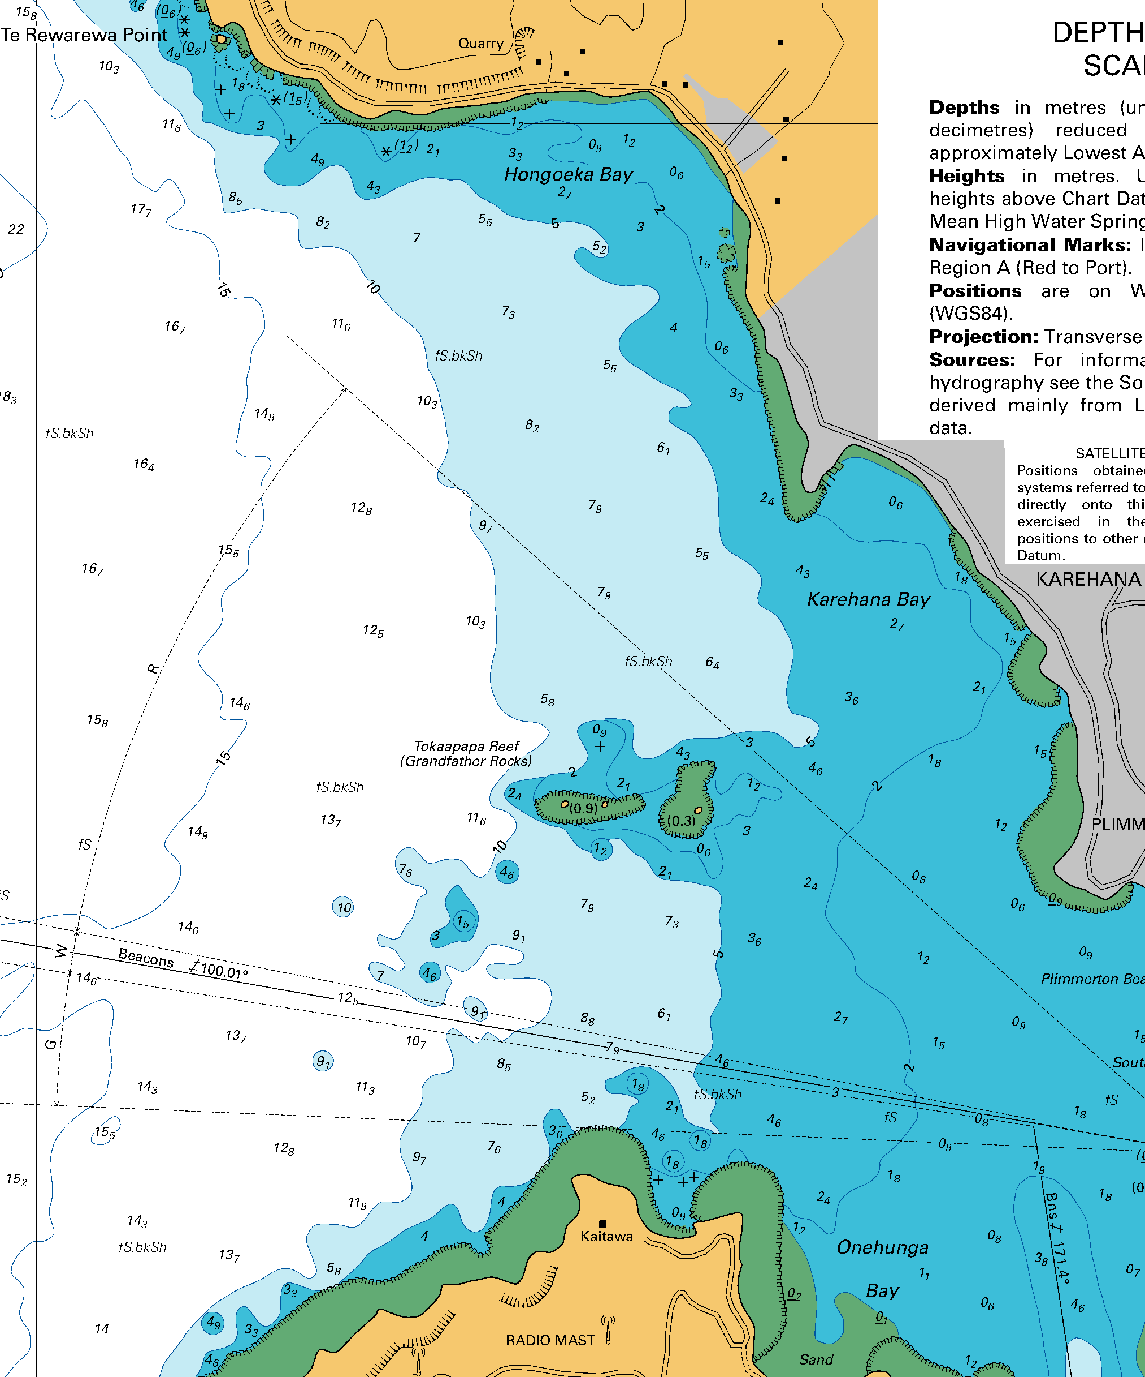
Addendum A – Course Illustration
Mark | Description
 | Orange cylindrical buoy
 | Orange cylindrical buoy
 | Orange cylindrical buoy
Starting mark starboard end | Staff flying orange flag on committee boat
Starting mark port end | Orange flag dan buoy
Finishing mark starboard end | Staff flying blue flag on committee boat
Finishing mark port end | Orange flag dan buoy

Course Illustration – Triangular course with start finish middle of beat

T
Course: Triangular course start finish middle of beat
1
2
3
S P
F P
S S
F S
3
S P
F S
F P
S S
1
2
Finish
Start
Signal | Mark Rounding Order
T1 | Start – 1 – 2 – 3 – Finish
T2 | Start – 1 – 2 – 3 – 1 – 3 – Finish
T3 | Start – 1 – 2 – 3 – 1 – 3 – 1 – 2 – 3 – Finish

Addendum A – Course Illustration
Course Illustrations – Windward course with start finish middle of beat

4s
4p
Course: Windward course start finish middle of beat
W
1
Wind
Finish
Start
S P
F P
S S
F S
Mark | Description
 | Orange cylindrical buoy
 | Orange cylindrical buoys
Starting mark starboard end | Staff flying orange flag on committee boat
Starting mark port end | Orange flag dan buoy
Finishing mark starboard end | Staff flying orange flag on committee boat
Finishing mark port end | Orange flag dan buoy

4s
4p
S P
F S
F P
S S
1
1#
1#

Signal | Mark Rounding Order
W1 | Start – 1 – 4s/4p – Finish
W2 | Start – 1 – 4s/4p – 1 – 4s/4p – Finish
W3 | Start – 1 – 4s/4p – 1 – 4s/4p – 1 – 4s/4p – Finish

