2023 NZ Inter-Provincial One-Design “P” Class Championship for the Tanner Cup

3rd – 5th January 2023

The Organising Authority is the Plimmerton Boating Club (PLBC)
66 Moana Road, Plimmerton | Porirua, 5026

NOTICE OF RACE

NB: The notation ‘[DP]’ in a rule in the Notice of Race means that the penalty for a breach of that rule may, at the discretion of the protest committee, be less than disqualification.

- RULES
  - The regatta will be governed by the rules as defined in The Racing Rules of Sailing.
  - The Yachting New Zealand Safety Regulations Part 1 shall apply.
  - Racing rules are changed as follows:
      - RRS A5.1 and A5.2 will be changed to state that a boat starting later than 4 minutes after her starting signal will be scored Did Not Start.
      - RRS A5.1 and A5.2 will be changed to state that boats still racing but failing to finish within 10 minutes after the first boats sails the course and finishes will be scored Did Not Finish.
      - RRRS 60.1 (a) will be changed to state that a competitor cannot protest another boat or competitor for breaches of some specific parts of the Sailing Instructions or Supplementary Sailing Instructions.
      - RRS 61.1(a) will be changed to state that “A competitor intending to protest is required to inform the race committee at the finish line of their intention to protest immediately after finishing.”
The changes will appear in the Supplementary Sailing Instructions. The Supplementary Sailing Instructions may also change other racing rules.

  - The Tanner Cup Rules and Conditions contained in the New Zealand One Design P Class Yacht Rules – 2021 shall apply
Refer www.yacht.org.nz
  - Appendix T, Arbitration will apply

- SAILING INSTRUCTIONS
  - The sailing instructions will consist of the instructions in RRS Appendix S, Standard Sailing Instructions, and Supplementary Sailing Instructions (SSI’s) that will be posted on the official notice board located at the event headquarters in the PLBC clubrooms and online at https://www.plimmertonboatingclub.org.nz/club-updates/p-class-nationals-2023 by 1800 2 January 2023
Paper copies will not be issued to competitors.
- COMMUNICATION
  - The official notice board will be located on the ground floor of the Plimmerton Boating Club clubrooms.
  - The online official notice board is located at https://www.plimmertonboatingclub.org.nz/club-updates/p-class-nationals-2023
  - [DP] Except in an emergency, a boat that is racing shall not make voice or data transmissions and shall not receive voice or data communication that is not available to all boats. This restriction also applies to mobile telephones.
- ELIGIBILITY AND ENTRY
  - The regatta is open to all P Class boats that comply with the Class Rules and have a current P Class National Certificate in the name of the current owner.
Refer - http://www.yacht.org.nz.
  - Each competitor shall have been nominated by an eligible challenging body as defined in the P Class Rules (including the Tanner Cup Rules and Conditions).
  - Eligible boats may enter by either;
(a) Completing the on-line booking form and payment on the event web-site, https://www.registernow.com.au/secure/Register.aspx?E=47493 and paying the required entry fee
  - Entries will be accepted up until 1700 on Friday 23rd December, 2022.
  - Late entries, accompanied with a late entry fee may be accepted at the
discretion of the Organising Authority up until 1200 on 2nd January 2023.
  - To be eligible to compete in this event each competitor shall be a financial member of a club recognised by the competitor’s national authority.
Proof of affiliated club membership may be requested.
  - Each competitor shall be under the age of 17 years on 31st January, 2023
  - The following documents shall be presented at registration:
- Proof of yacht club membership,
- current P Class National Certificate in the name of the current owner,
- Copy of competitor’s birth certificate or other proof of age – eg. Passport.
- FEES
  - Required fees, including GST, are as follows:
ENTRY | ENTRY FEE
Tanner Cup | $175
Combined Tanner & Tauranga Cup | $250
Late entry fee (additional) | $50

- COVID-19
  - The event will not go ahead at Covid traffic light Red level or lockdown or other gathering restrictions are in force for the Wellington region. Refunds will be organised for those who have paid in advance in the event of a COVID related cancellation.
  - DO NOT attend if you are feeling unwell or have been in close contact with someone confirmed with COVID-19 in the past 14 days
  - Practice good hygiene and ensure your sailors practice good hygiene, use soap to wash your hands thoroughly and there will be hand sanitiser around the club for your use as well
  - Alert race officials if you become unwell during or soon after the event so we can implement our Covid-19 response plan.
  - If it becomes necessary to cancel the event, payments made to PLBC by competitors in relation to the event will be refunded less a $35 admin and t-shirt fee. Please note – Due to lead times, event T-shirts have now been ordered and cannot be returned. PLBC will post T-shirts to all entrants.
Competitors and families who are unwell or have possible symptoms, or who have come into contact with a known case of Covid-19 are encouraged not to travel to the event, and PLBC will offer a full refund less the $35 admin and T-shirt fee. PLBC will post the t-shirt.

- CLASSIFICATION
  - There are no classification requirements in accordance with RRS 79.
- ADVERTISING AND IDENTIFICATION
  - Each competing boat shall carry on BOTH sides of its sail, contrasting letters at least 300mm high and 38mm wide, denoting the province or district (see P Class Rules - Rule 2 (a)) and unless reversible, such letters shall be arrange at
different heights on each side of the sail. Each competitor shall supply their
own letters.
  - [DP] Female competitors may be required to display a red diamond on their sail above the top batten.
The Organising Authority will supply the red diamond stickers and instructions for their use.
  - [DP] Boats may be required to display advertising chosen and supplied by the
organizing authority in accordance with World Sailing Regulation 20, Advertising Code.
  - [DP] The Organising Authority may provide bibs that competitors are required to wear as permitted by the World Sailing Advertising Code.
- SCHEDULE
  - Registration
Day | Date | From | To
Tuesday | 3rd January 2023 | 09:00 | 14:00

  - Equipment Inspection and Measurement
Day | Date | From | To
Tuesday | 3rd January 2023 | 9:00 | 14:00

  - Briefing
Day | Date | From
Tuesday | 3rd January 2023 | 14:00

  - Racing
Day | Date | Number of Races | Time of First Warning
Wednesday | 4th January 2023 | 3 | 11:00
Thursday | 5th January 2023 | 3 | 11:00

  - The target time for each race is 30 minutes.
  - On Thursday 5th January, no warning signal will be made after 17:00
- EQUIPMENT INSPECTION
  - [DP] Each boat shall be presented for measurement as per NoR 9.2.
  - Each competitor shall use only one hull, one set of foils, one mast, one boom and one sail for the entire Tanner Cup, all of which shall have been measured and marked at the official measuring.
  - All items that have been measured and marked as per NoR 9.2 shall not be
modified in any way from the time of measurement through to the end of the event.
  - In addition, wet clothing, spot measurement and safety checks may be conducted at any time during the event.
  - [DP] Boats shall comply with RRS 78.1 when presented for inspection.
- VENUE
  - NoR Attachment A shows the location of the event venue.
  - NoR Attachment B shows the approximate location of the racing areas.
- COURSES
  - The courses to be sailed shall be triangle or triangle, windward/leeward courses using laid marks.
- PENALTY SYSTEM
  - RRS 44.1 is changed so that the Two-Turns Penalty is replaced by the One-Turn Penalty.
  - Appendix P, Special Procedures for Rule 42, may apply as amended by the Supplementary Sailing Instructions.
- SCORING
  - Two (2) races are required to be completed to constitute a series.
  - (a) When fewer than 4 races have been completed, a boat’s overall score will be the total of her race scores.
(b) When 4 or more races have been completed, a boat’s overall score will be the total of her race scores excluding her worst score.
- SUPPORT PERSON VESSELS
  - [DP] All support boats must register with the Organising Authority at registration and nominate the boat(s) they support.
  - [DP] All support and coach boats must have VHF communications and be
available to assist the race committee if required.
  - [DP] All support and coach boats shall have an engine safety cut out switch (kill cord) attached to the driver at all times while the engine is running, unless prior written exemption has been provided by the Organising Authority.
- HAUL-OUT RESTRICTIONS
  - All boats must launch and retrieve from Plimmerton Boating Club
  - Beach trolleys shall be prominently marked with the boat’s sail number.
  - Beach trolleys should be in a compact area either side of the launching ramp and kept clear of the thoroughfare to the main launching ramps
Note: There will be no official security overnight at the club

- RIGHTS TO USE NAME AND LIKENESS
  - By participating in this event, competitors automatically grant to the Organising Authority and the event sponsors the right, in perpetuity, to make, use, and show, at their discretion, any photography, audio and video recordings, and other reproductions of them made at the venue or on the water from the time of their arrival at the venue, until their final departure, without compensation.
  - All those who take part in this event as competitors as well as support crew or spectators agree to be overflown by a drone during the duration of the event, this includes your person and your property (boats).
- RISK STATEMENT AND DISCLAIMER OF LIABILITY
  - RRS 3 states: ‘The responsibility for a boat’s decision to participate in a race or to continue to race is hers alone.’ By participating in this event each competitor agrees and acknowledges that sailing is a potentially dangerous activity with inherent risks. These risks include strong winds and rough seas, sudden changes in weather, failure of equipment, boat handling errors, poor seamanship by other boats, loss of balance on an unstable platform and fatigue resulting in increased risk of injury. Inherent in the sport of sailing is the risk of permanent, catastrophic injury or death by drowning, trauma, hypothermia or other causes.
  - Competitors participate in the regatta entirely at their own risk. See RRS 3, Decision to Race. The organising authority will not accept any liability for material damage or personal injury or death sustained in conjunction with or prior to, during, or after the regatta.
- INSURANCE
  - Each participating boat shall be insured with valid marine third-party liability insurance with a minimum cover of $1,000,000 per incident or the equivalent. Certificate of insurance is to be presented at registration.
- PRIZES
  - Prizes will be given as follows:
- 1st Overall Tanner Cup
- 2nd Overall Gisborne Cup
- 3rd Overall Otago Cup
- Winner 1st Race John Thompson Trophy
  - Other prizes may be awarded at the discretion of the Class Association or the Organising Authority.
  - Daily presentation will occur immediately after racing concludes each day.
  - The prize-giving for the Tanner Cup will take place in conjunction with the Tauranga Cup prize-giving at the conclusion of the Tauranga Cup Championship on Sunday 9th January, 2023.

- FURTHER INFORMATION
  - For further information please contact:
Todd Olson
sailing@plimmertonboatingclub.org.nz
021 612 004

ATTACHMENT A – Regatta Venue

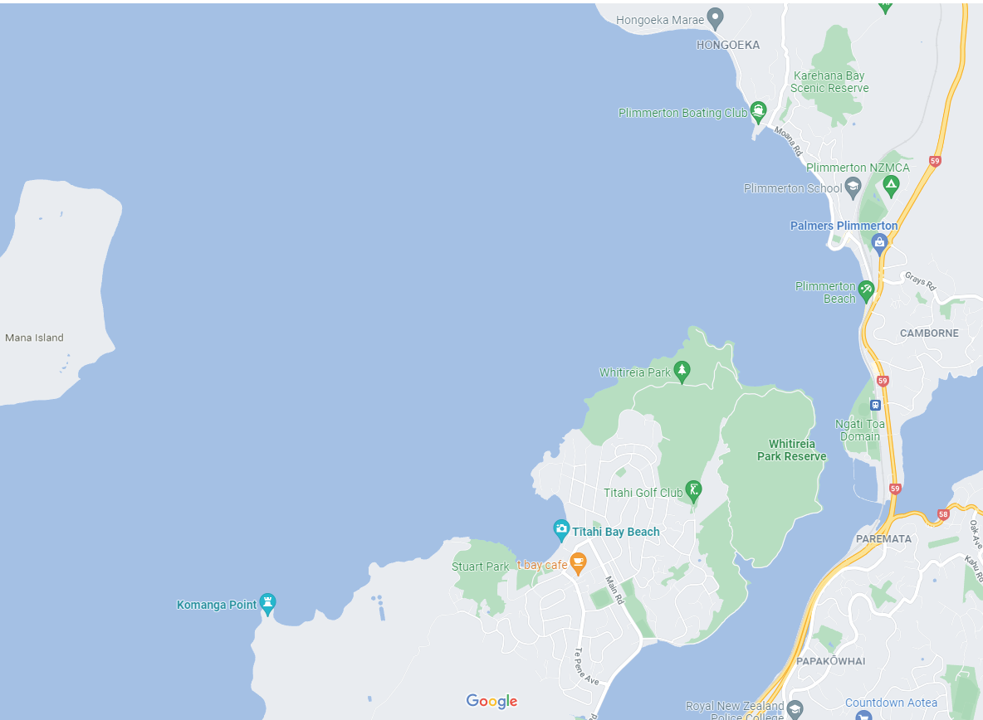

ATTACHMENT B – Approximate Racing Area

