How to Run an Effective De-Brief
A good de-brief is an essential part of a good training session. It gives both sailors and coaches a chance to reflect on their training, and it gives you a chance to give good, specific feedback to help the sailors improve. However if not done properly, a de-brief can also leave sailors feeling upset or not wanting to come back. We want to avoid this as much as possible, so here are some tips to make your de-brief so that you leave sailors wanting more.
- Always give a mixture of positive and negative feedback.
I like to use the feedback hamburger in a debrief. Start with positive feedback, say something that the whole group did well on and explain why. Then you can give constructive criticism, either to specific people or to the group as a whole. Make sure that the criticism is phrased as “you can improve on…” or “I want you to work on…” rather than “you did badly on…”.
This is vitally important. Our word choice sets the stage for how sailors will respond to our feedback. If you start your criticism with “You guys really sucked at … today”, then sailors are more likely to feel angry, upset, or badly about themselves leaving the debrief, and are more likely to not work on it or they even may not come back.
Finally, give more positive feedback. You can end off perhaps with something they improved on that session, or something that they really did well. It is important to leave them with the sense that they accomplished something today and that their efforts are paying off.
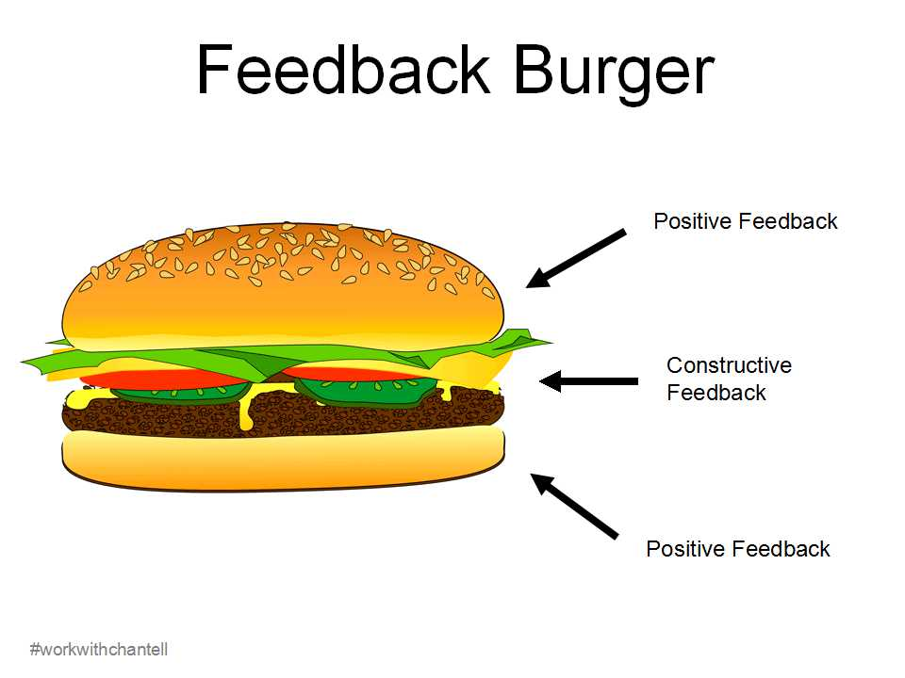
2. Get as many sailors to talk during the de-brief as you can.
By this, I do not mean chaotic talking over you or excited chatter. Something I often do during my briefing is write down a reflection question on the whiteboard. I get each sailor to answer the question. Even if they copy another sailor’s answer, remember that that’s okay and that every response is valid. Sometimes sailors don’t want to share their real response so they’ll copy someone else’s answer, but that doesn’t mean that they are not reflecting on their session.
Example reflection questions:
- What did you do well today? What do you want to improve on?
- What was one moment of triumph you had today?
- What’s one thing you learned today?
Other questions might be more focused on the lesson itself, such as:
- How did you know you were on the start line?
- How often did you check your sail/telltales today? Was that more, less, or the right amount?
- How did your roll tacks go today?
3. Specific is terrific
During your de-brief, you want to be giving specific feedback to sailors. However, this doesn’t mean that you should be telling sailors every single thing that they could do better and launch into a 45minute diatribe on the subject. While you’re on the water or while sailors are de-rigging, you should be sorting out the most important things to mention, and perhaps finding one or two things that the whole group needs to work on. While it is good to give specific feedback to individual sailors, other sailors don’t want to sit and listen to you giving feedback to everyone individually. Do that on the water.
Specific for the group is the best policy. For example, “I noticed today that everyone did an excellent job looking at the telltales and adjusting to them frequently. This will really help us succeed on our upwind legs, so great job all. I think something that we could still all work on is our boat balance, I noticed that many of you were heeling to windward in the light breeze. Why does that make us go slower?” Then after the answer, explain in a bit more detail, preferably with a drawing on the whiteboard.
A common vague de-brief scenario we all want to avoid goes something like this, “Great job guys, solid effort today. Your starts weren’t great, but your upwinds were alright and we were heeling too much, so that’s a thing. Any questions? Sweet see you next time.”
This is an example of a far too vague and short briefing, the opposite end of the spectrum is far too long and specific. We want to be finding a medium in between, the golden short and specific. Which brings me to our next point…
4. How long should your de-brief be?
Just like your briefing, your de-brief should be between 5-15minutes. If you have an older group of race team members, you can go up as far as 30min. However I normally aim for the 10 minute mark. I find that 10 minutes is enough to convey the feedback hamburger, get every sailor talking, and have them leaving happy. Remember if your de-brief is too long and you start to get glassy eyes and vacant expressions, you may have sailors leaving annoyed and bored and not wanting to come back.
5. How much should I use the whiteboard while de-briefing?
The short answer is as much as possible. Remember that everyone learns differently and it is important to have visual aids as well as questions written down for the readers, and explanations for the auditory learning.

If you follow these 5 tips for an effective briefing, then you can be sure to see fantastic results from your sailors, and you will have a better understanding of them as well.
Let us know if you have your own de-brief recipe for success, or if you have had any challenges in de-briefs that you could use a hand with.
Happy Coaching!

