How to structure your briefing effectively

The key to a good briefing is to keep it short and simple, but also convey all the information needed to hit the water and have a good train. This can be a very challenging line to walk, and many coaches struggle to get the right balance. On this page, I hope to give you a good idea of how to use the drills found on this website effectively, so that your sailors can live their best life.
- The best number of drills to use
Depending on the length of your sessions and the skill of your sailors, I recommend between 2-5 drills per lesson. For Learn to Sail, I find it is best to use 3 drills, whereas with a Race session, it can be beneficial to use 4-5.

- Start with a collector or warm-up
It is important that sailors get a chance to warm up their muscles before doing the main set or drill. This gets them in the right mindset for learning and you’ll get the best sailing out of them. I usually like my warm up to be a collector, so that all sailors are in the same place and it is easy to give them instructions for the next drill.
Examples: Circles of Death, Reaching Sausage, Windward/leeward

- The main drill or set
Each lesson should have a theme. The important thing to remember about kids (and even adults most of the time) is that they can’t take in 15 things they should be working on at once. The maximum number of things to work on for the lesson of the day should be 3. Don’t expect them to take every single one on board, often they will only remember one.
The main drill should relate to this theme, and that theme should be the one thing that you emphasize strongly on and off the water. For example, your theme could be telltales, and your main drill is Tacking on the Whistle. This gives your sailors a long upwind to watch their telltales, and also gives them the opportunity to watch their telltales on both tacks, simulating a long upwind in a race.
You will notice that many of the drills on this site have multiple teaching points, and again I stress only use max 2-3 of these teaching points per lesson. If you try and do a drill and use all the teaching points at once, it can lead to information overload and confusion in sailors.
If you are doing more than one main drill, make sure that it uses the same teaching points, but in a different way. This helps drive the message home for a lot of sailors and gives variation. Variation is important because everyone learns differently, so one drill might make one sailor shine, but another drill works far better for a few others.

- The Warm Down
At the end of the lesson, it is a good idea to have a bit of fun. I often use the warm down to play a game with the sailors, especially in Learn to Sail or Green Fleet, but with the race team as well. This lets sailors relax and enjoy the thrill of sailing, as well as use what they’ve learned in a different way. You can also end the lesson with a few fun races, or a long sail to a point and back to shore.
One thing that works great is if you write up the whole lesson plan on the whiteboard except the warm down, and during the briefing ask the sailors what they want to do. This can often make it more fun for them, and also gives you a good idea of what their favourite activities are as a group. This can help you plan lessons in the future that they will enjoy and learn from.

- How long should the Briefing be?
5-10 minutes, no more than 15 is the short answer. Keep in mind that sailors can only retain so much information and can only sit still in a classroom setting for so long, especially if this is an after school session.

- What should be on the whiteboard for the briefing?
Visual aids are crucial for sailors during a briefing. I have seen coaches deliver briefings with no writing or pictures before, and I think it is very important to remember that very few people are auditory learners. In a briefing, you want to cover as many ways of learning as possible in order to get through to as many sailors as possible. This means you should have diagrams with titles, key points/lesson themes written down, and also explain them orally. Here is an example of what a good lesson on a whiteboard might look like:
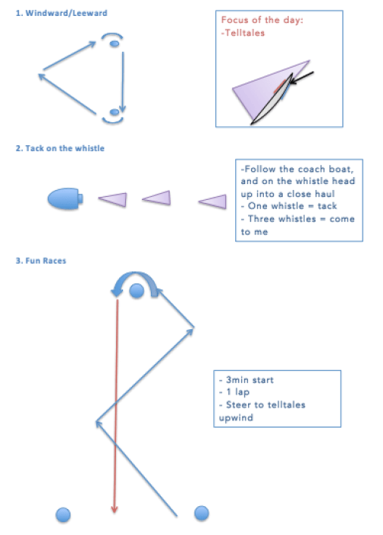
During the briefing, you might add to your drawings, showing perhaps where the telltales are on the sail with a drawing of a sail, or in the second drill showing arrows indicating sailors heading up to a close haul. You also want to explain steering to the telltales versus adjusting your sail to the telltales. Now that you’ve covered everything, kept it short, but also kept it informative, sailors are ready to hit the water!

Awesome. If you follow these simple steps to creating an effective briefing, you will find that you get the most out of your sailors and also of your time on the water. Enjoy!

Contact the YNZ Coach Development Manager with any questions or feedback.

