2022 NZ Inter-Club One-Design “P” Class Championship
for the
Tauranga Cup
Tuesday 4th to Sunday 9th January, 2022
Murrays Bay, Auckland, New Zealand
The Organising Authority is the Murrays Bay Sailing Club (MBSC)
511 Beach Road, Murrays Bay, Auckland, New Zealand.
NOTICE OF RACE ( NoR )
The notation ‘[DP]’ in a rule in the Notice of Race means that the penalty for a breach of that rule may, at the discretion of the protest committee, be less than disqualification.
1 | RULES
1.1 | The event is governed by the rules as defined in The Racing Rules of Sailing.
1.2 | The Yachting New Zealand Safety Regulations Part 1 shall apply.  Refer - http://www.yachtingnz.org.nz/racing/safety-regulations
1.3 | Under RRS 86, Changes to The Racing Rules the following racing rules will be changed as follows:  - RRS A5.1 and A5.2 will be changed to state that boats still racing but failing to finish within 10 minutes after the first boat sails the course and finishes will be scored Did Not Finish,  - RRS 60.1(a) will be changed to state that a competitor cannot protest another boat or competitor for breaches of some specific parts of the Sailing Instructions or Supplementary Sailing Instructions,  - RRS A5.1 and A5.2 will be changed to state that a boat starting later than 4 minutes after her starting signal will be scored Did Not Start.  The changes will appear in full in the Supplementary Sailing Instructions. The Supplementary Sailing Instructions may also change other racing rules.
1.4 | The Tauranga Cup Rules and Conditions contained in the New Zealand One Design P Class Yacht Rules – 2021 shall apply.  Refer - http://www.yacht.org.nz

1.5 | Appendix T, Arbitration will apply.
2 | SAILING INSTRUCTIONS
2.1 | The Sailing Instructions will consist of the instructions in RRS Appendix S, Standard Sailing Instructions, and Supplementary Sailing Instructions that will be on the official notice board.
2.2 | Supplementary Sailing Instructions will be posted on the official noticeboard, and on the MBSC website www.murraysbay.org by 18:00 on Monday 3rd January, 2022.  Paper copies will not be issued to competitors.
3 | COMMUNICATION
3.1 | The official notice board will be located on the main floor of the Murrays Bay Sailing Club clubrooms.
3.2 | The online official notice board is located at www.murraysbay.org
3.3 | The Race Office is located on the 2nd floor of the Murrays Bay Sailing Club clubrooms.
3.4 | Except in an emergency, a boat that is racing shall not make voice or data transmissions and shall not receive voice or data communication that is not available to all boats. [DP].
4 | ELIGIBILITY AND ENTRY
4.1 | The regatta is open to all P Class boats that comply with the Class Rules and have a current P Class National Certificate in the name of the current owner.  Refer - http://www.yacht.org.nz
4.2 | Each competitor shall have been nominated by an eligible challenging club as defined in the P Class Rules (including the Tauranga Cup Rules and Conditions)
4.3 | Eligible boats may enter by either;  - Completing the on-line booking form and payment on the club web-site,  www.murraysbay.org  go to Events, and select NZ P-Class Nationals  - completing the attached Entry Form and emailing it to info@murraysbay.org  and depositing the required entry fee into account 12-3042-0272614-05  Reference with Tauranga Cup – <Club><Sail No> – <Sailor surname>  eg. Tauranga Cup – MBSC P80 – Gifford
4.4 | Entries will be accepted up until 1700 on Friday 17th December, 2021.
4.5 | Late entries, accompanied with a late entry fee may be accepted at the discretion of the Organising Authority up until 1200 on Tuesday 4th January, 2022.
4.6 | To be eligible to compete in this event each competitor shall be a financial member of a club recognised by the competitor’s national authority.
4.7 | Each competitor shall be under the age of 17 years on 31st January, 2022.
4.8 | The following documents shall be presented at registration:  - Proof of yacht club membership,  - P Class National Certificate in the name of the current owner,  - Copy of competitor’s birth certificate or other proof of age – eg. Passport.
5 | FEES
The entry fees, including GST, are;
 | Entry Fee
Tauranga Cup | $175.00
Combined Tanner & Tauranga Cups | $250.00
Late entry fee (additional) | $50.00

6 | CLASSIFICATION
 | There are no classification requirements in accordance with RRS 79.
7 | ADVERTISING AND IDENTIFICATION
7.1 | [DP] Boats may be required to display advertising chosen and supplied by the organizing authority in accordance with World Sailing Regulation 20, Advertising Code.
7.2 | The Organising Authority may provide bibs that competitors are required to wear as permitted by the World Sailing Advertising Code.
8 | SCHEDULE
8.1 | Registration:  Day Date From To  Tuesday 4th January 12:00 17:00
8.2 | Equipment Inspection and Measurement:  Day Date From To  Tuesday 4th January 9:00 17:00
8.3 | Briefing:  Day Date From  Thursday 6th January 17:00

8.4 | Racing:  Day Date Number of Races Time of First Warning  Friday 7th January 3 12:00  Saturday 8th January 3 12:00  Sunday 9th January 3 12:00
8.5 | The Target Time for each race is 30 minutes.
8.6 | On Sunday 9th January, no warning signal will be made after 15:30.
9 | EQUIPMENT INSPECTION
9.1 | [DP] Each boat shall be presented for measurement as per NoR 8.2.
9.2 | Each competitor shall use only one hull, one set of foils, one mast, one boom and one sail for the entire Tauranga Cup, all of which shall have been measured and marked at the official measuring.
9.3 | All items that have been measured and marked as per NoR 9.2 shall not be modified in any way from the time of measurement through to the end of the event.
9.4 | In addition, wet clothing, spot measurement and safety checks may be conducted at any time during the event.
9.5 | [DP] Boats shall comply with RRS 78.1 when presented for inspection.
10 | VENUE
10.1 | NoR Attachment A shows the location of the event venue.
10.2 | NoR Attachment B shows the approximate location of the racing areas.
11 | THE COURSES
 | The courses to be sailed shall be triangle or triangle, windward/leeward courses using laid marks.
12 | PENALTY SYSTEM
 | Appendix P, Special Procedures for Rule 42, may apply as amended by the Supplementary Sailing Instructions.
13 | SCORING
13.1 | Five (5) races are required to be completed to constitute a series.
13.2 | (a) When fewer than 5 races have been completed, a boat’s series score will be the total of her race scores.
 | (b) When from 5 to 7 races have been completed, a boat’s series score will be the total of her race scores excluding her worst score.
 | (c) When 8 or more races have been completed, a boat’s series score will be the total of her race scores excluding her two worst scores.

14 | SUPPORT BOATS
14.1 | [DP] All support boats must register with the Organising Authority at registration and nominate the boat(s) they support.
14.2 | [DP] All support and coach boats must have VHF communications and be available to assist the race committee if required.
14.3 | [DP] All support and coach boats shall have an engine safety cut out switch (kill cord) attached to the driver at all times while the engine is running, unless prior written exemption has been provided by the Organising Authority.
15 | LAUNCHING AND STORAGE
15.1 | [DP] All competing boats shall be kept in their assigned places while on the Murrays Bay Reserve, unless instructed otherwise by the Organising Authority.
15.2 | [DP] All competing boats shall be launched and retrieved from Murrays Bay beach, unless instructed otherwise by the Organising Authority.
15.3 | [DP] Beach trolleys shall be prominently marked with the boat’s sail number.
15.4 | [DP] While a boat is racing, their beach trolleys must be stacked neatly to the north of the public launching ramp.
16 | RIGHTS TO USE NAME AND LIKENESS
16.1 | By participating in this event, competitors automatically grant to the Organising Authority and the event sponsors the right, in perpetuity, to make, use, and show, at their discretion, any photography, audio and video recordings, and other reproductions of them made at the venue or on the water from the time of their arrival at the venue, until their final departure, without compensation.
16.2 | All those who take part in this event as competitors as well as support crew or spectators agree to be overflown by a drone during the duration of the event, this includes your person and your property (boats).
17 | RISK STATEMENT
 | RRS 3 states: “The responsibility for a boat’s decision to participate in a race or to continue to race is hers alone.” By participating in this event each competitor agrees and acknowledges that sailing is a potentially dangerous activity with inherent risks. These risks include strong winds and rough seas, sudden changes in weather, failure of equipment, boat handling errors, poor seamanship by other boats, loss of balance on an unstable platform and fatigue resulting in increased risk of injury. Inherent in the sport of sailing is the risk of permanent, catastrophic injury or death by drowning, trauma, hypothermia or other causes.
18 | INSURANCE
 | Each participating boat shall be insured with valid marine third-party liability insurance with a minimum cover of $1,000,000 per incident or the equivalent. Certificate of insurance is to be presented at registration.

19 | DISCLAIMER OF LIABILITY
 | Competitors participate in the regatta entirely at their own risk. See RRS 4, Decision to Race. The organizing authority and any sponsors associated with the event will not accept any liability for material damage or personal injury or death sustained in conjunction with or prior to, during, or after the regatta.
20 | PRIZES
20.1 | Prizes will be given as follows:  - 1st Overall Tauranga Cup  - 2nd Overall Memorial Cup  - 3rd Overall Carter Cup  - 1st Female Overall Naomi James Challenge Trophy  - 2nd Female Overall Harken Trophy  - Winner Race 1 Harry Highet Salver  - Highest placed first-time Murrays Bay Cup  competitor  - Youngest competitor Farr & Associates Trophy  in top 10 overall  - Club of the Tauranga Franklin Plumbing Trophy  Cup winner  - Highest placed sailor Colin Smith Trophy  from host club  - Highest placed sailor Craig Monk Trophy  over 55kg
20.2 | Other prizes may be awarded at the discretion of the Class Association or the Organising Authority.
20.3 | Daily “bullet” prizes will be awarded to the first male and first female in each race immediately after racing concludes each day.
20.4 | The prize-giving will take place in conjunction with the Tanner Cup prize-giving at the conclusion of the Tauranga Cup Championship on Sunday 9th January, 2022.

22 | FURTHER INFORMATION
For further information please contact;

Web-site www.murraysbay.org

Phone 021 242 6272

Nigel Soper mbsc.manager@gmail.com
(Club Manager)

Scott Leith sleithal@yahoo.com
(Class Rep)

Dave West djwesty@orcon.net.nz
(Race Officer)

ATTACHMENT A

APPROXIMATE LOCATION OF THE REGATTA VENUE

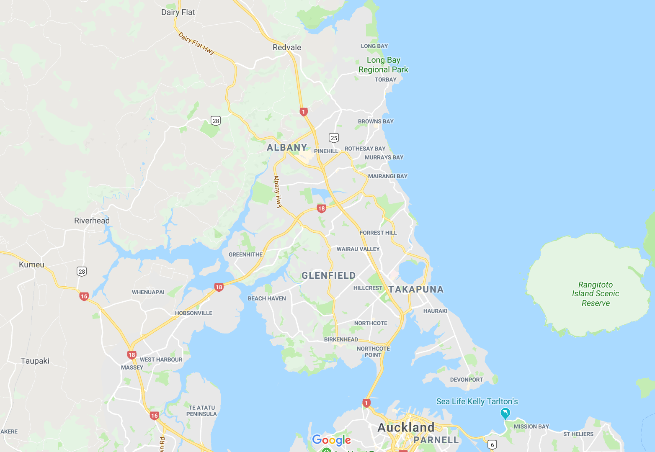

Location of the Murrays Bay Sailing Club

511 Beach Road
Murrays Bay
Auckland

ATTACHMENT B

APPROXIMATE LOCATION OF THE RACING AREA

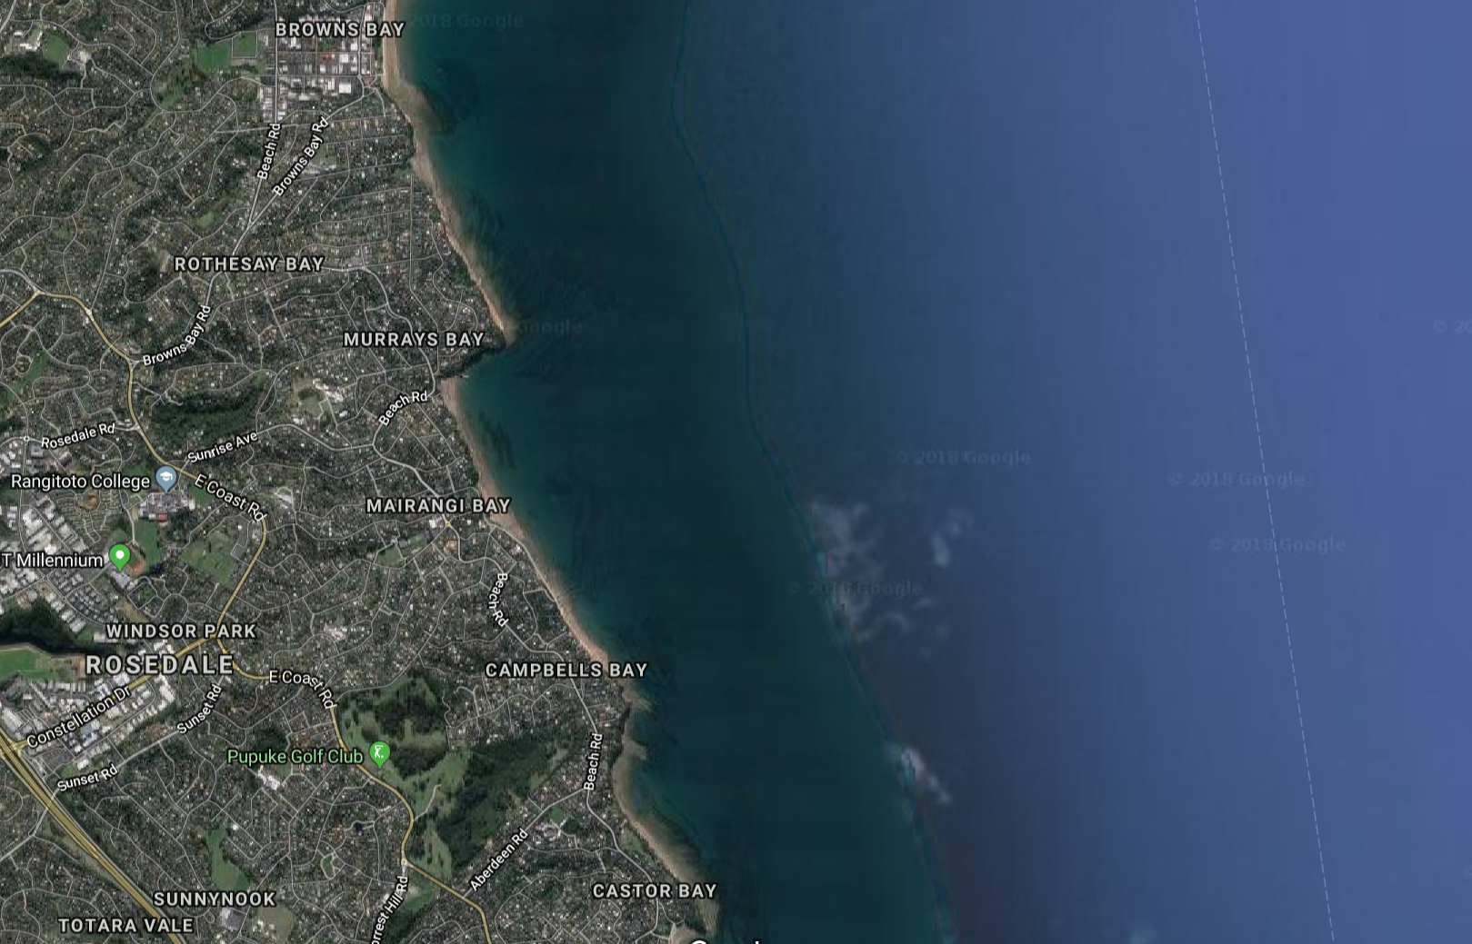

Murrays Bay Sailing Club

Approx. racing area

