2022 New Zealand KiteFoil National Championships
4th-6th March 2022
The Organising Authority is Takapuna Boating Club,
39 The Strand, Takapuna, Auckland 0622
Notice of Race
The notation ‘[DP]’ in a rule in the Notice of Race means that the penalty for a breach of that rule may, at the discretion of the protest committee, be less than disqualification
1 RULES
1.1 The event is governed by the rules as defined in The Racing Rules of Sailing, 2021 – 2024.

1.2 The Yachting New Zealand Safety Regulations Part 1 shall apply.

1.3 2022 New Zealand KiteFoil National Championships Notice of Race, available at https://www.takapunaboating.org.nz/calendar/

1.4 Appendix T, Arbitration will apply.

1.5 Crash helmets are recommended to be worn at all times when afloat.

1.6 Each Competitor shall wear an identification bib.

2 SAILING INSTRUCTIONS
2.1 The sailing instructions will be available no later than 25 February 2022 on The notice board in the main deck of Takapuna Boating Club, and on the club website.

2.2 The sailing instructions will consist of the instructions in RRS Appendix S, Standard Sailing Instructions, and supplementary sailing instructions that will be on the official notice board.

3 ELIGIBILITY AND ENTRY
3.1 The event is open to all KiteFoil that comply with the International Kite Racing Class and foil rules.

3.2 Competitors shall be financial members of a club recognised by Yachting New Zealand.

3.3 Enter by completing the entry form and submitting it, together with the required fee, to www.takapunaboating.org/webform/kitefoil_national_champs_entry.

3.4 No entries will be accepted after 1600 on 2nd March 2022.
3.5 At registration please provide:
a) Proof of club and class association membership,
b) Evidence of third party insurance,
c) Proof of age if requested,
d) Parental permission, for those under the age of 18 years.

4 FEES
4.1 The Entry fee is $ 185.00

5 ADVERTISING
5.1 Boats may be required to display advertising chosen and supplied by the organizing authority.

6 SCHEDULE
Friday 4th March 2022
Registration from 0900 to 1100
Briefing 1115
Racing 1300 First warning signal, up to 6 races in two sessions of 3.
Saturday 5th March 2022
Racing 1200 First warning signal, up to 6 races in two sessions of 3.
Sunday 6th March2022
Racing 1200 First warning signal, up to 6 races in two sessions of 3.
Prizegiving Time to be confirmed, at the conclusion of racing.
No warning signal will be made after 1600.
6.1 No more than 4 races shall be sailed in any one session. A minimum of 30 minutes is required between sessions.
6.2 The target time for each race is 12 minutes.
6.3 If it is necessary for competitors to launch at a place other than Takapuna beach, then 4 races will be sailed in a single session.

7 Boats may be inspected at any time.

8 VENUE
8.1 NoR Addendum A shows the plan of the event venue.
8.2 NoR Addendum B shows the location of the racing areas.

9 COURSES
9.1 The courses to be sailed will be Windward leeward. Details will be supplied in the Sailing instructions.

9.2 Target time for each race is 12 minutes.
.

10 PENALTY SYSTEM
10.1 RRS 44.1 is changed so that the Two-Turns Penalty is replaced by the One-Turn Penalty.

11 SCORING
11.1 Eighteen races are scheduled.
11.2 Five races are required to constitute a series.
11.3 When fewer than six races have been completed, a competitor’s score will be the total of their race scores.
11.4 When six to eleven races have been completed, a competitor’s score will be the total of their races excluding their worst score.
11.5 When twelve to seventeen races have been completed, a competitor’s score will be the total of their races excluding their two worst scores.
11.6 When eighteen races have been completed, a competitor’s score will be the total of their scores excluding their worst three scores.

12 SUPPORT PERSON VESSELS
12.1 [DP] Support person vessels shall be registered at registration.
13 Radio communication
Except in an emergency, a competitor shall neither make nor receive radio transmissions while racing that are not available to all competitors. This restriction includes mobile phones.

14 RISK STATEMENT
14.1 RRS 3 states: ‘The responsibility for a boat’s decision to participate in a race or to continue to race is hers alone.’ By participating in this event each competitor agrees and acknowledges that sailing is a potentially dangerous activity with inherent risks. These risks include strong winds and rough seas, sudden changes in weather, failure of equipment, boat handling errors, poor seamanship by other boats, loss of balance on an unstable platform and fatigue resulting in increased risk of injury. Inherent in the sport of sailing is the risk of permanent, catastrophic injury or death by drowning, trauma, hypothermia or other causes.
15 INSURANCE
15.1 Each participating boat shall be insured with valid third-party liability insurance with a minimum cover of $1,000,000 per incident or the equivalent. Certificate of insurance is to be presented at registration.
16 PRIZES
16.1 Trophies will be awarded to First Female and First Male., Other prizes, Certificates or spot prizes may be awarded at the discretion of the Organising Authority and/or the NZKRA.

17 Launching
17.1 While Takapuna beach is the preferred launch site, If conditions necessitate launching from another beach such as Torpedo bay, confirmation of safe launching and the number of competitors shall be communicated to Takapuna boating club race control by phone or text message. Similarly Club safety boats will remain on standby until all competitors are safely returned to shore as confirmed by the nominated representative of the racers, Beach Master.

18 Covid 19 Pandemic
18.1 In accordance with the New Zealand COVID-19 Protection Framework (traffic light system) all competitors, volunteers, supporters, coaches, and event staff that attend the event need to be fully vaccinated against COVID 19 and provide documented proof on entry, or obtain a medical exemption.

18.2 Any person who obtains a medical exemption may be required to do a COVID test prior to participation in the event.
18.3 Further information regarding COVID 19 alert levels, measures and advice can be found at.
https://www.yachtingnz.org.nz/news/ynz-advice-clubs-during-covid-19-alert-levels.

19 FURTHER INFORMATION
19.1 For further information please contact members@takapunaboating.org.

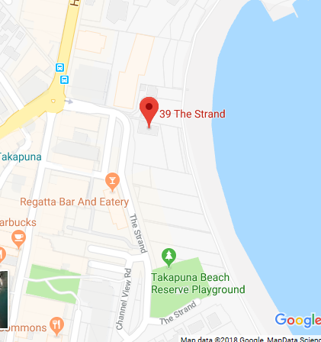
Addendum A
Location of Takapuna Boating Club

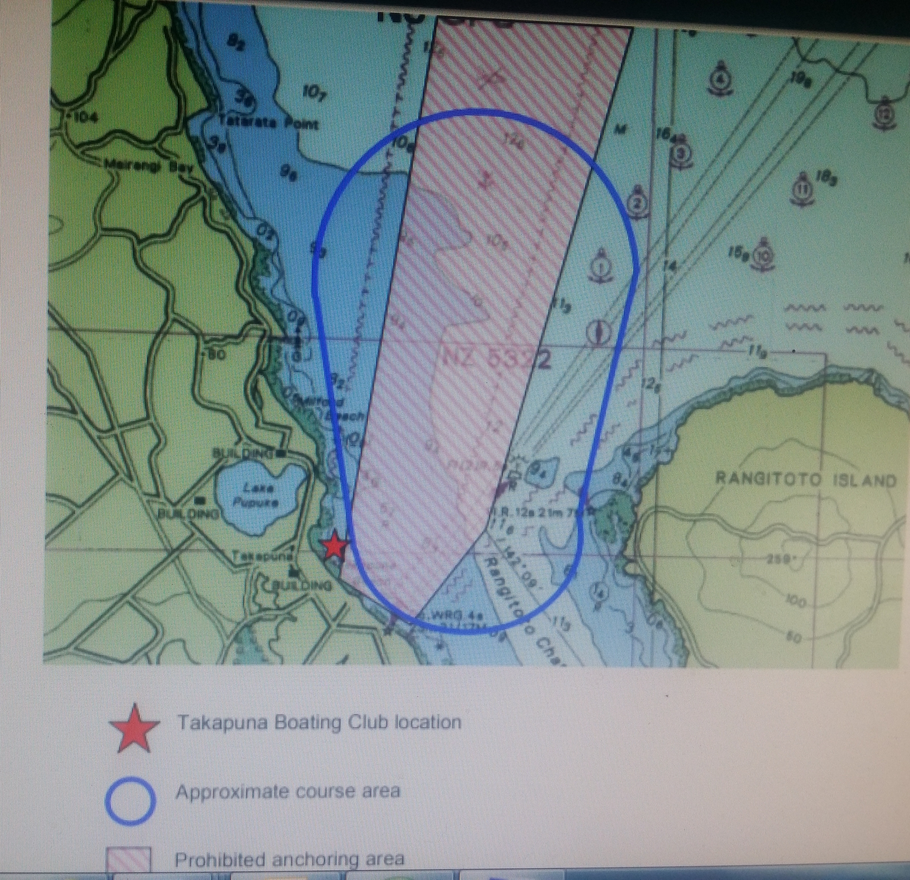

Addendum B
Approximate location of the racing area.

2022 New Zealand Kite foil National Championships4th-6th March 2022 Takapuna Boating Club
Entry Form

Organising Authority:
Class Kite-Foil
Country code on sail Bib number
Hull Colour
Boat Name

Takapuna Boating Club
39 the Strand Takapuna,
Auckland 0622
competitor
First Name
Surname
World Sailing Sailor’s Code (if registered)
Gender
Date of Birth | Age Today or on (insert date)
Nationality
Yacht Club
Postal Address
Email
Contact number
I agree to be bound by the Racing Rules of Sailing and all other rules that govern this event. I understand that yacht racing has inherent risks and dangers that are beyond the control of the organizing authority. I understand that neither the organising authority and its officers, members and servants nor other persons assisting with the conduct of the regatta accept any responsibility in respect of any injury or loss to person or property that may be sustained by reason of participation in the regatta or howsoever arising in connection with the regatta.
I agree to the use of my photograph(s) and other relevant information in any event publicity and in the ongoing promotion of New Zealand yachting. I agree to the Organising Authority and Yachting New Zealand holding the above information for the general administration and well-being of the sport, and for them to retain, use and disclose the information to affiliated organisations and any other persons or organisations that Yachting New Zealand believes will further the interests and objectives of Yachting New Zealand. I acknowledge my right to access to and correction of this information. The consent is given in accordance with the Privacy Act 1993.
Competitor’s Signature | Parent/Guardian’s Signature (if sailor under 18 years old)
Date | Date

Enclosures
Entry Fee | Proof of Club Membership | Proof of Class Assn Membership | Proof of Date of Birth | Certificate of insurance | Measurement / Rating Certificate
$185.00

Office Use
Entry Fee Paid | Cash / Cheque / Eftpos / online banking | Date | Comment

