

Stay at home **if you feel unwell.**

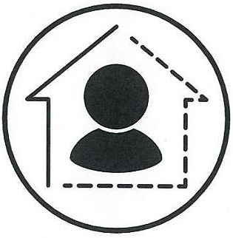

Physically distance one-metre

**between people you know when outside and inside the clubhouse.**

**Try and sit beside people you know in the clubhouse.**

Be aware of the number of people **the club is limited to. This is:**

**100 people outside on the deck and in the rigging area.**

**50 people inside the clubhouse.**



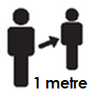

Physically distance two-metres

**between you and others who you do not know when on the deck or in the rigging area.**

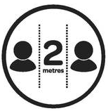

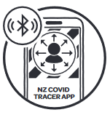

Wear a mask

**when outside or indoors.**

**You can remove it to eat or drink, or when showering.**

**You do not need to wear a mask while sailing as this is exercising.**



Scan or sign-in **on arrival in clubhouse, deck or rigging area.**

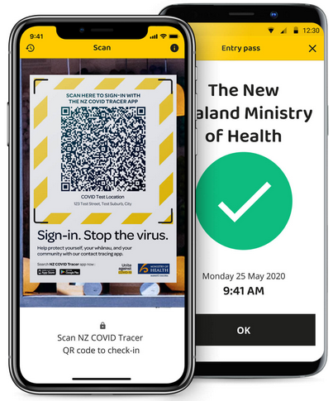

Vauxhall Yacht Club

is holding sailing activities and events under the new Covid Rules for

DELTA LEVEL 2