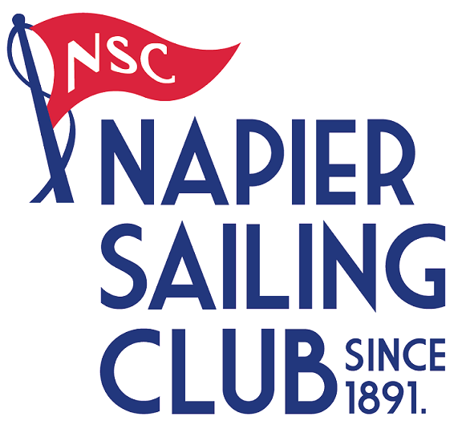
2022 New Zealand
Europe Dinghy
National Championship
25th - 28th November 2021
The Organising Authority is the Napier Sailing Club
63 West Quay, Ahuriri, Napier
www.napiersailingclub.org.nz

NOTICE OF RACE

- RULES
  - The regatta will be governed by the rules as defined in The Racing Rules of Sailing.

  - The Yachting New Zealand Safety Regulations

Part 1 shall apply.

  - Class Rules for Europe Dinghy will apply to all yachts competing.
  - Racing rules

The Sailing Instructions may change other racing rules.

  - Appendix T, Arbitration, will apply.

- ADVERTISING
  - Boats may be required to display advertising chosen and supplied by the Organising Authority. If this rule is broken, World Sailing Regulation 20.9.2 applies. [DP]

- ELIGIBILITY AND ENTRY
  - The regatta is open to all boats of the Europe Dinghy class whose owners are current financial members of their National Class Association.

  - Eligible boats may enter by completing the attached form and emailing to manager@napiersailingclub.org.nz.
Payment to be made electronically to Napier Sailing Club by 1700hrs, 19th November 2021.
  - Late entries accompanied by the contest entry fee plus the late entry fee may be accepted at the race committee’s discretion until 1700 hrs. 23rd November 2021.

  - To be eligible to compete in this event each Skipper and crew member(s) shall be a financial member of a club recognised by the Skipper and crew member’s national authority.

Proof of affiliated club membership shall be presented at registration

- FEES
Required fees are as follows:

CLASS | FEE
Europe Dinghy | $120.00

  - Late Entry Fee $50.00

- SCHEDULE
  - Registration: Thursday 25th November 2021, 1600 - 1700hrs, Napier Sailing Club
Friday 26th November 2021, 0800 – 0900hrs, Napier sailing club
  - Equipment inspection

Measurement by Private Arrangement with class Association
  - Schedule of Event:

Date | Times | Activity
Friday 26th November | 0930hrs. | Briefing
Friday 26th November | Time of 1st warning Signal 1100hrs. | 3 Races back-to-back
Saturday 27th November | Time of 1st warning Signal 1100hrs. | 3 Races back-to-back
Sunday 28th November | Time of 1st warning Signal 1100hrs. | 3 Races back-to-back

  - Number of races: 9 Races are scheduled.
Class | Number of Races per day | Target time for each race
Europe Dinghy | 3 Races | 45 Minutes

  - On the last scheduled day of racing no warning signal will be made after 1530hrs.

- MEASUREMENT

  - Each boat shall produce a valid measurement certificate. In addition, Boat weight and other measurements may be taken to ensure boats meet Class Rules and Safety Regulations. Any sails not previously signed will be required to be measured prior to Event.

  - A boat shall comply with RRS 78.1 throughout the contest and may be checked at any time during the event.

  - A Peer Review Safety Checklist & Safety Declaration is to be completed at registration. NB; a safety check may be made on any boat at any time during the event.

- SAILING INSTRUCTIONS

7.1 The sailing instructions will consist of the instructions in RRS Appendix S, Standard Sailing Instructions, and supplementary sailing instructions that will be on the official notice board located in Foyer of Napier Sailing club

- VENUE
  - Attachment A; shows the location of the regatta venue.

  - Attachment B; shows the location of the racing area.

- THE COURSES
The courses to be sailed will be Trapezoid, Triangular, Windward/ Leeward or a combination.

- PENALTY SYSTEM

- SCORING
  - 5 races are required to be completed to constitute a series.

a) When fewer than 6 races have been completed, a boat’s series score will be the total of her race scores.

b) When 6 to 9 races have been completed, a boat’s series score will be the total of her race scores excluding her worst score.

- SUPPORT BOATS
  - Support boats shall Register with the Organising Authority. [DP]

12.2 [DP] All support person vessels shall always have an engine safety cut out switch (kill cord) attached to the driver while the engine is running, unless prior written exemption has been provided by the Organising Authority.

- BERTHING
Boats shall be kept in their assigned places while they are in the boat park. [DP]

- LAUNCHING & RETRIEVAL RESTRICTIONS
Competitors shall launch and retrieve vessels from Napier Sailing Club ramps during the regatta, except with and according to the terms of, prior written permission of the race committee. [DP]

- RADIO COMMUNICATION
[DP] From the first warning signal until the end of the last race of the day, except in an emergency, a boat shall not make voice or data transmissions and shall not receive voice or data communication that is not available to all boats.

- PRIZES
Prizes may be awarded at the discretion of the Organising Authority in conjunction with the Class Association.

- PHOTOGRAPHY CONSENT
By entering the Championships competitors accept that they may be photographed and/or videotaped participating in the race and/or using the Championship facilities and they consent to the taking of such images and to the use, reuse, publication and republication of such images in any media, in conjunction with the competitor’s name or not, without compensation and without the competitor’s approval of such images or any use thereof. Such photography may be from a drone.

- INSURANCE
Each participating boat should be insured with valid marine third-party liability insurance with a minimum cover of $1,000,000 per incident or the equivalent.

- Risk Statement
RRS 3 states: ‘The responsibility for a boat’s decision to participate in a race or to continue to race is hers alone.’ By participating in this event each competitor agrees and acknowledges that sailing is a potentially dangerous activity with inherent risks. These risks include strong winds and rough seas, sudden changes in weather, failure of equipment, boat handling errors, poor seamanship by other boats, loss of balance on an unstable platform and fatigue resulting in increased risk of injury. Inherent in the sport of sailing is the risk of permanent, catastrophic injury or death by drowning, trauma, hypothermia or other causes.

- Event Cancellation
In the event of cancellation due to any causes outside of the Organising Authority’s control, all efforts will be made to reimburse Entry fees minus any Event associated cost already incurred that are not recoverable.

- Sustainability
This club is committed to implementing and encouraging environmentally responsible actions and initiatives from management to participants.

- Please see our Sustainability Policy on the club’s website for further Detail; www.napiersailingclub.org.nz

- FURTHER INFORMATION
For further information please contact:

Dee Ford
Napier Sailing Club
PO Box 12048
Napier 4144

Ph. 06 835 3811
Cell. 027 209 3868
Napier Sailing Club Manager

Manager@napiersailingclub.org.nz
www.napiersailingclub.org.nz

Attachment A

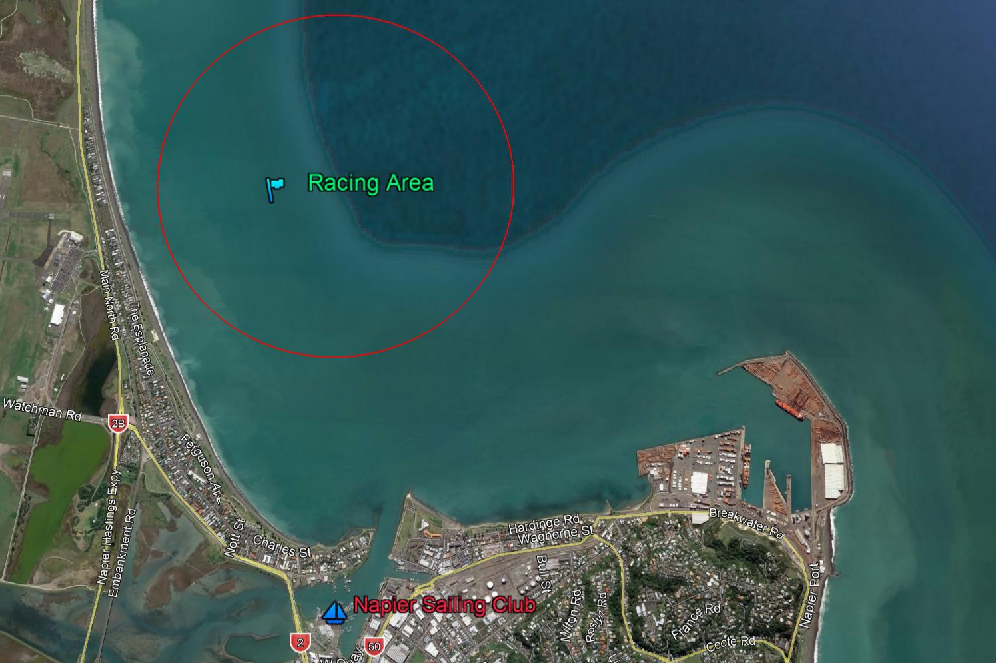
Attachment B

2022 New Zealand
Europe Dinghy Championship
25th - 28th November 2021
The Organising Authority is the Napier Sailing Club

Entry Form
Class
Sail Number | Boat name

Skipper Details
First name | Surname
Yacht Club | Address
Email
Mobile

I.C.E Details
First name | Surname
Relationship | Address
Email
Mobile
Please add additional contact details if more than two crew

I agree to be bound by the Racing Rules of Sailing and all other rules that govern this event. I understand that yacht racing has inherent risks and dangers that are beyond the control of the organizing authority. I understand that neither the organising authority and its officers, members and servants nor other persons assisting with the conduct of the regatta accept any responsibility in respect of any injury or loss to person or property that may be sustained by reason of participation in the regatta or howsoever arising in connection with the regatta.
I agree to the use of my photograph(s) and other relevant information in any event publicity and in the ongoing promotion of New Zealand yachting. I agree to the Organising Authority and Yachting New Zealand holding the above information for the general administration and well-being of the sport, and for them to retain, use and disclose the information to affiliated organisations and any other persons or organisations that Yachting New Zealand believes will further the interests and objectives of Yachting New Zealand. I acknowledge my right to access to and correction of this information. The consent is given in accordance with the Privacy Act 1993.

Skipper /Owner Signature: Date:

Office Use: Entry Fee Paid Method: Amount:
Payment & registration to be returned electronically to Napier Sailing Club,
Acct No. 03-0698-0040708-000;
include your boat sail number, class and/or name in the reference field.

