2022 New Zealand Paper Tiger
Mitre10 MEGA
National Championships
and International Selection Trials
Monday 3rd – Friday 7th January 2022
The Organising Authority is the New Plymouth Yacht Club (NPYC)
Ocean View Parade, Ngamotu Beach, New Plymouth

Notice of Race

The notation ‘[DP]’ in a rule in the Notice of Race means that the penalty for a breach of that rule may, at the discretion of the protest committee, be less than disqualification and the notation ‘[NP]’ in a rule in the Notice of Race means rules that are not grounds for protest by a boat.

1 RULES

1.1 The event is governed by the rules as defined in The Racing Rules of Sailing ‘(RRS)’ and the New Zealand Paper Tiger Class rules.

1.2 The Yachting New Zealand Safety Regulations Part 1 shall apply.

1.3 Appendix T, Arbitration will apply.

2 SAILING INSTRUCTIONS

2.1 The sailing instructions will be available after 1200 hrs on 3rd January 2022 at Registration.

3 COMMUNICATION

3.1 The official notice board is located at NPYC.

4 ELIGIBILITY AND ENTRY

4.1 The event is open to all boats of the Paper Tiger class.

4.2 Eligible boats may enter by completing the entry form and emailing it, together with the required fee, to New Plymouth Yacht Club (email hatchfamilynp@gmail.com) and depositing the required entry fee into the NPYC Regatta Bank Account: TSB Bank 15-3953-0795504-00 and providing the Sail Number as Reference.

4.3 Completed entries and fully paid entry fees must be received by 1700 hrs on Monday 15th November 2022.

4.4 Boats may enter the event by registering online at www.npyc.co.nz.

4.5 To be considered an entry in the event, a boat shall complete all registration requirements and pay all fees.

4.6 Late entries accompanied by the late entry fee may be accepted at the Race Committee’s discretion until 1700 hrs on 31st December 2021.

4.7 To be eligible to compete in this event each competitor shall be a financial member of a club recognised by Yachting New Zealand. Proof of affiliated club membership is to be submitted with entry.

4.8 Each competitor shall be a member of the New Zealand Paper Tiger Owners Association (NZPTOA).

5 FEES

5.1 The entry fee for junior sailors is $170 and for all other age group sailors $200 (includes Regatta Fee, one regatta shirt and one ticket to the prize giving dinner).

5.2 The late fee is an additional $50. This fee may not include a regatta shirt.

6 ADVERTISING

6.1 Boats may be required to display advertising chosen and supplied by the Organizing Authority.

7 SCHEDULE

7.1 Registration:
Monday 3rd January 2022 1200 – 1500 at the NPYC Clubhouse.

7.2 Equipment inspection and event measurement:
Monday 3rd January 2022 1200 – 1500 at the NPYC Clubhouse.

7.3 Briefing:
The briefing is scheduled for 1700hrs on Monday 3rd January 2022 at the NPYC Clubhouse.

7.4 Dates of Racing:
Tuesday 4th January 2022 3 races back to back 1st Warning Signal: 1155 Wednesday 5th January 2022 3 races back to back 1st Warning Signal: 1155 Thursday 6th January 2022 3 races back to back 1st Warning Signal: 1155 Friday 7th January 2022 2 races back to back 1st Warning Signal: 1155
7.5 Number of races: 11 races are scheduled for the series.

7.6 Up to 4 races may be sailed per day.

7.7 On Friday 7th January 2022 no warning signal will be made after 1455 hrs.

8 EQUIPMENT INSPECTION

8.1 All boats must comply with the rules of the New Zealand Paper Tiger Class.

8.2 Boats that were measured and passed at the 2021 New Zealand Paper Tiger Nationals will not need to be re-measured for the 2022 NZ Paper Tiger Nationals with the following provisions:
8.2.1 Skippers shall complete and sign a formal declaration (form to be provided at Registration) stating that no changes have been made to their Paper Tiger (including hulls/platform, sail and mast) since its previous measurement in 2021.
8.2.2 That the hull platforms that weighed in at less than 52 kgs in 2021 must submit their hulls for re-weighing.

8.3 All equipment that was not measured and passed at the 2021 Paper Tiger Nationals, or prior, must be measured for the 2022 Paper Tiger Nationals.

8.4 Any previously measured equipment that has been modified must be re-measured.

8.5 The class measurer may direct any competing Paper Tiger to be measured at any time during the measurement time or during the contest.

8.6 All beach trailers/trolleys must have boat names and numbers clearly marked on them.

8.7 A safety declaration must be completed at Registration. A safety check may be made on any boat at any time during the event.

9 VENUE

9.1 Addendum A shows the plan of the event venue.

9.2 Addendum B shows the location of the racing area.

10 COURSES

10.1 The courses to be sailed will be triangular courses including windward, reaching and leeward marks. Course diagrams will be supplied with the Sailing Instructions.

10.2 The target time for each race will be 45 minutes for the leading boat.

11 PENALTY SYSTEM

11.1 Rule RRS 44.1 and 44.2 are changed so that the Two-Turns Penalty is replaced by the One-Turn Penalty.

12 SCORING

12.1 5 races are required to be completed to constitute a series.

12.2 (a) When fewer than 6 races have been completed, a boat’s series score will be the total of her race scores.
(b) When from 6 to 9 races have been completed, a boat’s series score will be the total of her race scores excluding her worst score.
(c) When 10 or more races have been completed, a boat’s series score will be the total of her race scores excluding her two worst scores.

13 SUPPORT PERSON VESSELS

13.1 [DP] [NP] Support person vessels are permitted but will be subject to restrictions.

14 LAUNCHING

14.1 [DP] [NP] Unless otherwise directed by the Organising Authority, all competing boats and equipment shall be launched and retrieved from the beach in front of the NPYC Clubhouse.

15 RISK STATEMENT

15.1 RRS 3 states: ‘The responsibility for a boat’s decision to participate in a race or to continue to race is hers alone.’ By participating in this event each competitor agrees and acknowledges that sailing is a potentially dangerous activity with inherent risks. These risks include strong winds and rough seas, sudden changes in weather, failure of equipment, boat handling errors, poor seamanship by other boats, loss of balance on an unstable platform and fatigue resulting in increased risk of injury. Inherent in the sport of sailing is the risk of permanent, catastrophic injury or death by drowning, trauma, hypothermia or other causes.
16 DISCLAIMER OF LIABILITY
16.1 The Organising Authority will not accept any liability for material damage or personal injury or death sustained in conjunction with, prior to, during, or after the race.
17 INSURANCE

17.1 Each participating boat shall be insured with valid third-party liability insurance with a minimum cover of $1,000,000 per incident or the equivalent. Certificate of insurance is to be submitted with entry.
18 PRIZES
18.1 Prizes will be given as follows:
- A Division: 1st, 2nd, 3rd
- B Division: 1st, 2nd, 3rd
- C Division: 1st, 2nd, 3rd
- First Female Skipper
- First place in the following age groups:
                - Junior
                - Veteran
                - Grand Master
                - Great Grand Master
                - Legend
                - Most improved since previous Nationals sailed

18.2 Other prizes may be awarded at the discretion of the NZPTOA or the Organising Authority

19 INTERNATIONAL SELECTION TRIALS

The criteria for selection to attend the 2022 International Paper Tiger Regatta is described in Addendum C.

20 CORONA VIRUS STATEMENT

20.1 Decision making on the event in relation to Government Covid-19 Alert Levels will be made according to the local Taranaki status as follows:
Level 4 – Event will be cancelled
Level 3 – Event will be cancelled
Level 2 – Event will go ahead with precautions.
Level 1 – Event will go ahead with precautions.

If any region other than Taranaki is subject to Covid-19 Alert Level 3 or higher, competitors from that region will not be able to travel to the event. The number of competitors unable to travel, and the overall viability of the event will be factored into the decision whether to cancel the event or not.

If any region that a competitor is entered from is at a higher Alert Level than Taranaki, all competitors and families from that region will be required to consider themselves still under that Alert Level, and precautions will be taken to ensure the segregation and physical distancing of those competitors and families.

If it becomes necessary to cancel the event, payments made to NPYC by competitors in relation to the event will be refunded. Please note –Due to lead times, event T-shirts may have been ordered, so the $35 is non-refundable. The NPYC will post T-shirts to all entrants.

Competitors & families who are unwell or have possible symptoms, or who have come into contact with a known case of Covid-19 are encouraged not to travel to the event, and NPYC will offer a full refund less the $35.

21 FURTHER INFORMATION

21.1 For further information please contact:
Ann and Mark Hatch Phone: 06-758-7577 or 027-475-4591
Email: hatchfamilynp@gmail.com
Addendum A – Event Venue

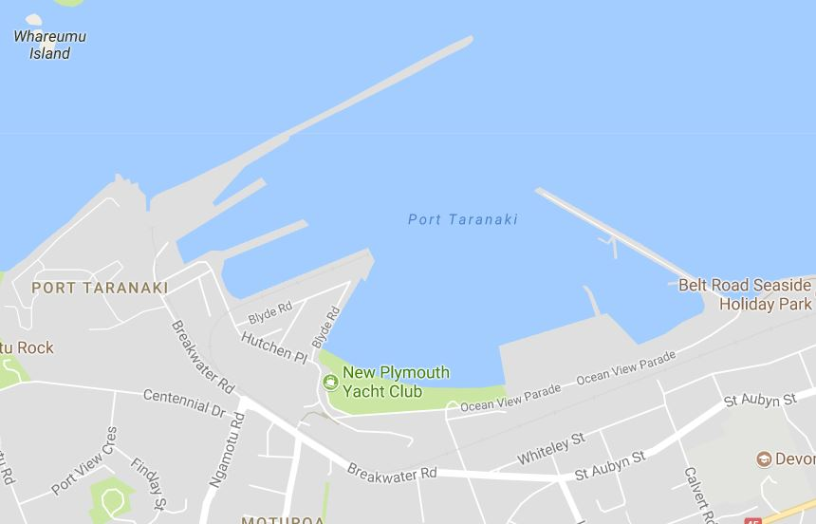

Addendum B – Course Area

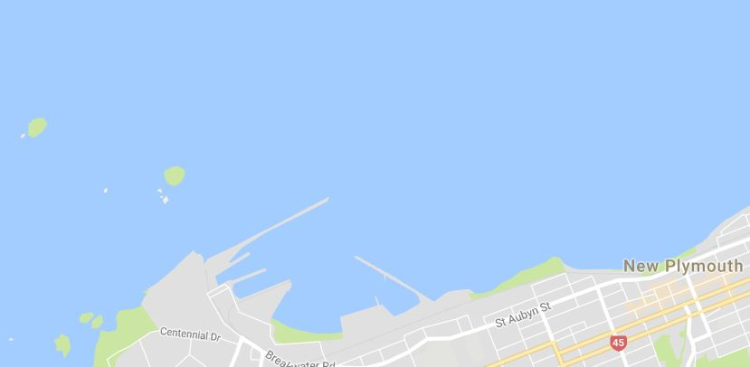

Addendum C – Selection Criteria and Information
NZ Paper Tiger Owners Association
International Selection Trials January 2022 Information

Qualifying Criteria

The criteria for selection of the New Zealand team for this event will be as follows:
- The top 10 finishers in the 2022 Nationals will qualify for the Kiwi Team to race against the Kangaroo Team for the International Teams Trophy.
- The next 10 finishers will qualify for the Tui Team to race against the Wombat Team.
- Where qualifiers are not intending to travel, their places will be offered to the next finishers until all twenty positions in the teams are confirmed.

Easter 2022 regatta

It is still the hope for the Paper Tiger Internationals to be run during Easter 2022 at Koonawarra on Lake Illawarra in NSW. The Lake is approx. 100km or 90 mins drive south of Sydney Airport. See map below.

There is ongoing discussion as to the viability of running the event due to the ongoing effects of Covid. Factors relating to container availability and cost of flights and shipping are also being factored in. A decision on this is due to be made at the end of October 2021.

As always the NZPTOA will hope to fill a container with 20 boats for travel to Australia.

If the October decision is to go ahead with the event, please decide if you are interested in attending before the 2022 Nationals to facilitate easier organisation.
