2021 STARLING NATIONAL CHAMPIONSHIP
Kohimarama Yacht Club
18-22 April 2021
The Organising Authority is the Kohimarama Yacht Club
Kohimarama
Auckland
NOTICE OF RACE

The notation ‘[DP]’ in a rule in the Notice of Race means that the penalty for a breach of that rule may, at the discretion of the protest committee, be less than disqualification.

The notation ‘[NP]’ in a rule means that a boat may not protest another boat for breaking that rule. This changes RRS 60.1 (a)

1 RULES
  - The event is governed by the rules as defined in The Racing Rules of Sailing.

1.2 The Yachting New Zealand Safety Regulations Part 1 shall apply.

1.3 Racing Rule 61.1(a) is changed to state that “A competitor intending to protest is required to inform the race committee at the finish line of their intention to protest immediately after finishing” The change will appear in the Sailing Instructions. The Sailing Instructions may also change other racing rules.

1.4 Appendix T, Arbitration will apply.

1.5 Appendix P shall apply as amended in the Sailing Instructions.

2 SAILING INSTRUCTIONS
2.1 The Sailing Instructions will be available no later than Monday 12 April 2021 on the Notice Board at the Kohimarama Yacht Club and online at www.kyc.org.nz.

No paper copies will be provided.

3 COMMUNICATION
3.1 [DP] While racing, except in an emergency, a boat shall not make voice or data transmissions and shall not receive voice or data communication that is not available to all boats.

4 ELIGIBILITY AND ENTRY
4.1 The event is open to all boats of the Starling Class that comply with the Starling Class constitution and class rules.

4.2 Eligible boats may enter by completing the online form and together with required entry fee at www.kyc.org.nz by Monday 12 April 2021.

4.3 To be considered an entry in the event, a boat shall complete all registration requirements and pay all fees.
4.4 Late entries will be accepted up until and including Friday 16 April 2021 with the payment of the required late entry fee.

4.5 To be eligible to compete in this event each competitor shall be a financial member of a club recognised by the competitor’s national authority.
4.6 Each competitor shall be current financial members of the Starling Class Association (SCA).
4.7 The Development Fleet is to encourage less experienced and less confident Starling sailors to sail and participate at major Starling regattas. To be eligible to race in Development Fleet a competitor shall not have previously raced in Open Fleet except where no Development Fleet is offered.
5 FEES
5.1 Entry fees are as follows:

CLASS | FEE
Starling Open Fleet | $200
Starling Development Fleet | $200
Late Entry Fee (In addition to normal entry fee) | $40

6 ADVERTISING
6.1 [DP] Boats may be required to display advertising chosen and supplied by the organizing authority.

7 QUALIFYING SERIES AND FINAL SERIES
7.1 Open Fleet
The event may consist of a qualifying series and a final series. If entries exceed 70 boats in the Open Fleet, the fleet may be split into 2 as near equal divisions as possible and the regatta will consist of a qualifying series and a final series. For the final series, the Open Fleet may be split into Gold and Silver fleet. More details will be set out in the Sailing Instructions.
7.2 Development Fleet
The regatta will be run as a single series and will be one fleet and there will be no qualifying series or final series.
8 SCHEDULE
8.1 Registration will be held from 0900 hrs to 1700 hrs on Saturday 18 April 2021

8.2 The intention is to hold a sailor briefing at 0930 hrs on Sunday 19 April 2021 at the Kohimarama Yacht Club. This may change depending on the Covid-19 Alert Level and restrictions /guidelines in place at the time.

8.3 Equipment inspection and event measurement:
Saturday 18 April 2021
From 0900 hrs to 1700 hrs

8.4 Dates of racing:

Open Fleet

Date | Target Warning Signal | No of Races Scheduled
19 April 2021 | 1200 hrs | 3
20 April 2021 | 1100 hrs | 3
21 April 2021 | 1100 hrs | 3
22 April 2021 | 1100 hrs | 3

Development Fleet

Date | Target Warning Signal | No of Races Scheduled
19 April 2021 | 1230 hrs | 2
20 April 2021 | 1130 hrs | 2
21 April 2021 | 1130 hrs | 2
22 April 2021 | 1130 hrs | 2

8.5 On the last scheduled day of racing no warning signal will be made after 1600 hrs.

9 EQUIPMENT INSPECTION
9.1 Each boat shall be registered on the Starling Class Association measurement list.

9.2 Each boat shall be presented to the regatta measurer for measurement and inspection.

9.3 Each boat shall comply with Yachting NZ safety regulations Part 1. In particular this includes a rudder/tiller lock, a towing eye or fairlead, a centreboard lanyard, a suitable bailer tied on, the sail number of the hull in figures 50 mm high.

9.4 Wet clothing, measurement and equipment checks may be made throughout the Regatta at the discretion of the Race Committee or Protest Committee.

9.5 Boats may be inspected at any time.

9.6 [DP] Boats shall also comply with RRS 78.1when presented for inspection.

10 VENUE
10.1 NoR Addendum A shows the plan of the event venue.
10.2 NoR Addendum B shows the location of the racing areas.
11 COURSES
The courses to be sailed will be Trapezoid or Windward/Leeward

12 SCORING
12.1 Five races are required to constitute a series.

12.2 Open Fleet
(a) When fewer than 5 races have been completed, a boat’s series score will be the total of her race scores.
(b) When from 5 to 8 races have been completed, a boat’s series score will be the total of her race scores excluding her worst score.
(c) When 9 or more races have been completed, a boats series score will be the total of her race scores excluding her two worst scores.
12.3 Development Fleet
(a) When fewer than 4 races have been completed, a boat’s series score will be the total of her race scores.
(b) When 4 or more races have been completed, a boat’s series score will be the total of her race scores excluding her worst score.
13 SUPPORT PERSON VESSELS
[DP] Support boats shall register with the organising authority prior to the first warning signal.

14 LAUNCHING
[DP] All Starlings shall be launched from Kohimarama Beach. All beach trolleys shall be clearly marked with the sail number of the boat.

15 RISK STATEMENT
15.1 RRS 3 states: ‘The responsibility for a boat’s decision to participate in a race or to continue to race is hers alone.’ By participating in this event each competitor agrees and acknowledges that sailing is a potentially dangerous activity with inherent risks. These risks include strong winds and rough seas, sudden changes in weather, failure of equipment, boat handling errors, poor seamanship by other boats, loss of balance on an unstable platform and fatigue resulting in increased risk of injury. Inherent in the sport of sailing is the risk of permanent, catastrophic injury or death by drowning, trauma, hypothermia or other causes.

16 INSURANCE
16.1 Each participating boat shall be insured with valid third-party liability insurance with a minimum cover of $1,000,000 per incident or the equivalent. Certificate of insurance is to be presented at registration.
17 PRIZES
17.1 Prizes will be given as follows:

Open Fleet Under 19 unless stipulated otherwise.
John Peet Trophy shall be awarded to the highest placed competitor in the overall open fleet results and they shall be awarded the title Starling National Champion.
Kohi Cup shall be awarded to the second highest placed competitor in the Open Fleet.
Murrays Bay Cup shall be awarded to the third highest placed competitor in the Open Fleet.
Alan Sayer Trophy shall be awarded to the highest placed female competitor in the Open Fleet.
John Binsley Trophy shall be awarded to the second highest placed female competitor in the Open Fleet.
Chris Timms Trophy shall be awarded to the highest placed under 16 year old in the overall Open Fleet.
The Harken Trophy shall be awarded to the youngest skipper in the first 10 places overall in the Open Fleet.
The Cooke Trophy shall be awarded to the leading competitor at the end of the qualifying series. If there is no qualifying series this trophy shall be awarded to the boat leading the series after the middle race of the series, or if there are two middle races then after the later of these two races.
The Howick Cup shall be awarded to the winner of the Silver division of the Open Fleet. If there is no qualifying and finals series, this trophy shall be awarded to the boat finishing nearest to the middle of the fleet. If two boats are the middle boats it shall be awarded to the lower of these boats.
The Queen Charlotte Trophy shall be awarded to the most improved skipper in the Open Fleet throughout the championship.
The Graeme Leonard Hays Shield shall be awarded to any skipper, who in the opinion of the host club, showed exceptional courage and effort during the event.

Open Fleet Over 19
The Des Townson Trophy shall be awarded to the highest placed competitor over 19 in the Open Fleet.

Development Fleet
The Development Fleet Trophy shall be awarded to the highest placed competitor under 19 in the Development Fleet.

The age date for prizes is the 22nd April, 2021

18 FURTHER INFORMATION
18.1 For further information please contact:
Murray Scott
Rear Commodore
Kohimarama Yacht Club
murrodz@gmail.com
021 494 793

Addendum A

Location of Regatta Venue
Kohimarama Yacht Club
80 Tamaki Drive, Kohimarama

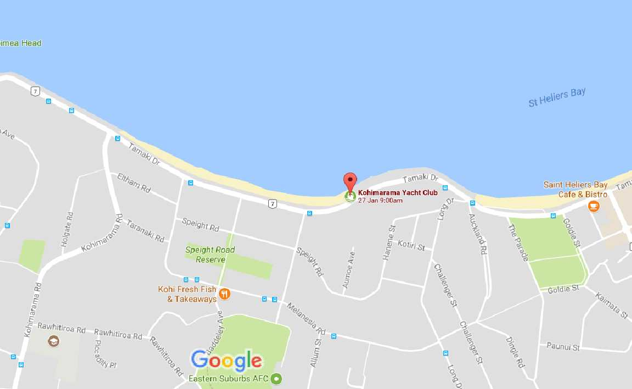

Addendum B

Racing Area

