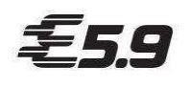
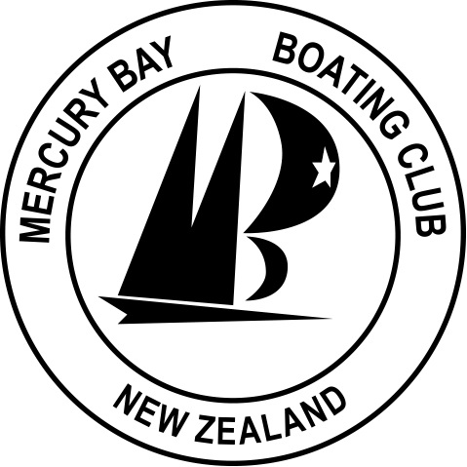
2021 Elliott 5.9 National Championships

20th – 22nd May 2021

Notice of Race
The Organising Authority is the Mercury Bay Boating Club (MBBC)
90 Buffalo Beach Road | PO Box 81, Whitianga 3542

NB: The notation ‘[DP]’ in a rule in the Notice of Race means that the penalty for a breach of that rule may, at the discretion of the protest committee, be less than disqualification and the notation [NP] in a rule in the Notice of Race means rules that are not grounds for protest by a boat.

- Rules
  - The event is governed by the ‘rules’ as defined in the Racing Rules of Sailing (“RRS”) and the Elliott 5.9 Class Association.
  - The Yachting New Zealand Safety Regulations Part 1 shall apply.
  - All boats must supply and clearly display visible two-digit bow numbers with a minimum height of 350mm. The numbers to be used by each boat are those approved by the E5.9 Class Association and will generally be the last digits of the sail number – e.g., “00”. These must be positioned within 1 metre of the bow, on the port and starboard sides of the hull, above the waterline.
  - Appendix T, Arbitration will apply.
- Sailing Instructions
The Sailing Instructions will only be available online and a copy posted on the Official Notice Board. The Sailing Instructions may also be posted on the Elliott 5.9 website prior to registration.
- Communication
3.1 On the water, the race committee will make courtesy broadcasts to competitors on VHF. This may include the time of the warning signal but will not include boats that are called OCS.
3.2 [DP] From the first warning signal until the end of the last race of the day, except in an emergency, a boat shall not make voice or data transmissions and shall not receive voice or data communication that is not available to all boats.
- Eligibility and Entry
  - The event is open to all boats of the Elliott 5.9 class and whose owner(s) re current member of the class association.
  - Eligible skippers must enter via by completing the ONLINE ENTRY FORM and paying the required fee by Wednesday 12th May 2021.
Entry fees are to be paid into the following bank account:
Account number: 03-1578-0038616-00
Reference: 5.9 Nats – Sail Number – Helm surname
Eg: 5.9 Nats – 1234 – Smith
  - Late entries accompanied by the late entry fee may be accepted at the Race Committee’s discretion until 1000 on Thursday 20th May 2021.
  - To be eligible to compete in this event each entrant and crew member shall be a financial member of a yacht club recognised by that person’s national authority. Proof of affiliated club membership shall be presented at registration.
- Fees
  - The entry fee is $150.00.
  - The late fee is an additional $50.
- Advertising
Boats may be required to display advertising chosen and supplied by the Organising Authority.
- Schedule
  - Registration
Thursday 20th May 2021 0830 - 1000 MBBC
  - Briefing
The briefing is scheduled for 1000 on Thursday 20th May 2021 in the MBBC Clubhouse.
  - Dates of Racing
Date | Race Day | Time of 1st Warning Signal | Number of Races
Thursday 20th May | 1 | 1125hrs | 4
Friday 21st May | 2 | 1025hrs | 4
Saturday 22nd May | 3 | 1025hrs | 4

  - Number of Races
(a) 12 Races are scheduled for the series.
(b) Up to 5 races may be sailed per day.
(c) On Saturday 22nd May no warning signal will be made after 1500.
- Equipment Inspection
  - [DP] Boats may be inspected at any time.
  - Boats shall also comply with RRS 78.1 at all times while racing.
- Venue
  - Addendum A shows the location of the event venue.
  - The Racing area and are the waters known as Mercury Bay.
- Courses to be Sailed
  - The courses to be sailed will be windward/leeward courses.
  - The target time for each race will be 45 minutes for the leading boat.
- Penalty System
RRS 44.1 is changed so that the ‘Two-Turns’ penalty is replaced by the ‘One-Turn’ Penalty.
- Scoring
  - 5 races are required to be completed to constitute a series.
  - When fewer than 6 races have been completed, a boat’s series score will the total of her race scores.
  - When 6 or more races have been completed, a boat’s series score will be the total of her race scores excluding her worst score.
- Support Boats [DP] [NP]
Support boats are permitted but may be subject to restrictions and must comply with all local bylaws.
- Launching & Berthage [DP] [NP]
Unless otherwise directed by the Organising Authority, all competing boats and equipment shall be launched and retrieved from the Mercury Bay Marina. Information on boat storage will be provided by the Class Association and the OA.
- Risk Statement
RRS 3 states: ‘The responsibility for a boat’s decision to participate in a race or to continue to race is hers alone.’ By participating in this event each competitor agrees and acknowledges that sailing is a potentially dangerous activity with inherent risks. These risks include strong winds and rough seas, sudden changes in weather, failure of equipment, boat handling errors, poor seamanship by other boats, loss of balance on an unstable platform and fatigue resulting in increased risk of injury. Inherent in the sport of sailing is the risk of permanent, catastrophic injury or death by drowning, trauma, hypothermia or other causes.
- Insurance
Each participating boat shall be insured with valid third-party liability insurance with a minimum cover of $1,000,000 per incident or the equivalent. Certificate of insurance is to be presented at registration.
- Prizes
  - Elliott 5.9 Class Association National Trophies will be awarded.
  - Other prizes may be awarded at the discretion of the Class Association or the Organizing Authority.
- Further Information
For further information please contact:

Mercury Bay Boating Club
Phil Hart Jonathan Kline
Treasurer Commodore
021 960 494 027 392 7280
Email: committee.mbbc@gmil.com
Web: https://www.sporty.co.nz/mercurybayboating

Class Association
Stu Clarke
Phone: 021 890 067
Email: stu.clarke@xtra.co.nz
Web: http://www.elliott59.weebly.com

Addendum A –Event Venue

