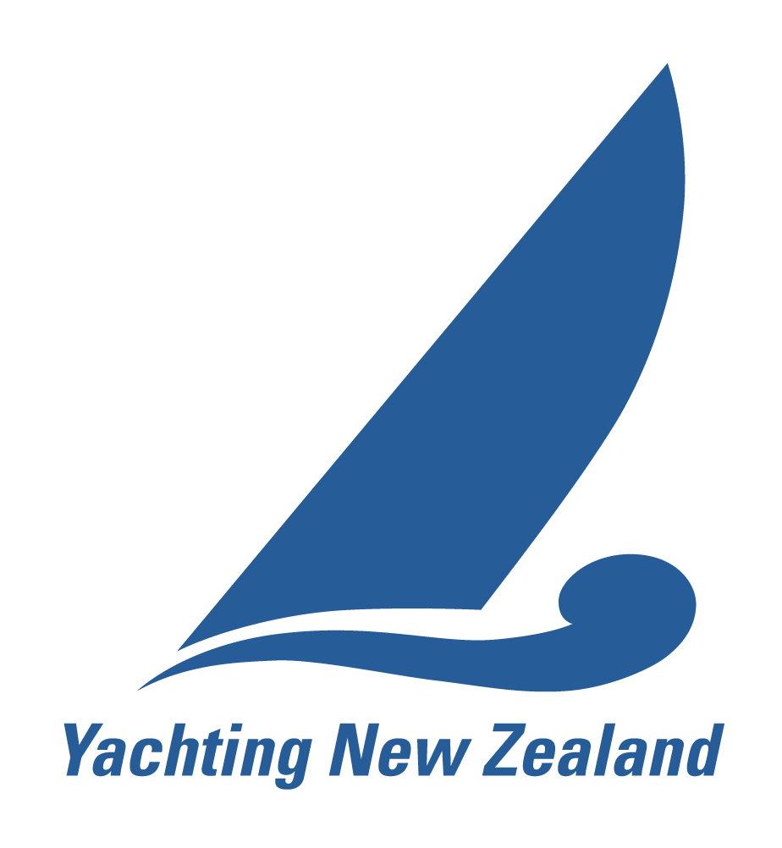
National Event Report Form – Match Racing

The Organising Authority must arrange for this form to be completed by the relevant personnel and forwarded to Yachting New Zealand within two weeks of the completion of the event. Completed form to be sent to: alana@yachtingnz.org.nz or fax: (09) 360 2246 or
Yachting New Zealand, PO Box 33 1487, Takapuna, Auckland 0740,
Phone: (09) 361 4028

Name of the Championship:

Organising Authority
Venue
Inclusive dates of the event
Were any dispensations granted by YNZ (please specify)
Format (Round Robin, Knockout etc)
Number of Teams / Sailors
All entrants & crew members financial members of a yacht club affiliated to YNZ, or comply with World Sailing Regulation 19(b) | YES NO
Name of Race Officers (current NRO YES/NO) | 1.  2. | YES NO  YES NO
Names of Protest Committee/ Umpires (Min 3 incl 1 NJ) | Status CU, NU, IU, CJ, NJ or IJ?  (Please tick below)
1 (Chairman ) | CU NU IU CJ NJ IJ
2 | CU NU IU CJ NJ IJ
3 | CU NU IU CJ NJ IJ
4 | CU NU IU CJ NJ IJ
5 | CU NU IU CJ NJ IJ

Winning Team/Sailor | Mailing Address (so that YNZ may send a certificate)

Challenges, successes and difficulties (lessons learnt) (give details):

Any significant issues (give details):

Successes in overcoming these issues (give details):

Were there any requests for redress under RRS 62.1 (a)? not including umpire calls Yes No

If yes, give details: (enclose a copy of protest / redress)

Were the Notice of Race and Sailing Instructions as approved by Yachting New Zealand used?
Yes No

If ‘No’ Why?

Suggestions and recommendations for the continued development and improvement of this event.
(Give detail, use extra sheet if necessary):

Declaration by the Chairman of the Organising Authority
I hereby declare that this event was conducted in accordance with the Racing Rules of Sailing, World Sailing regulation 20 (Advertising), and all other rules that governed this event including YNZ Regulation 4.5.4.

Name Signature: Date:

Attached hereto are the following documents as issued to competitors or displayed on the official notice board.

Official results Any amendments to published Notice of Race and/or Sailing instructions
[Do not include any Race Officer worksheets, mark rounding, result sheets, protests (except RR62.1 (a). These are to be held by the Organising Authority)]

(For Office use only) National Event reviewer:
I am happy that the above event has met Yachting New Zealand requirements and the winner should be recognised as National Champion.
The event has not met Yachting New Zealand requirements for the following reasons:

Signature: Date:

