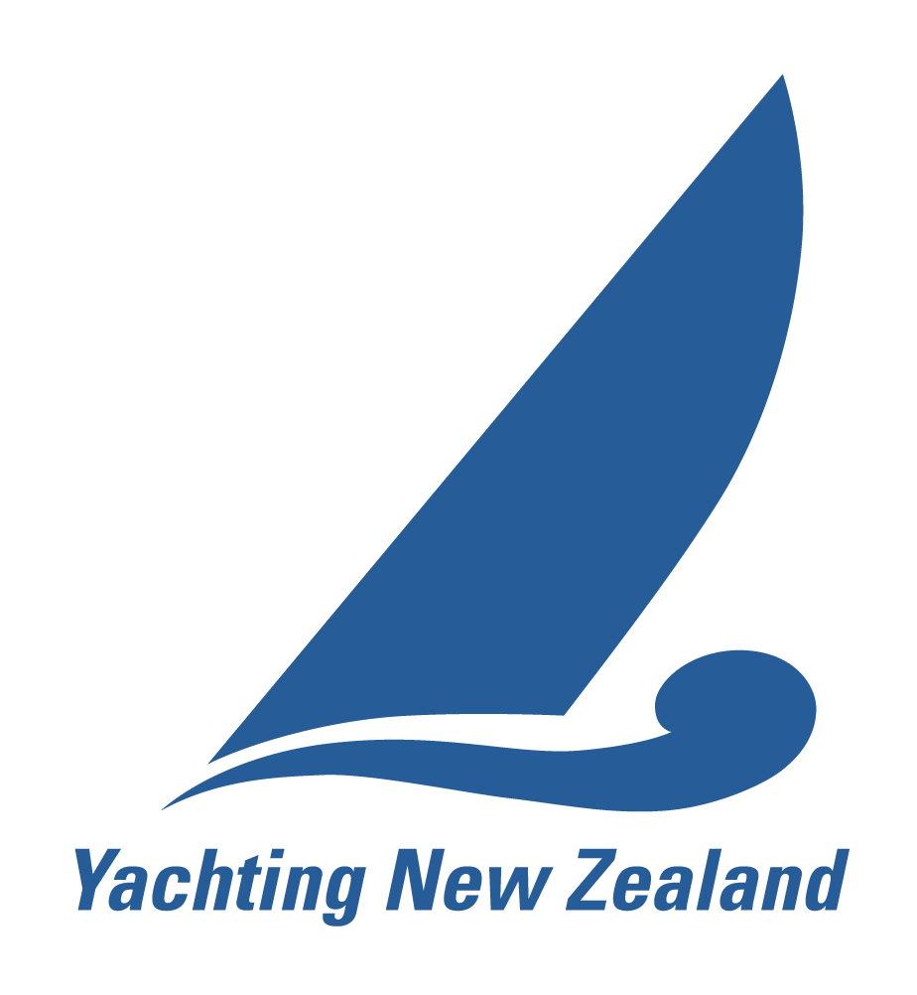
YACHTING NEW ZEALAND
Information for holding a National Championship

There are a few important criteria required to be met for the event to be signed off as a National championship and the winner to be recognised by Yachting New Zealand as the National Champion.

Regulation 4.5.4 can be found in full on the Yachting New Zealand website but these criteria include:

- A National/Major Event Application Form to run the event must be submitted to Yachting New Zealand, no later than 30th June.
- Public Liability insurance to a minimum of $5,000,000 (with no marine and/or watercraft restrictions) and 3rd party liability insurance for vessels operated by the Organising Authority
- The race officer must be a Yachting NZ qualified National Race Officer
- The protest committee must include a minimum of one Yachting NZ qualified National Judge. Dispensation can be granted to allow a National Judge on telephone link if necessary.
- Race documents must be produced using the YNZ Standard NOR/SI templates.
- Notice of Race must be submitted to Yachting New Zealand for approval before publication, 4 months prior to the event.
- Sailing Instructions must be submitted to Yachting New Zealand for approval before publication, 2 months prior to the event.
- A minimum of 7 races shall be scheduled of which a minimum of 5 races are required to be completed to constitute a series
- A minimum of six yachts must have started in any one race in the series (with the exception of the following classes: Skud 18, 2.4, Sonar, Hansa 2.3, Hansa Liberty, Hansa 303 – Single Handed, Hansa 303 – Double Handed where 5 yachts must have started in any one race in the series).
- All entrants and crew members shall be financial members of a yacht club affiliated to Yachting New Zealand, or be a member of his/her Member National Authority
- An event report shall be submitted to Yachting New Zealand within two weeks after the event
It is up to the Organising Authority to ensure these requirements are complied with. Failure to comply will result in the winner not being recognised as national champion.
Yachting New Zealand may give dispensation to requirements of this addendum upon application from the Organising Authority prior to the event.
All National championship events will be appointed a National Race Officer to review your race documentation and provide race management guidance if required.
More information can be found on the on the Yachting New Zealand Race Official and Event Resources page
YACHTING NEW ZEALAND
Major/National Event Application Form

Yachting New Zealand (YNZ) approval is required for any event that is to be described as a National Championship. Please return this form to Yachting NZ by June 30th prior to the season or at no later than 6 months before your event, whichever occurs earlier.

Keep the following points in mind:
- The Racing Rules of Sailing, Yachting NZ’s Regulation 4.5.4 (Major and National Event Management) and Yachting NZ Safety Regulations will apply.
- The Race Officer, Protest Committee, NOR & SI’s all require approval from Yachting NZ.

Event Title:

Planned dates (inclusive of registration / prize giving):

Host Club:

Sailing Water:
Organising Authority if different from Host Club:

Organising Authority:
(Must comply with RRS Rule 89.1)
Contact Person:
Email: | Phone
Event Website (for regatta results / reports):

Class Association Contact (if applicable):

Email: | Phone

Event Type:
National Championship Selection Trial International Event
If selection trials or international event provide details:

Race Officials Details: (if Known)
Name of Race Officer:
must be YNZ qualified National Race Officer
Name of Protest Committee Chair:

Names of Protest Panel Members:

Protest panel must be a minimum of 3 people and include at least one YNZ qualified National Judge.

Requests for Dispensation:

Applications for dispensation from Yachting NZ Regulation 4.5.4 must be lodged in writing to the Chief Executive Officer of Yachting New Zealand.

Your request may be sent via email to the CEO via alana@yachtingnz.org.nz

A written request is also required if you tick Yes below.

Is The Organising Authority intending to apply for a dispensation to deny the right of appeal?
(Refer to RRS 70.5) Yes No

Yachting New Zealand Affiliation:

In order to run a National event the Host Club and Class Association MUST have paid their Yachting NZ Affiliation Fee for the current financial year of the National Event.

Insurance requirement:

The Organising Authority is required to hold adequate insurance to cover the Organising Authority, its officers, employees, and any members or other volunteers assisting the Organising Authority in conducting the event, against any claims by third persons arising from the event. This shall include:

- current Public Liability insurance to a minimum of $5,000,000. This cover must have no marine and/or watercraft restrictions.
- 3rd party liability insurance for vessels operated by the Organising Authority for the event

We understand and acknowledge the insurance requirements above and have attached certificate of insurance

The Organising Authority hereby agrees that it will conduct this event in accordance with the Racing Rules of Sailing, the prescriptions of Yachting New Zealand (YNZ) and the YNZ Safety Regulations. The provisions of Yachting NZ’s regulation 4.5.4 are acknowledged and every reasonable effort will be made to ensure that these provisions are complied with.

Signed on behalf of the Organising Authority:
Name: | Date:
Position Held:

PLEASE KEEP A COPY OF THIS FORM FOR YOUR RECORDS

Completed form to be sent to:

Yachting New Zealand
PO Box 33 1487
Takapuna
Auckland 0740

or email to: alana@yachtingnz.org.nz
Phone: (09) 361 4028
or fax: (09) 360 2246

