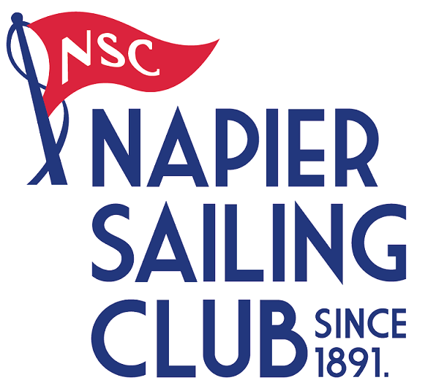
OK Dinghy
National Championship
5th - 7th February 2021
The Organising Authority is the Napier Sailing Club
63 West Quay, Ahuriri
www.napiersailingclub.org.nz

NOTICE OF RACE

NB: The notation ‘[DP]’ in a rule in the Notice of Race means that the penalty for a breach of that rule may, at the discretion of the protest committee, be less than disqualification.

- RULES
  - The regatta will be governed by the rules as defined in The Racing Rules of Sailing.

  - The Yachting New Zealand Safety Regulations Part 1 shall apply.

  - The International OK Dinghy (OKDIA) Class rules will apply.

  - The Sailing Instructions may change racing rules.

  - Appendix T, Arbitration, will apply.

- ADVERTISING
  - Boats may be required to display advertising chosen and supplied by the organising authority. If this rule is broken, World Sailing Regulation 20.9.2 applies. [DP]

- ELIGIBILITY AND ENTRY
  - The regatta is open to all boats of the OK Dinghy class whose owners are current financial members of their National Class Association.

  - Eligible boats may enter by completing the attached form and emailing to manager@napiersailingclub.org.nz.
Payment to be made electronically to Napier Sailing Club by 1700hrs. 29th January 2021.

  - Late entries accompanied by the contest entry fee plus the late entry fee may be accepted at the Race Committee’s discretion until 1700 hrs. 4th February 2021.

  - To be eligible to compete in this event each competitor shall be a financial member of a club recognised by the competitor’s National Authority.

Proof of affiliated club membership to be presented at registration

- FEES
Required fees are as follows

CLASS | FEE
OK Dinghy | $150.00

  - Late Entry Fee $50.00

- SCHEDULE
  - Registration: Thursday 4th February 2021, 1200-1800hrs, Napier Sailing Club.
Friday 5th February 2021, 0800-0900Hrs, Napier Sailing Club.
  - Equipment inspection
Thursday 4th February 2021, 1200-1800hrs, Napier Sailing Club.
Friday 5th February 2021, 0800-0900Hrs, Napier Sailing Club.
  - Schedule of Event:

Date | Times | Class
Friday 5th February | 0930hrs. | Briefing
Friday 5th February | Time of first warning Signal 1100hrs. | Racing  3 Races back to back
Saturday 6th February | Time of first warning Signal 1000hrs. | Racing  3 Races back to back
Sunday 7th February | Time of first warning Signal 1000hrs. | Racing  3 Races back to back

  - Number of races: 9 Races are scheduled.
Class | Number Races per day | Target time for each race
OK Dinghy | 3 Races | 45 Minutes

  - On the last scheduled day of racing no warning signal will be made after 1530hrs.

- MEASUREMENT

  - Each boat shall produce a valid measurement certificate no later than at the time of registration.

  - A boat shall comply with RRS 78.1 throughout the contest and may be checked at any time during the event.
  - A Safety Declaration is to be completed at registration. NB; a safety check may be made on any boat at any time during the event.

- SAILING INSTRUCTIONS
The sailing instructions will be available after 0900Hrs on Monday 04 January 2021 from the Napier sailing club website.

- VENUE
  - Attachment A; shows the location of the regatta venue.

  - Attachment B; shows the location of the racing area.

- THE COURSES
The courses to be sailed will consist of: Windward / Leeward, Triangles or a mixture of both.
- SCORING

  - 5 races are required to be completed to constitute a series.

a) When fewer than 6 races have been completed, a boat’s series score will be the total of her race scores.

b) When 6 races have been completed, a boat’s series score will be the total of her race scores excluding her worst score.

- SUPPORT BOATS
Support boats shall Register with the Organising Authority. [DP]

- BERTHING
Boats shall be kept in their assigned places while they are in the boat park. [DP]

- LAUNCHING & RETRIEVAL RESTRICTIONS
Competitors shall launch and retrieve vessels from Napier Sailing Club Ramps during the regatta except with, and according to the terms of, prior written permission of the race committee. [DP]

- RADIO COMMUNICATION
Except in an emergency, a boat that is racing shall not make voice or data transmissions and shall not receive voice or data communication that is not available to all boats. This restriction also applies to mobile telephones. [DP]

- PRIZES
Prizes may be awarded at the discretion of the Organising Authority in conjunction with the Class Association

- INSURANCE
Each participating boat shall be insured with valid marine third-party liability insurance with a minimum cover of $1,000,000 per incident or the equivalent. Certificate of insurance is to be presented at registration

- DISCLAIMER OF LIABILITY
Competitors participate in the regatta entirely at their own risk. See RRS 4, Decision to Race. The Organising Authority will not accept any liability for material damage or personal injury, or death sustained in conjunction with or prior to, during, or after the regatta.

- Event Cancellation
In the event of cancellation due to any causes outside of the Organising Authority control all efforts will be made to reimburse Entry fees less any Event associated cost already incurred not recoverable.

- FURTHER INFORMATION
For further information please contact:

Dee Ford
Ph. 06 835 3811 Cell. 027 209 3868
Napier Sailing Club Manager

Manager@napiersailingclub.org.nz
www.napiersailingclub.org.nz

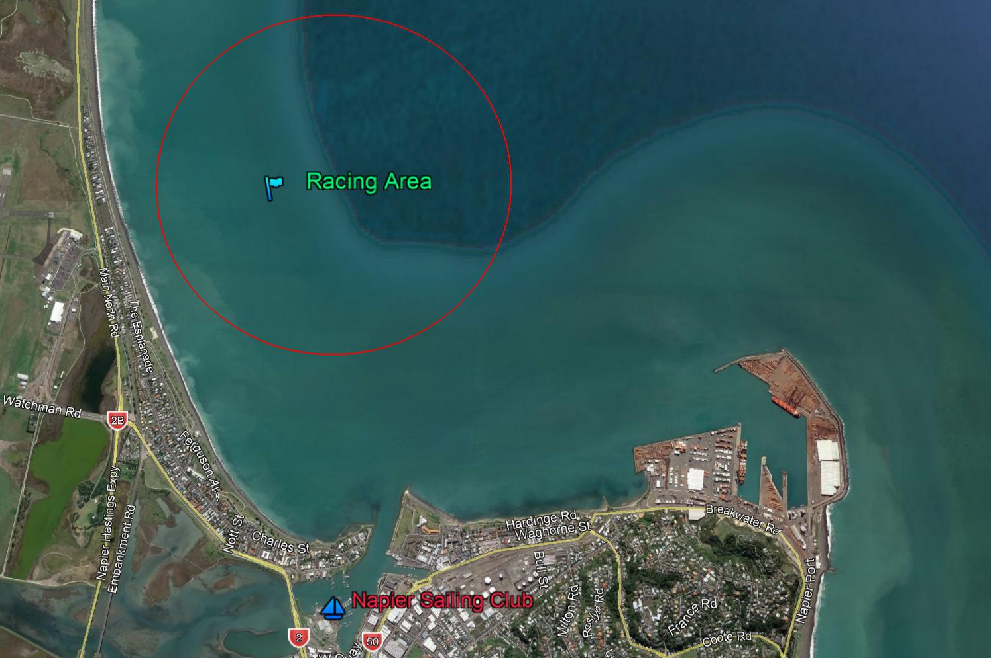
Attachment B
Attachment A
OK Dinghy National Championship
5th - 7th February 2021
The Organising Authority is the Napier Sailing Club
63 West Quay, Ahuriri
Entry Form
Class
Sail Number | Boat name

Skipper Details
First name | Surname
Yacht Club | Address
Email
Mobile

Crew Details
First name | Surname
Yacht Club | Address
Email
Mobile

Crew Details
First name | Surname
Yacht Club | Address
Email
Mobile
Please add additional contact details if more than two crew

I agree to be bound by the Racing Rules of Sailing and all other rules that govern this event. I understand that yacht racing has inherent risks and dangers that are beyond the control of the organizing authority. I understand that neither the organising authority and its officers, members and servants nor other persons assisting with the conduct of the regatta accept any responsibility in respect of any injury or loss to person or property that may be sustained by reason of participation in the regatta or howsoever arising in connection with the regatta.
I agree to the use of my photograph(s) and other relevant information in any event publicity and in the ongoing promotion of New Zealand yachting. I agree to the Organising Authority and Yachting New Zealand holding the above information for the general administration and well-being of the sport, and for them to retain, use and disclose the information to affiliated organisations and any other persons or organisations that Yachting New Zealand believes will further the interests and objectives of Yachting New Zealand. I acknowledge my right to access to and correction of this information. The consent is given in accordance with the Privacy Act 1993.

Skipper /Owner Signature: Date:

Office Use: Entry Fee Paid Method: Amount:
Payment & registration to be returned electronically to Napier Sailing Club,
Acct No. 03-0698-0040708-000;
include your boat sail number, class and/or name in the reference field.

