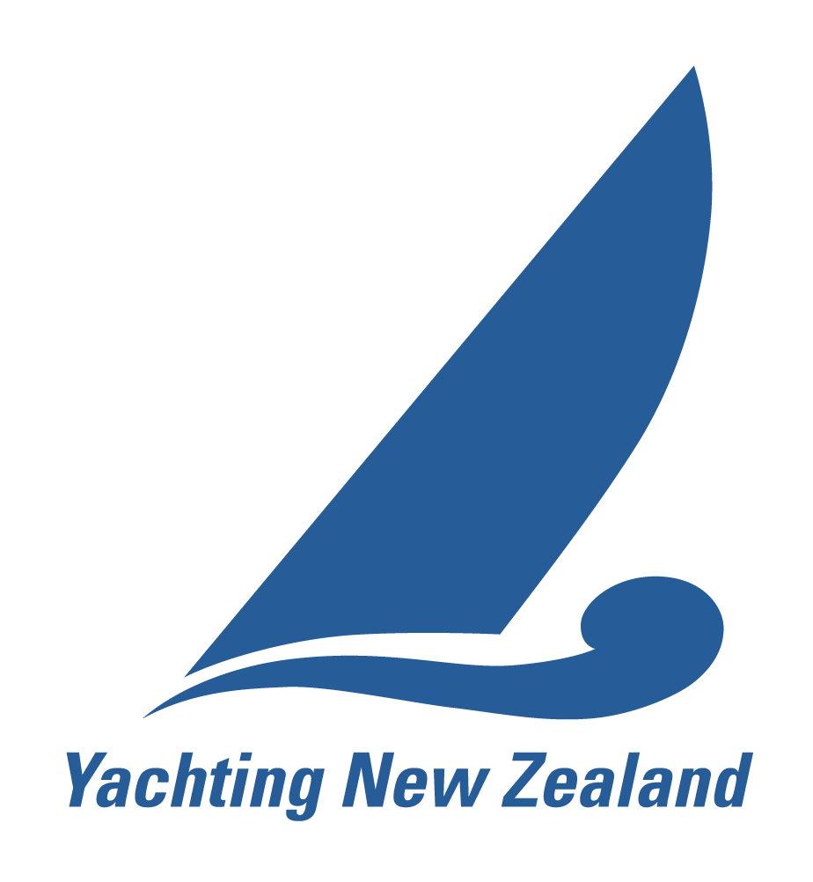
YACHTING NEW ZEALAND

CLUB RACE OFFICER – APPLICATION FORM

Please tick the qualification you are applying for
New Application Renewal
Criteria for initial appointment or renewal: During the last four years the applicant must have
- Demonstrated ability and experience in:
- running club events
- knowledge of the rules pertaining to Race Management
- Completed the Yachting New Zealand online Club Race Officer course on Embark
- Complete Part A and Part B of the application
PART A
Surname:
First Names:
Yacht Club:
Postal Address:
Phone (Home): |  | Mobile:
Email:

I have completed the Yachting New Zealand online Club Race Officer course

Recommendations from a Flag Officer of a yacht club affiliated to Yachting New Zealand, acknowledging the club’s satisfaction of this race officer’s work and supporting this application.
I acknowledge that the applicant has demonstrated, to our club’s required standard, the following (please tick):

has good knowledge of the club’s Health & Safety practices and specific club hazards to ensure racing is conducted safely, including decision to race responsibilities.
sets reasonable courses for required classes and level of sailors
has good understanding of flags, starting procedures and race committee actions that can occur during a race.
completes end of day procedures as required by the role
has good knowledge of radio procedures
can competently lead a race management team

Name: |  | Signature:
Yacht Club: |  | Title:

I hereby apply for appointment as a Yachting New Zealand Club Race Officer. I agree to Yachting New Zealand holding the above information for the general administration and well-being of the sport, and for them to retain, use and disclose the information to affiliated organisations and any other persons or organisations that Yachting New Zealand believes will further the interests and objectives of Yachting New Zealand. I acknowledge my right to access to and correction of this information. The consent is given in accordance with the Privacy Act 1993.

I agree to abide by the Yachting New Zealand Race Official Code of Conduct and acknowledge that
disciplinary action may be taken against me for a proven or established breach of the Code of Conduct.
Signature: |  | Date:

Completed form to be sent to: Yachting New Zealand, PO Box 33 1487, Takapuna, Auckland 0740,
or email to: colin@yachtingnz.org.nz or fax: (09) 360 2246
YACHTING NEW ZEALAND CLUB RACE OFFICER – APPLICATION FORM

PART B: Demonstrating Ability and Experience
Note: If you have been submitting a record of the club racing/regattas you have acted as a Race Officer for using the Yachting NZ Regatta Report form online, there is no need to complete Part B as the information should be in your file at YNZ.

List the eight (8) most significant days of racing for which you have been the RACE OFFICER in the past four (4) years. Note the Race Officer is the person in charge of a race course who has other personnel assisting, under the Race Officer’s direction, the running of the racing:

Date | Event | Club | Number of Races | Number of boats competing | Number of personnel under your direction | Number of race management boats under your direction | Format of racing: Fleet  Match  Teams

List up to eight (8) days where you have undertaken other race management duties.
Date | Event | Club | No of Races | No of Competing boats | Your role (choose from):  Flag officer, Timekeeper, Recorder, Line sighter start,  Line sighter finish, Mark layer skipper, Mark layer crew,  Duty officer, Results, Safety boat skipper, Safety boat crew

