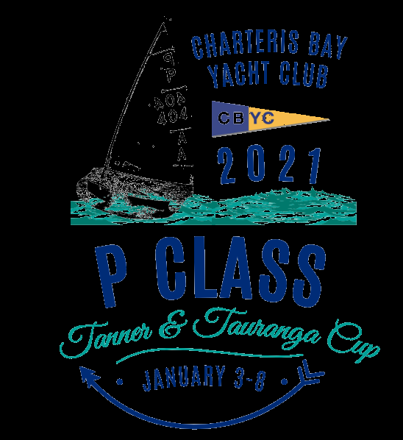

2021 P Class Inter-Provincial Championship for the Tanner Cup

Sunday 3rd January 2021 to Tuesday 5th January 2021

The Organising Authority is:

Charteris Bay Yacht Club (inc), Charteris Bay

PO Box 1 Diamond Harbour, Canterbury

**NOTICE OF RACE**

NB: The notation ‘[DP]’ in a rule in the Notice of Race means that the penalty for a breach of that rule may, at the discretion of the protest committee, be less than disqualification and the notation [NP] in a rule in the Notice of Race means rules that are not grounds for protest by a boat*.*

1. **RULES**
   1. The regatta will be governed by the rules as defined in *The Racing Rules of Sailing* – *Note: This event will be sailing under the RRS 2021 – 2024.*
   2. The Yachting New Zealand Safety Regulations Part 1 shall apply.

* 1. The Tanner Cup rules and conditions will apply ([www.yacht.org.nz](http://www.yacht.org.nz)).
  2. Appendix “P” will apply.
  3. Appendix “T”, Arbitration, will apply.
  4. Each competing boat shall carry on both sides of its sail contrasting letters at least 300mm high and 38mm wide denoting the province or district they are representing (refer to the Tanner Cup Rules and Conditions - 10 DISTINGUISHING LETTERS). Unless reversible, such letters shall be arranged at different heights on each side of the sail. These are to be supplied by each competitor

1. **ADVERTISING [DP]**

Boats may be required to display advertising chosen and supplied by the organising authority. If this rule is broken, World Sailing Regulation 20.9.2 applies.

1. **ELIGIBILITY AND ENTRY**
   1. The regatta is open to all boats of the P Class that complies with the Class Rules and have a current P Class National Certificate in the name of the current owner, and who have been nominated by an eligible challenging body as defined in the P Class Rules (including the Tanner Cup Rules and Conditions)
   2. Eligible boats may enter by completing the attached form and sending it, together with the required fee, to:

Charteris Bay Yacht Club

PO Box 1

Diamond Harbour

Christchurch 8972

OR

Email to cbycpclass@gmail.com and direct debit to our bank account:

03-0802-0100839-00

Reference: Tanner Cup – *Province & Sail Number – Helms surname*

* 1. Entries close 1700 Tuesday 8th December 2020
  2. Late entries accompanied by the late entry fee may be accepted at the Race Committee’s discretion until 1700 Monday 28th December 2020.
  3. To be eligible to compete in this event each entrant shall be a financial member of a club recognised by the event’s national authority.
  4. Each competitor shall be under the age of 17 years on the 31st January 2021
  5. The following documents must be provided no later than at completion on registration:
* Proof of yacht club membership
* Proof of current P Class Registration
* Copy of competitor’s birth certificate.

1. **FEES**
   1. Required fees are as follows:

|  |  |
| --- | --- |
|  | FEE |
| Entry | $130 |
| Late Entry | $180 |
| Combined Tanner and Tauranga Cups | $250 |

1. **SCHEDULE**
   1. Registration:

Sunday January 3rd, 2021, 1200 to 1500 at CBYC Clubhouse.

* 1. Equipment inspection and event measurement:

Sunday January 3rd, 2021, 1200 to 1700 at CBYC Rescue Boat Shed.

* 1. Briefing:

Monday January 4th, 2021, 0900 at the CBYC Clubhouse

* 1. Dates and number of races:

|  |  |  |
| --- | --- | --- |
| ***Date*** | ***Races*** | ***Target Time*** |
| *Monday 4th January 2021* | *Races 1 -3* | *45 Minutes* |
| *Tuesday 5th January 2021* | *Races 4-6* | *45 Minutes* |

* 1. The scheduled time of the warning signal for the first race each day is 1055
  2. Up to 4 races may be scheduled each day
  3. On the last scheduled day of racing no warning signal will be made after 1630.

1. **MEASUREMENT [NP]**
   1. Each boat shall be presented for measurement per NoR 5.2. In addition, competitors shall use one hull, one set of foils, one mast, boom and one sail for the entire Tanner Cup, all of which shall have been measured and marked at the official measuring.
   2. Wet clothing, measurement and equipment checks may be made at any time during the event.
   3. A boat shall comply with RRS 78.1 at Sunday January 3rd, 2021, 1200.
2. **SAILING INSTRUCTIONS**

The sailing instructions will be available after registration and available after 5pm on Sunday 6th December 2020 on the CBYC website. [www.charterisbayyachtclub.co.nz](http://www.charterisbayyachtclub.co.nz)

1. **VENUE**
   1. Attachment “A” shows the location of the regatta venue.
   2. Attachment “B” shows the location of the racing areas.
2. **COURSES**

The courses to be sailed will be Triangle or Triangle / Windward Leeward.

1. **SCORING**
   1. 4 races are required to be completed to constitute a series.

a) When fewer than 4 races have been completed, a boat’s series score will be the total of her race scores.

b) When 4 to 6 races have been completed, a boat’s series score will be the total of her race scores excluding her worst score.

1. **SUPPORT BOATS [DP] [NP]**
   1. Support boats are permitted but may be subject to restrictions.
   2. If fitted boat skippers must wear kill switch lanyards

Support Boat Skippers should be familiar with Local Body bylaws regarding the wearing of PFDs. <https://www.ecan.govt.nz/do-it-online/harbourmasters-office/recreational-boating/>

* 1. Support boats and the person in charge must be registered with the Organising Authority at Registration.

1. **LAUNCHING [DP] [NP]**

Unless otherwise directed boats must launch and retrieved from Charteris Bay Yacht Club

1. **RADIO COMMUNICATION [DP] [NP]**

Except in an emergency, a boat that is racing shall not make voice or data transmissions and shall not receive voice or data communication that is not available to all boats. This restriction also applies to mobile telephones.

1. **PRIZES**
   1. Prizes will be given as follows:

* The Tanner Cup: Highest ranked sailor in the overall results
* The Gisborne Cup: Second place in the overall results
* The Otago Cup: Third place in the overall results
* The John Thompson Trophy: Winner of the first race of the Championship
  1. Other Prizes may be awarded at the discretion of the Class Association or the Organising Authority
  2. The prize-giving for the Tanner Cup will take place in association with the Tauranga Cup at the conclusion of the Tauranga Cup Championship.

1. **INSURANCE**

It is recommended that each participating boat be insured with valid marine third-party liability insurance with a minimum cover of $1,000,000 per incident or the equivalent.

1. **DISCLAIMER OF LIABILITY**

Competitors participate in the regatta entirely at their own risk. See RRS 4, Decision to Race. The organising authority will not accept any liability for material damage or personal injury or death sustained in conjunction with or prior to, during, or after the regatta.

1. **FURTHER INFORMATION**

For further information please contact:

Charteris Bay Yacht Club

PO Box 1

Diamond Harbour

Email: [cbycpclass@gmail.com](mailto:cbycpclass@gmail.com)

Scott Chisholm

Phone: 021 770048



**Attachment A Directions**

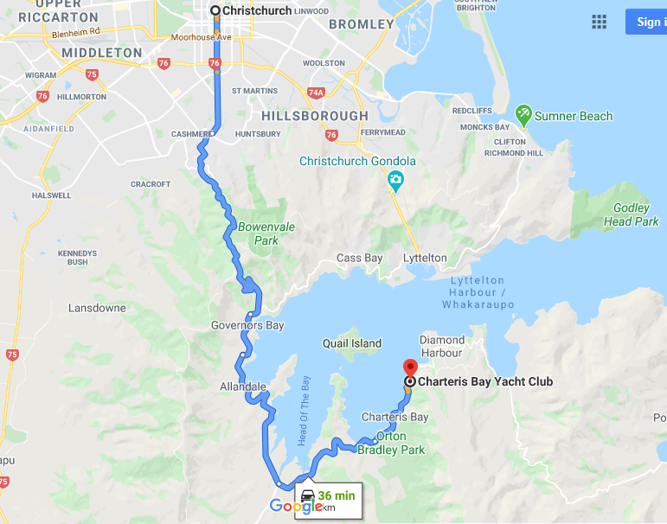

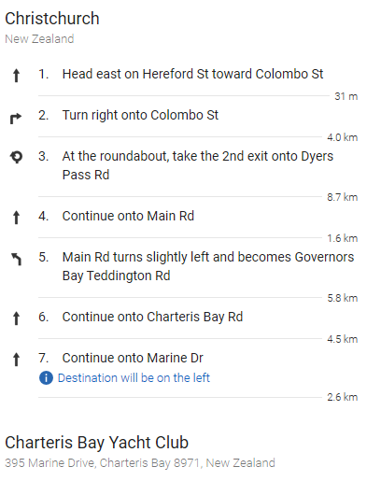

**Attachment B Course Area**

**Primary** racing area shown in green. Secondary racing area shown in red.

