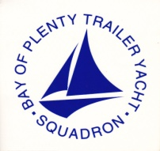
Ross 780
National Championship
4th - 6th February 2021
The Organising Authority is the Bay of Plenty Trailer Yacht Squadron (BOPTYS)
Okawa Bay Rd, Lake Rotoiti
https://www.boptys.net/
NOTICE OF RACE

NB: The notation ‘[DP]’ in a rule in the Notice of Race means that the penalty for a breach of that rule may, at the discretion of the protest committee, be less than disqualification.

- RULES
  - The regatta will be governed by the rules as defined in The Racing Rules of Sailing 2021-2024

  - The Yachting New Zealand Safety Regulations

Ross 780s Part V category C shall apply, upgraded so that all boats competing must carry a VHF radio transceiver capable of receiving and transmitting VHF channel 77, a minimum of 5 litres of fuel each day of the regatta, and an operational outboard engine prescribed for in the Ross 780 class rules.

  - Class Rules for the Ross 780s will apply to all yachts competing in their Fleet.

  - Racing rules
A boat that does not start within four minutes after her starting signal will be scored Did Not Start without a hearing. This changes RRS A4 and A5.

The sailing instructions may also change other racing rules.

  - Appendix T, Arbitration, will apply.

- ADVERTISING
  - Boats may be required to display advertising chosen and supplied by the organising authority. If this rule is broken, World Sailing Regulation 20.9.2 applies. [DP]

- ELIGIBILITY AND ENTRY
  - The regatta is open to all boats of the Ross 780 class whose owners are current financial members of their National Class Association.

  - Eligible boats may enter by completing the attached form and emailing to secretary@boptys.org.nz
Payment to be made electronically to BOPTYS by 1700hrs, 1st February 2021.

  - Late entries accompanied by the contest entry fee plus the late entry fee may be accepted at the race committee’s discretion until 1200 hrs 3rd February 2021.

  - To be eligible to compete in this event each Skipper and crew member(s) shall be a financial member of a club recognised by the Skipper and crew member’s national authority.

Proof of affiliated club membership to be presented at registration

- FEES
Required fees are as follows:

CLASS | FEE
Ross 780 | $100.00

  - Late Entry Fee $50.00

- SCHEDULE
  - Registration: Wednesday 3rd February 2021, 1700-1900hrs
BOPTYS, Okawa Bay Reserve, Okawa Bay Rd, Mourea, Rotorua

  - Equipment inspection and event measurement:

Class | Times / Date | Location
Ross 780 | 1100hrs – 1900hrs | BOPTYS

  - Schedule of Event (actual number of races per day is dependant on the Race Officer’s assessment of weather conditions):

Date | Times | Activity
Thursday 4th Feb | 0900hrs. | Briefing
Thursday 4th Feb | Time of 1st warning Signal 1100hrs. | 3 Races Back to Back
Friday 5th Feb | Time of 1st warning Signal 1100hrs. | 3 Races Back to Back
Saturday 6th Feb | Time of 1st warning Signal 1100hrs. | 3 Races Back to Back

  - Number of races: 9 Races are scheduled.
Class | Target time for each race
Ross 780 | 45 Minutes

  - On the last scheduled day of racing no warning signal will be made after 1500hrs.

- MEASUREMENT

  - Each boat shall produce a valid measurement certificate. In addition, Boat Weight and other Measurements maybe taken to ensure boats meet Class Rules and Safety Regulations. Any sails not previously signed will be required to be measured.

  - A boat shall comply with RRS 78.1 throughout the contest and may be checked at any time during the event.

  - A Safety Declaration is to be completed at registration. NB; a safety check may be made on any boat at any time during the event

- SAILING INSTRUCTIONS
The sailing instructions will be available after 0900Hrs on Saturday 2 January 2021 from the BOPTYS club website, and will be available at registration.

- VENUE
  - Attachment A; shows the location of the regatta venue.

- THE COURSES
The courses to be sailed will be as follows: Windward / Leeward, Triangles or a mixture of both.

- PENALTY SYSTEM
  - For the ALL classes RRS 44.1 is changed so that the Two-Turns Penalty is replaced by the One-Turn Penalty.

- SCORING
  - 5 races are required to be completed to constitute a series.

a) When fewer than 6 races have been completed, a boat’s series score will be the total of her race scores.

b) When 6 to 8 races have been completed, a boat’s series score will be the total of her race scores excluding her worst score.
c) When 9 races have been completed, a boat’s series score will be the total of her race scores excluding her two worst scores.

- SUPPORT BOATS
Support boats shall Register with the Organising Authority.

- BERTHING
Boats shall be kept in their assigned places while they are in the boat park. There is limited secure compound space available; boats shall be kept in their assigned place. Otherwise, there is car/boat parking adjacent to clubrooms, and limited on-water berthage.

- LAUNCHING & RETRIEVAL RESTRICTIONS
Competitors shall Launch and Retrieve vessels from the BOPTYS Ramps during the regatta, except with and according to the terms of, prior written permission of the race committee.

- RADIO COMMUNICATION
Except in an emergency, a boat that is racing shall not make voice or data transmissions and shall not receive voice or data communication that is not available to all boats. This restriction also applies to mobile telephones.

- PRIZES
Prizes may be awarded at the discretion of the Organising Authority in conjunction with the Class Association

- INSURANCE
Each participating boat shall be insured with valid marine third-party liability insurance with a minimum cover of $1,000,000 per incident or the equivalent.

- DISCLAIMER OF LIABILITY
Competitors participate in the regatta entirely at their own risk. See RRS 4, Decision to Race. The organising authority will not accept any liability for material damage or personal injury, or death sustained in conjunction with or prior to, during, or after the regatta.

- Event Cancellation
In the event of cancellation due to any causes outside of the Organising Authorities control, all efforts will be made to reimburse Entry fees less any Event associated cost already incurred not recoverable.

- FURTHER INFORMATION
For further information please contact:

Jimmy O’Callahan
Ph. 07 345 5769
Cell. 027 434 7871
Commodore
Bay of Plenty Trailer Yacht Squadron

commodore@boptys.org.nz
www.boptys.net

Attachment A

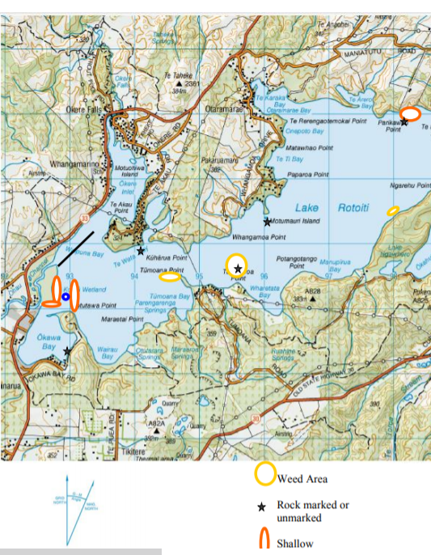
Attach

Ross 780 National Championship
4 – 6 February 2021 The Organising Authority is the Bay of Plenty Trailer Yacht Squadron
Okawa Bay Lake Rotoiti
Entry Form
Class
Sail Number | Boat name

Skipper Details
First name | Surname
Yacht Club | Address
Email
Mobile

Crew Details
First name | Surname
Yacht Club | Address
Email
Mobile

Crew Details
First name | Surname
Yacht Club | Address
Email
Mobile
Crew Details
First name | Surname
Yacht Club | Address
Email
Mobile
Please add additional contact details if more than two crew
I agree to be bound by the Racing Rules of Sailing and all other rules that govern this event. I understand that yacht racing has inherent risks and dangers that are beyond the control of the organizing authority. I understand that neither the organising authority and its officers, members and servants nor other persons assisting with the conduct of the regatta accept any responsibility in respect of any injury or loss to person or property that may be sustained by reason of participation in the regatta or howsoever arising in connection with the regatta.
I agree to the use of my photograph(s) and other relevant information in any event publicity and in the ongoing promotion of New Zealand yachting. I agree to the Organising Authority and Yachting New Zealand holding the above information for the general administration and well-being of the sport, and for them to retain, use and disclose the information to affiliated organisations and any other persons or organisations that Yachting New Zealand believes will further the interests and objectives of Yachting New Zealand. I acknowledge my right to access to and correction of this information. The consent is given in accordance with the Privacy Act 1993.
Skipper /Owner Signature: Date:

Office Use: Entry Fee Paid Method: Amount:
Payment & registration to be returned electronically to BOPTYS, secretary@boptys.org.nz
Acct No. 38-9011-0207956-000 Entry Fee: $100.00
include your boat sail number and name in the reference fields.

