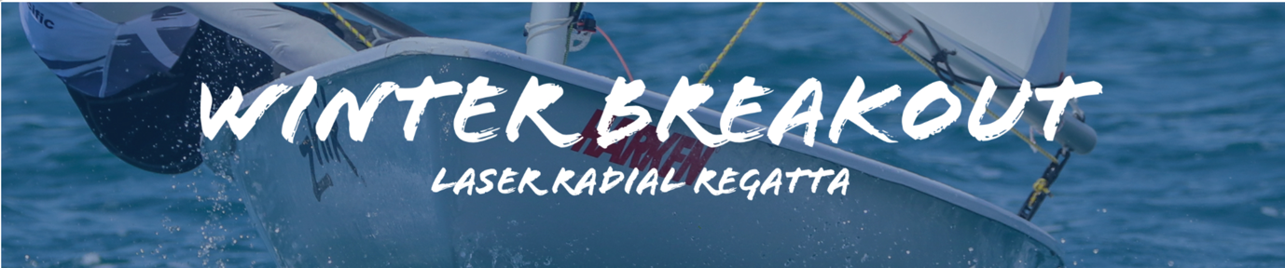
2020 Laser Radial Winter Breakout Regatta
22nd and 23rd August
Notice of Race
The Organising Authority is Royal Akarana Yacht Club (RAYC),
8-10 Tamaki Drive, Okahu Bay, Auckland

1. Rules
1.1. The regatta will be governed by the ‘rules’ as defined in the Racing Rules of Sailing (RRS)
1.2. Yachting New Zealand Safety Regulations Part 1.
1.3. For protests where only a Rule of Part 2, or Rule 31 is alleged to have been broken an arbitration hearing will be offered prior to a formal hearing.
1.4 The sailing instructions will consist of the instructions in RRS Appendix S, Standard Sailing Instructions and supplementary sailing instructions that will be on the official noticeboard and on the website at https://rayc.co.nz/laserwinterbreakout/

2. Advertising
2.1. Boats may be required to display advertising chosen and supplied by the Organising Authority.
3. Eligibility
3.1 The regatta is open to all boats of the Laser Radial Class.
3.2 Eligible entrants may enter by completing the online entry form along with entry payment on the RAYC website https://rayc.co.nz/product/winter-breakout-laser-radial-regatta/

3.3 Completion of online entry and payment must be made by no later than 1800 hours on Friday 21st August, 2020.
3.4 A minimum of (10) ten entries are required by the entry closing date of 21st August, 2020
3.5 To be eligible to compete in this event each entrant shall be a financial member of a yacht club recognised by the entrant and crew’s national authority.
Proof of affiliated club membership shall be presented at registration.

4. Entry Fee
4.1 The entry fee for the regatta is NZD$55.00
4.2 Late entries, if accepted, shall, in addition to payment of the regatta entry fee, be accompanied by a late entry fee of $40.00.

5. Schedule
5.1 Registration: Saturday 22nd August 2020, 0900 – 1000 RAYC
5.2 Briefing: The briefing is scheduled for 1000hours on Saturday 22nd August 2020 in the RAYC clubrooms.
5.4 Dates of racing and number of races:
Day: | Date: | First warning signal | Number of Races | Target Time for each race:
Saturday | 22nd August | 1100 | Up to four (4) races back to back | 40 minutes
Sunday | 23rd August | 1000 | Up to four (4) races back to back | 40 minutes

5.5 On the last scheduled day of racing no warning signal will be made after 1500 hours.

6. Sailing instructions
6.1 Appendix S shall apply
The Supplementary Sailing Instructions will be available at the time of Registration and will be available on the RAYC website prior to the regatta.
The Supplementary Sailing Instructions will be available at the race briefing.

7. Measurement and Inspection
7.1 A boat shall comply with RRS 78.1 at all times
7.2 Beach trolleys shall be prominently marked with the boat’s sail number.
7.3 In addition, spot measurement and safety checks may be conducted at any time throughout the regatta.
8. Venue
8.1 The host club is Royal Akarana Yacht Club, Okahu Bay, Auckland. Attachment A shows the location of the regatta venue.
8.2. The racing will take place in the waters inside Okahu Bay or outside Okahu Bay. Attachment B shows the approximate location of the Racing Area.
9. Courses
9.1 The courses will be outlined in the Sailing instructions
10. Scoring
10.1 Eight (8) races are scheduled.
10.2 Two (2) races are required to be completed to constitute a series.
10.3 When fewer than five (5) races have been completed, a boat’s series score will the total of her race scores.
10.3. When 5 or more races have been completed, a boat’s series score will be the total of her race scores excluding her worst score.
11. Penalty System
11.1. RRS 44.1 is changed so that the Two-Turns Penalty is replaced by the One-Turn Penalty.

12. Safety
12.1 Competitors must wear a life jacket or other adequate personal buoyancy at all times when afloat.
12.2 Wet suits and dry suits do not constitute adequate personal buoyancy.
12.3 All support and safety boat crews are required to wear life jackets under the Auckland Council Navigation Safety Bylaw 2014.

13. Launching
All competing boats shall be launched and retrieved from Okahu Bay in the vicinity of the RAYC, unless instructed otherwise by the Organising Authority.
14. Coach and Support Boats
Support boats are welcome but must stay outside 50m from the fleet except before the warning signal and after the finish. In a case of emergency, they may be asked to assist.
15. Radio Communications
Except in an emergency, a boat that is racing shall not make voice or data transmissions and shall not receive voice or data communication that is not available to all boats. This restriction also applies to mobile telephones.
16. Prizes
Prizes will be given as follows:
1st, 2nd, 3rd – female
1st, 2nd, 3rd – male
1st master
1st youth female
1st youth male

17. Disclaimer of Liability
Competitors participate in all races entirely at their own risk. Refer to RRS Rule 4. The Organising Authority will not accept any liability for material damage or personal injury or death sustained in conjunction with, prior to, during, or after the regatta.

18. Insurance

Each participating boat shall be insured with valid marine third-party liability insurance with a minimum cover of $1,000,000 per incident or the equivalent.

19. Rights to Use Name & Likeness
By participating in the event, a competitor automatically grants to the Organising Authority and the sponsors of the event, the right in perpetuity, to make, use and show, from time to time and at the discretion, any motion pictures, still pictures and live, taped or film television and other reproductions of him/her during the period of the competition for said event in which the competitor participated and in all material related to the said event without compensation.
20. Use of Drone for Media
All those who take part in the regatta as competitors as well as support crew or spectators agree to be overflown by a drone during the duration of the event, this includes your person and your property (boats).

21. Further Information
For further information, please contact:
Suellen Hurling
Email: suellen@rayc.co.nz

APPENDIX A LOCATION OF ROYAL AKARANA YACHT CLUB
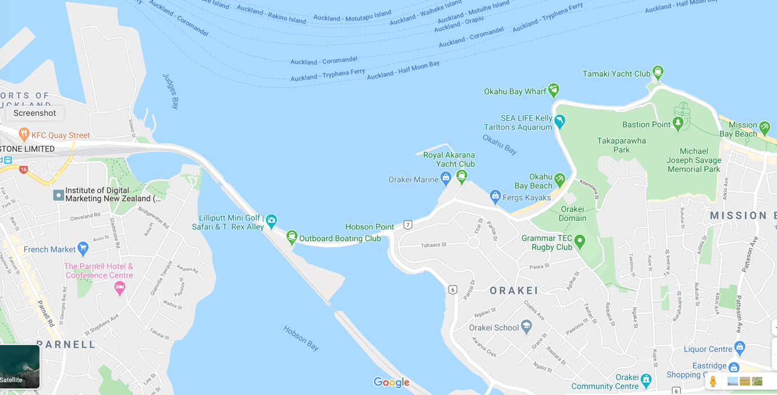

APPENDIX B APPROXIMATE LOCATION OF THE RACING AREA

