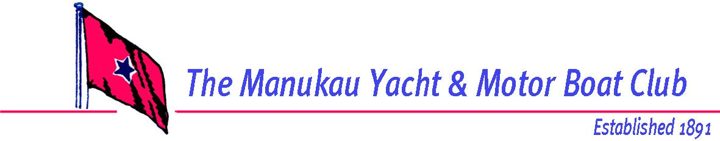

54th Hartley 16 National Championship
25th to 28th March 2020
Manukau Yacht and Motor Boat Club

Notice of Race

The Organising Authority is the Manukau Yacht and Motor Boat Club Inc.
Kiwi Esplanade, Mangere Bridge, Auckland.

NB: The notation ‘[DP]’ in a rule in the Notice of Race means that the penalty for a breach of that rule may, at the discretion of the protest committee, be less than disqualification.

1 RULES
1.1 The regatta will be governed by the rules as defined in the Racing Rules of Sailing.
1.2 Hartley 16 – The Yachting New Zealand Safety Regulations Part 1 shall apply
1.3 Appendix T, Arbitration, will apply.

2 ADVERTISING
Boats may be required to display advertising chosen and supplied by the organising authority. If this rule is broken, World Sailing Regulation 20.9.2 applies. [DP]

3 ELIGIBILITY AND ENTRY
3.1 The regatta is open to all boats of the Hartley 16 that comply with the class rules and whose owner(s) are current financial members of the H16 Class Association.
3.2 Eligible boats may enter by completing the contest entry form and sending it, together with the required fee, to Hartley Nats, Manukau Yacht and Motor Boat Club, PO Box 59034, Mangere Bridge, Auckland 2151 or by emailing the contest entry form to sinsley6@gmail.com and depositing the required entry fee into the following bank account 12-3014-0838684-02 and providing the following details Particulars:
Boat Name; Code – Sail Number; and Reference – Helmsperson Surname

Completed entries and fully paid entry fees must be received by Wednesday 18th March 2020.

3.3 Late entries, accompanied by the contest entry fee plus the late entry fee may be accepted at the race committee’s discretion until 1500 hours Wednesday 25th 2020.

3.4 To be eligible to compete in this event each entrant and crew member shall be a financial member of an affiliated club recognized by the entrant and crew member’s national authority.

4 FEES
Required fees are as follows:
Contest Entry Fee $120.00
Late Entry Fee (additional) $50.00

5 SCHEDULE
5.1 Registration – MYMBC Clubhouse
Wednesday 25th March 2020
From 1200 to 1600 hours

5.2 Measurement and inspection – MYMBC Clubhouse
Wednesday 25th March 2020
From 1200 to 1600 hours

5.3 Briefing, AGM and welcome – MYMBC Clubhouse
Wednesday 25th March 2020
AGM – 1700 hours,
Briefing - 1800 hours

5.4 Racing schedule:
Thursday 26th March 2020 3 races back to back.
Friday 27th March 2020 3 races back to back.
Saturday 28th March 2020 3 races back to back.

5.5 The scheduled time of the warning signal for the first race of the contest each day is:

Date: | No of Races: | Time of First Warning Signal: | Tide time
Thursday 26th March 2020 | 3 | 1115hrs | 1252hrs
Friday 27th March 2020 | 3 | 1145hrs | 1323hrs
Saturday 28th March 2020 | 3 | 1215hrs | 1355hrs

5.6 On Saturday 28th March 2020 no warning signal will be made after 1500 hours.

6 MEASUREMENTS
6.1 Boats will be weighed and other measurements taken to ensure boats meet class rules and safety regulations. Any sails not previously signed will also be measured.

6.2 A safety declaration is to be completed at registration. NB: a safety check may be made on any boat at any time during the event.

7 SAILING INSTRUCTIONS
The sailing instructions will be available at registration on Wednesday 25th March 2020 at the Manukau Yacht and Motor Boat Club.

8 VENUE & RACING AREA
The venue is the Manukau Yacht and Motor Boat Club. The sailing area is on the waters of the Manukau harbor off the Mangere Bridge shoreline. See attachment A & B.

9 THE COURSES
The courses to be sailed will be Windward Leeward.

10 PENALTY SYSTEM
Rule 44.1 is changed so that the Two-Turns Penalty is replaced by the One-Turn Penalty.

11 SCORING
Five races are required to be completed to constitute a series.
(a) Hartley 16 Fleet
When fewer than 6 races have been completed, a boat’s series score will be the total of her race scores. When from 6 to 9 races have been completed, a boat’s series score will be the total of her race scores excluding her worst score
.

12 LAUNCHING
Unless otherwise directed by the Organising Authority, all competing boats and equipment shall be launched and retrieved from boat ramps adjacent to the Manukau Yacht and Motor Boat Club.

13 RADIO COMMUNICATION
Except in an emergency, a boat that is racing shall not make voice or data transmissions and shall not receive voice or data communication that is not available to all boats. This restriction also applies to mobile telephones. [DP]

14 PRIZES
Prizes will be given as follows:

Hartley 16
Line Honors
Handicap
First Family crewed boast
Other prizes may also be awarded

15 DISCLAIMER OF LIABILITY
Competitors participate in the regatta entirely at their own risk. See rule 4, Decision to Race. The organising authority will not accept any liability for material damage or personal injury or death sustained in conjunction with or prior to, during, or after the regatta.

16 FURTHER INFORMATION
For further information please contact:

Gareth Insley
027 4555447
Gareth3933@gmail.com

54th Hartley 16 National Championship
25th to 28th March 2020

Manukau Yacht and Motor Boat Club

Class

Sail Number

Hull Colour
Boat Name

The Organising Authority is the Manukau Yacht and Motor Boat Club Inc.

PO Box 59034, Mangere Bridge
Helmsperson |  | Skipper/ Crew #1
First Name |  | First Name
Surname |  | Surname
Gender |  | Gender
Male / Female |  | Male / Female
Date of Birth |  | Date of Birth
Nationality |  | Nationality
Yacht Club |  | Yacht Club
Address |  | Address
Email |  | Email
Phone |  | Phone - Work
I agree to be bound by the Racing Rules of Sailing and all other rules that govern this event. I understand that yacht racing has inherent risks and dangers that are beyond the control of the organizing authority. I understand that neither the organising authority and its officers, members and servants nor other persons assisting with the conduct of the regatta accept any responsibility in respect of any injury or loss to person or property that may be sustained by reason of participation in the regatta or howsoever arising in connection with the regatta.
I agree to the use of my photograph(s) and other relevant information in any event publicity and in the ongoing promotion of New Zealand yachting. I agree to the Organising Authority and Yachting New Zealand holding the above information for the general administration and well-being of the sport, and for them to retain, use and disclose the information to affiliated organisations and any other persons or organisations that Yachting New Zealand believes will further the interests and objectives of Yachting New Zealand. I acknowledge my right to access to and correction of this information. The consent is given in accordance with the Privacy Act 1993.
Helmsperson’s Signature (Parent or Guardian if under 18) | Crew’s Signature
 | Date

Additional Crew Members | Full Name  Can be completed at registration. | Yacht Club
2
3

Enclosures (if stated as required to be presented in Notice of Race)
Entry Fee  $120 | Proof of Club Membership |  | Proof of Class Assn Membership |  | Measurement Complete |  | Proof of Insurance Certificate

Office Use
Entry Fee Paid |  | Cash / Cheque / Eftpos |  | Date |  | Comment

Attachment A: The venue, hosting club and launching area.

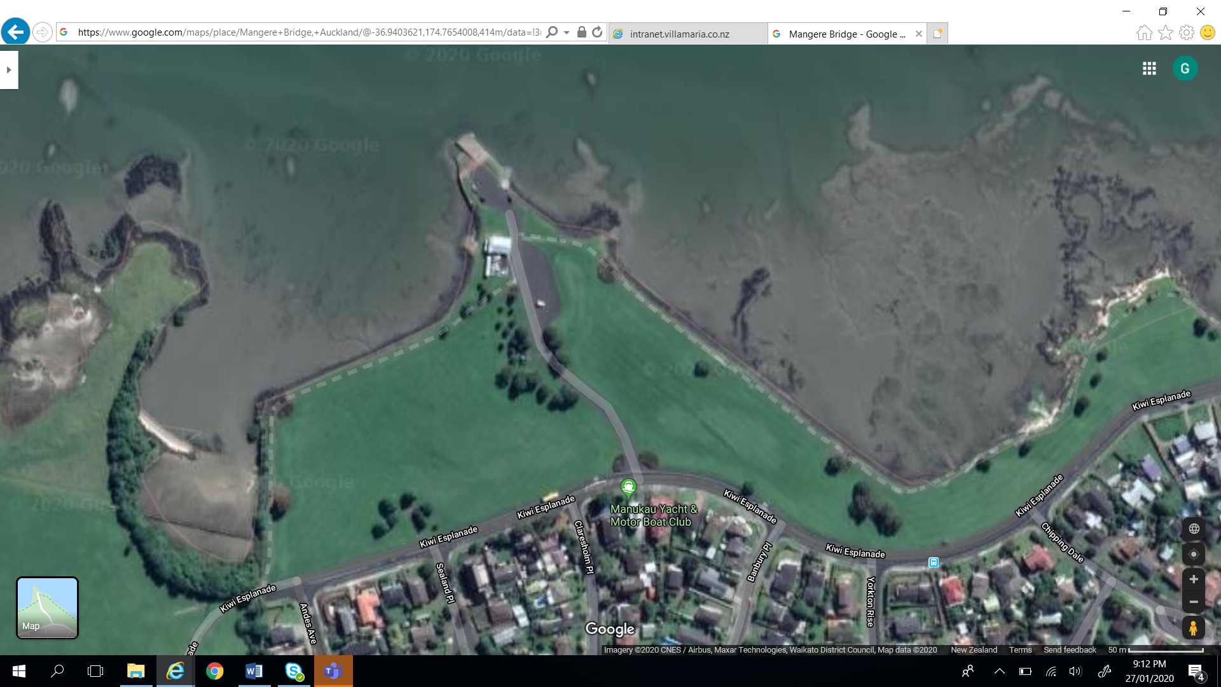

Attachment B: The Sailing Area
