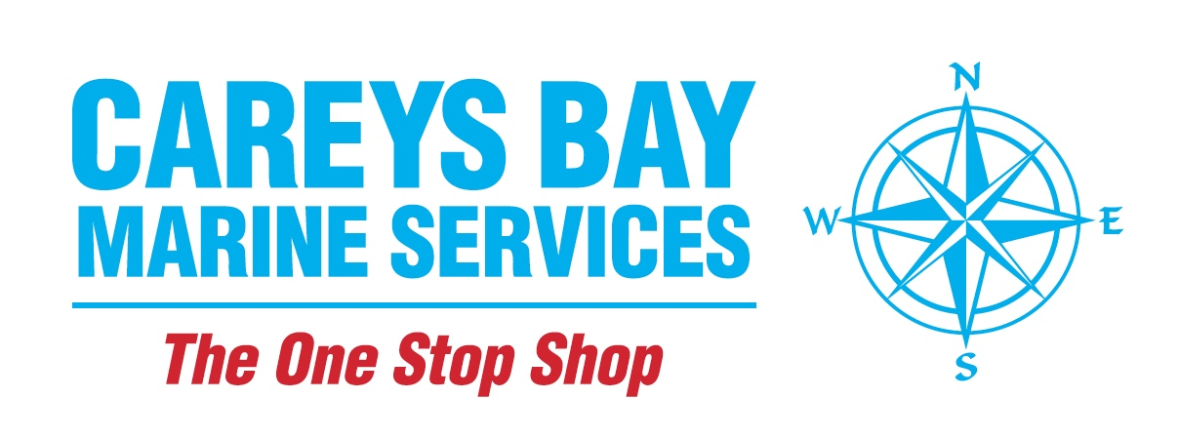
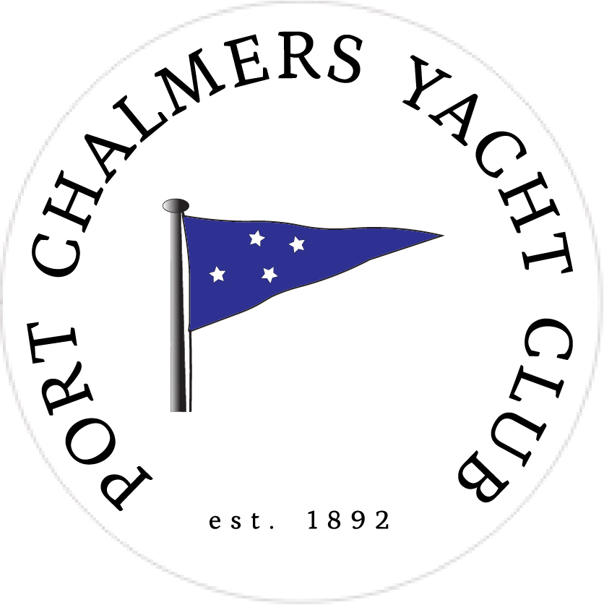

2019 Noelex 22
South Island
Championships
Saturday 16th and Sunday 17th November
2019

Notice of Race

To be held on the
Otago Harbour
From the Port Chalmers Yacht Club.
Back Beach, Port Chalmers

The Organising Authority: Port Chalmers Yacht Club (Inc), (PCYC).

1 Rules

  - The regatta will be governed by the rules as defined in the Racing Rules of Sailing.

  - The Yachting New Zealand Safety Regulations Part V Category C shall apply.

  - Any changes to the Racing Rules of Sailing will appear in full in the Sailing Instructions.

  - Noelex 22 Association Class Rules shall apply

2 Advertising

Not Applicable.

3 Eligibility and Entry

3.1 The regatta is open to Noelex 22 yachts

3.2 Boats may enter by the following means;
- By completing the attached form and posting it to: The Secretary, Port Chalmers Yacht Club, Box 7, Port Chalmers 9050.
- By completing the attached form and emailing it to: secretary@pcyc.org.nz
- By entering online at the PCYC website at the following link - http://pcyc.org.nz/109-2

3.3 Payment can be made by the following means;
- By posting payment to the PCYC Club Secretary
- By paying online
- By paying at the PCYC Clubrooms
Please refer to the entry form for details on these payment options

3.4 To be eligible to compete in this event, each entrant and crew member shall be a financial member of a club affiliated to Yachting New Zealand.

4 Entry Fees

4.1 All boats - $50.00

4.2 Eftpos facilities are available at the P.C.Y.C. Clubrooms

5 Schedule

5.1 Registration: At Port Chalmers Yacht Club
From 1800hrs. until 2000hrs. on Friday 15th. November and from 0900hrs. to 1030hrs.on Saturday 16th. November.

5.2 Dates of Racing:
Saturday 16th. November
Sunday 17th. November

5.3 The scheduled time for the warning signal for the first start of the first race on
Saturday is 1155hrs. and on Sunday is also 1155hrs.

5.4 No race shall start after 1600hrs... on Sunday 17th. Nov.

6 Measurements

6.1 Each boat shall comply with their respective class measurement rules.

7 Sailing Instructions

7.1 The Sailing Instructions will be available upon Registration at the Port Chalmers Yacht Club

8 Venue

8.1 Racing will be held on the waters of the Lower Harbour of the Otago Harbour, most likely the area known as Portobello Bay

9 Courses

9.1 The courses will be Windward/Leeward .. Such courses will be defined and clearly shown in the Sailing Instructions.

10 Scoring

10.1 1 race is required to constitute a series.

10.2 When less than six races have been completed a yacht’s score will be the total of her race scores

10.3 When six races have been completed a yachts score will be the total of her race score excluding her worst score.

11 Support Boats
Support Boats are welcome during this regatta but the organising club requests that they refrain from entering the course area during racing without first requesting such permission from the Race Officer on Channel 77.

12 Launching
All boats that launch from the ramp at Back Beach are requested to be retrieved from the same ramp. If a boat chooses to retrieve from a different ramp they are requested to notify the Race Officer on Channel 77.

13 Radio Communication

13.1 Except in an emergency, a boat shall neither make radio transmissions while racing nor receive radio communications not available to all boats. This restriction also applies to mobile telephones.

14 Prizes

14.1 A Prizegiving will take place on Sunday 17th. at the P.C.Y.C. clubrooms at the conclusion of racing and after de-rigging of entrants boats.

14.2 The appropriate class trophies will be awarded

14.3 Handicap prizes will be awarded for both classes.

15 Disclaimer or Liability

15.1 Competitors participate in the regatta as per Rule 4, Decision to Race, RRS

16 Further Information
For further information contact any of the below
Les. McBean lesnbron@gmail.com 027-614-8756
Richard Hawkins richardhawkins100@gmail.com 027-686-6680

Attachment:

Entry Form for Noelex 22 South Island Championships

