OPEN KITE FOIL
NEW ZEALAND NATIONAL CHAMPIONSHIPS 2019
22nd, 23rd, 24th March 2019
The Organising Authority is The Takapuna Boating Club,
The Strand, Takapuna, Auckland, New Zealand.

NOTICE OF RACE

NB: The notation ‘[DP]’ in a rule in the Notice of Race means that the penalty for a breach of that rule may, at the discretion of the protest committee, be less than disqualification.

1 RULES
1.1 The regatta will be governed by the rules as defined in The Racing Rules of Sailing. [See appendix F]

  - The Yachting New Zealand Safety Regulations Part 1 shall apply.

1.3 Appendix T will apply for Protests where only a Rule of Part 2, or Rule 31 is alleged to have been broken.

1.4 The sailing instructions will consist of the instructions in RRS Appendix S, Standard Sailing Instructions, and supplementary sailing instructions that will be on the official notice board located on the middle floor of the Takapuna Boating Club.

2 ELIGIBILITY AND ENTRY
2.1 The regatta is open to Kites that comply with the International Kite Racing Class, and Foil.

2.2 Eligible Kiters may enter online at New Zealand Kitefoil Racing Facebook page

2.3 To be eligible to compete in this event each entrant shall be a financial member of a club recognised by Yachting New Zealand.
Proof of affiliated club membership to presented at registration.

3 FEES
The Entry Fee is NZ$150.00

4 SCHEDULE
4.1 Friday 22nd March
Registration: From 0900 to 1100
Briefing 1115
Racing 1300 First Warning Signal
Up to 6 races in two 3 race sessions

Saturday 23rd March
Racing 1300 First Warning Signal
Up to 6 races in two 3 race sessions

Sunday 24th March
Racing 1300 First Warning Signal
Up to 6 races in two 3 race sessions

4.2 On the Sunday 24th March no warning signal will be made after 1700

4.3 No more than 4 races shall be sailed in any one session. A minimum of 30 minutes is required between sessions.

5 SAILING INSTRUCTIONS
The sailing instructions will be available at Registration and on the Takapuna Boating Club website

6 VENUE
6.1 Attachment A shows the location of the regatta venue.

6.2 Attachment B shows the location of the racing areas.

7 THE COURSES
The courses to be sailed will be Windward Leeward courses.

8 PENALTY SYSTEM
Rule 44.1 is changed so that the Two Turns penalty is replaced by a One Turn Penalty.

- SCORING
9.1 Five races are required to be completed to constitute a series.

9.2 When six races have been completed, a boat’s series score will be the total of her race scores excluding her worst performance.

9.3 When twelve races have been completed, a boat’s series score will be the total of her race scores excluding her worst two scores.

9.4 When eighteen races have been completed, a boat’s series score will be the total of her race scores excluding her worst three scores.

10 SUPPORT BOATS
Support boats shall be registered at Registration

11 LAUNCHING
Unless otherwise directed by the Organising Authority, all competing kites shall be launched from Takapuna Beach [DP]

12 RADIO COMMUNICATION
Except in an emergency, a boat that is racing shall not make voice or data transmissions and shall not receive voice or data communication that is not available to all boats. This restriction also applies to mobile telephones. [DP]

13 PRIZES
Prizes may be awarded.

14 DISCLAIMER OF LIABILITY
Competitors participate in the regatta entirely at their own risk. See RRS 4, Decision to Race. The organising authority will not accept any liability for material damage or personal injury or death sustained in conjunction with or prior to, during, or after the regatta.

15 FURTHER INFORMATION
For further information please contact manager@takapunaboating.org.nz or
NZ Kite Racing Association Pepper@ihug.co.nz

Attachment A
Location of Takapuna Boating Club
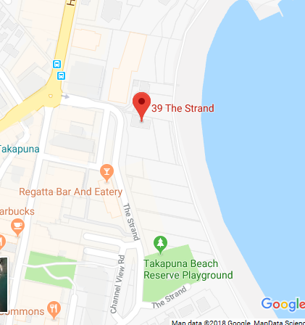

Attachment B
Racing Area
