2019 New Zealand RS:X Class National Championships
(DATES 28 February – 3 March 2019)
The Organising Authority is Takapuna Boating Club Inc
39 The Strand, Takapuna, Auckland
New Zealand.

NOTICE OF RACE

NB: The notation ‘[DP]’ in a rule in the Notice of Race means that the penalty for a breach of that rule may, at the discretion of the protest committee, be less than disqualification.

- RULES
  - The regatta will be governed by the rules as defined in The Racing Rules of Sailing.

  - The Yachting New Zealand Safety Regulations Part 1 shall apply.

  - Appendix B will apply.

  - The sailing instructions will consist of the instructions in RRS Appendix S, Standard Sailing Instructions, and supplementary sailing instructions that will be on the official notice board located on the middle floor of the Takapuna Boating Club.

  - Appendix T, Arbitration, will apply.

- ADVERTISING

  - Competitor advertising will be restricted as follows: No boat shall carry advertising that conflicts with advertising supplied by or sponsors of the organising authority.

- ELIGIBILITY AND ENTRY

  - The regatta is open to boats of the RS:X class.

  - Eligible boats may enter by completing the attached form and sending it, together with the required fee, to Takapuna Boating Club, 39 The Strand, Takapuna, Auckland, New Zealand or manager@takapunaboating.org.nz by 22 February 2019.

  - Late entries will be accepted under the following conditions: Payment of late entry fee $NZD50.00. Late entries will be accepted until 11.00 on 28 February 2019.

  - To be eligible to compete in this event each competitor shall be a financial member of a club recognised by the competitor’s national authority.

  - Proof of affiliated club membership to be submitted with entry.

  - Each competitor shall be a member of their class association.

- FEES
  - Required fees are as follows:
CLASS | FEE
RS:X | NZD150.00

- SCHEDULE
  - Registration: 09.00 -11.00 on 28 February 2019.

  - Dates of racing:

Date | Class
28 February | RS:X
1 March | RS:X
2 March | RS:X
3 March | RS:X

  - Number of races:
Class | Number Races per day | Target time for each race
RS:X | Up to 4 | 25 minutes

  - The scheduled time of the warning signal for the first race each day is 12.00.

  - On the last scheduled day of racing no warning signal will be made after 15.00.

- MEASUREMENT
Each boat shall produce a valid measurement certificate.

- SAILING INSTRUCTIONS
The supplementary sailing instructions will be available after 09.00 on 28 February 2019 at Takapuna Boating Club and www.takapunaboating.org.nz

- VENUE
  - Attachment A shows the location of the regatta venue.

  - Attachment B shows the location of the racing areas.

- THE COURSES
The courses to be sailed will be Trapezoid or Windward/Leeward or as advised in the supplementary sailing instructions.

- SCORING

  - The scoring system is as follows:

  - Five (5) races are required to be completed to constitute a series.

  - a) When fewer than five races have been completed, a boat’s series score will be the total of her race scores.

b) When five to eleven races have been completed, a boat’s series score will be the total of her race scores excluding her worst score.

c) When twelve or more races have been completed, a boat’s series score will be the total of her race scores excluding her two worst scores.

- BERTHING
Boats shall be kept in their assigned places while they are in the boat park. [DP]

- RADIO COMMUNICATION
Except in an emergency, a boat that is racing shall not make voice or data transmissions and shall not receive voice or data communication that is not available to all boats. This restriction also applies to mobile telephones. [DP]
- PRIZES
Prizes will be given as follows: 1st, 2nd and 3rd in Open, Women and U21 Men and Women

- INSURANCE
Each participating boat shall be insured with valid marine third-party liability insurance with a minimum cover of $1,000,000 per incident or the equivalent. Certificate of insurance is to be presented at registration.

- DISCLAIMER OF LIABILITY
Competitors participate in the regatta entirely at their own risk. See RRS 4, Decision to Race. The organising authority will not accept any liability for material damage or personal injury or death sustained in conjunction with or prior to, during, or after the regatta.

- FURTHER INFORMATION
For further information please contact: Andrew Snell +64 21 489 573 andrew.snell@xtra.co.nz

Attachment A
Location of Takapuna Boating Club

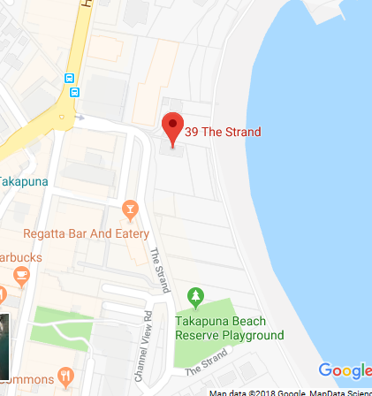

Attachment B
Racing area
