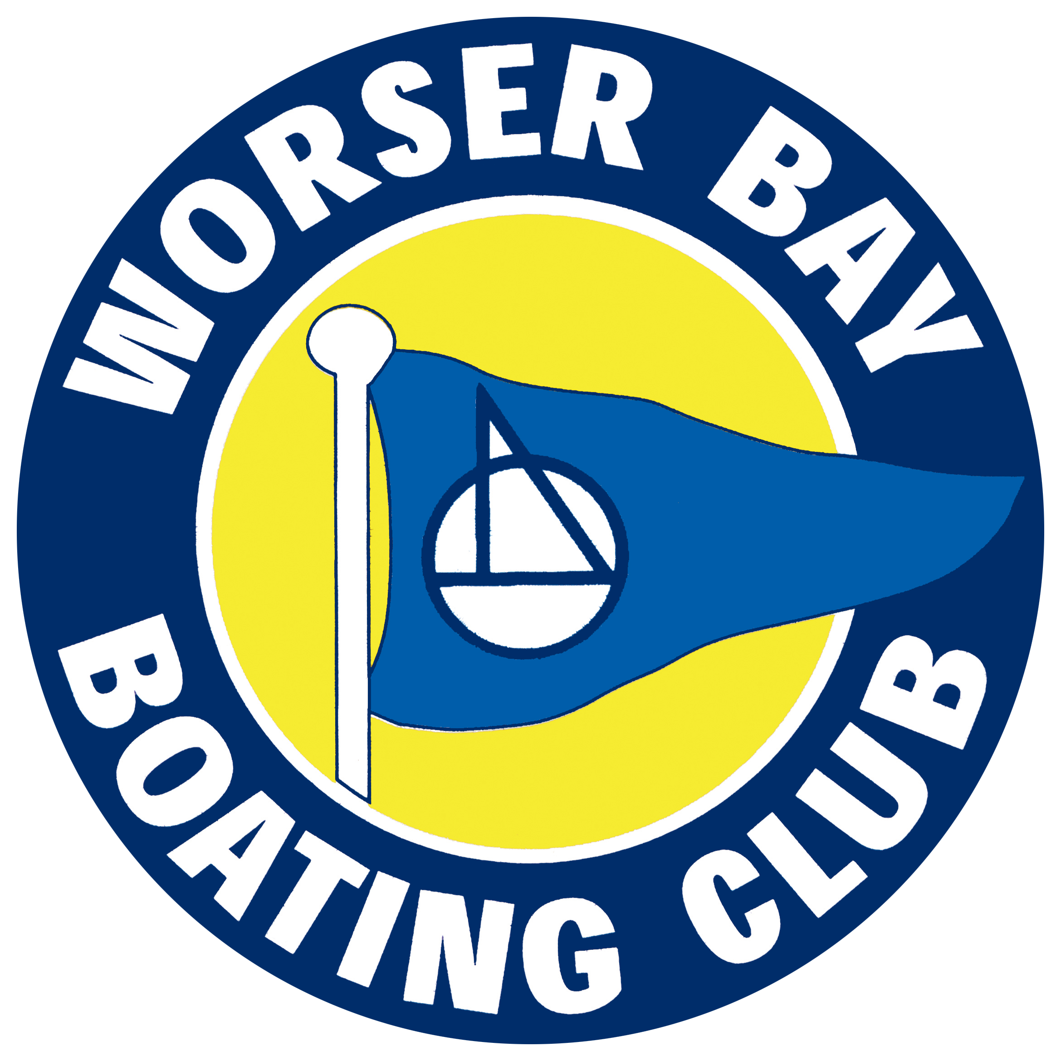
Wellington Junior and Youth Championship
&
Worser Bay Boating Club Regatta

9th February 2019

The Organising Authority is Worser Bay Boating Club Inc
Marine Parade, Seatoun, Wellington

NOTICE OF RACE

NB: The notation ‘[DP]’ in a rule in the Notice of Race means that the penalty for a breach of that rule may, at the discretion of the protest committee, be less than disqualification.

- RULES
  - The regatta will be governed by the rules as defined in The Racing Rules of Sailing.
  - The Yachting New Zealand Safety Regulations Part 1 shall apply.
  - The sailing instructions will consist of the instructions in RRS Appendix S, Standard Sailing Instructions and Supplementary Sailing Instructions that will be on the official notice board located at the event headquarters in the vicinity of Worser Bay, and will be made available online by 3rd February 2019 at the Worser Bay Boating Club website www.wbbc.org.nz.
  - Appendix T, Arbitration, will apply.

- ADVERTISING
  - Boats may be required to display advertising chosen and supplied by the organising authority. [DP]

- ELIGIBILITY AND ENTRY
  - The regatta is open to all dinghy classes including catamarans and sailboards and including a separate division for Green Fleet Optimists.
  - Entry forms and registration will be accepted from 8.30am on the day of the regatta and until 45 minutes prior to the warning signal of any race.
  - To be eligible to compete in this event each entrant and crew member shall be a financial member of a club recognised by the skipper and crew member’s national authority.

- FEES
  - Required fees are as follows:
ENTRY | FEE
Junior Classes | $10
Senior Classes | $20

- SCHEDULE
  - Registration is from 08:30 hours at Worser Bay Boating Club clubrooms.
  - Briefing is at 09:15 at Worser Bay Boating Club clubrooms.
  - Racing is scheduled for Saturday 9th February 2019.
  - There are four races scheduled. (The first Afternoon Race is a NZ Sunburst Association Wellington Branch Series Race for the Sunburst Class).
  - The scheduled time of the warning signal for the first race is 10:10 hours.
  - No warning signal will be made after 15:45 hours.

- MEASUREMENT
  - All boats entered shall comply with their respective class rules.

- VENUE
  - Attachment A shows the location of the regatta venue.
  - Attachment B shows the location of the racing area.

- THE COURSES
  - The courses to be sailed will be triangular and/or windward-leeward.

- SCORING

  - One race is required to be completed to constitute a series.
  - All races sailed will be scored; no race score will be excluded.

- PENALTY SYSTEM
  - For all catamaran, foiling and skiff classes RRS 44.1 is changed so that the Two-Turns Penalty is replaced by the One-Turn Penalty.

- SUPPORT VESSELS
  - Support vessels must register with the Organizing Authority at Registration. [DP]

- HAUL-OUT RESTRICTIONS
  - All boats must launch and retrieve from the Worser Bay Beach south of the club house building site and must remain outside of any swim patrol flag area. [DP]
  - Beach trolleys should be in a compact area and must not be left between any swim flags on the beach while competitors are afloat. [DP]

- RADIO COMMUNICATION
  - Except in an emergency, a boat that is racing shall not make voice or data transmissions and shall not receive voice or data communication that is not available to all boats. This restriction also applies to mobile telephones. [DP]

- PRIZES
  - Prizes will be given as follows:

Junior and Youth Championship:

1st, 2nd, 3rd for Optimist Green
1st, 2nd, 3rd for Optimist Open
1st, 2nd, 3rd for Starling
1st, 2nd, 3rd for Laser Radial
1st for P Class

Centreboard Regatta:

Optimist (Open) Barton Marine Handicap Cup
P Class Pennsylvania Cup
Starling Worser Bay Cup
Sunburst Sunburst Shield
Zephyr Zephyr Trophy
Open* Bob Arkley Shield
Mono* Briscoe Trophy
Catamarans* Hal Finney Memorial Cup

(* calculated on class yardsticks currently used by WBBC).

  - Other prizes may be awarded.

- INSURANCE
  - Each participating boat shall be responsible for their own insurance. As a minimum a current 3rd party policy should be held.

- DISCLAIMER OF LIABILITY
  - Competitors participate in the regatta entirely at their own risk. See RRS 4, Decision to Race. The organising authority will not accept any liability for material damage or personal injury or death sustained in conjunction with or prior to, during, or after the regatta.

- RIGHTS TO USE NAME AND LIKENESS
  - By participating in this event competitors automatically grant to the Organising Authority and the event sponsors the right, in perpetuity, to make, use, and show, at their discretion, any photography, audio and video recordings, and other reproductions of them made at the venue or on the water from the time of their arrival at the venue, until their final departure, without compensation.

- FURTHER INFORMATION
  - For further information please view the Worser Bay Boating Club Regatta Website - www.wbbc.org.nz
or
Alastair Campbell, 027 556 6797.

ATTACHMENT A – Regatta Venue

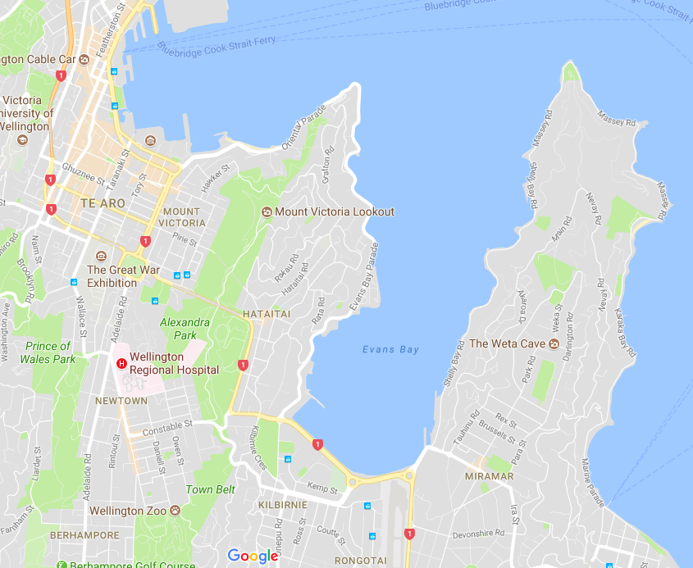

ATTACHMENT B – Racing Area

