New Zealand Skiff Regatta
Incorporating the

2019 New Zealand R Class Skiff National Championship
And the12 ft Skiff Championship
14th February to 17th February 2019

Organising Authority:
Naval Point Club Lyttelton
NOTICE OF RACE
NB: The notation ‘[DP]’ in a rule in the Notice of Race means that the penalty for a breach of that rule may, at the discretion of the protest committee, be less than disqualification.

1 | RULES
1.1 | The regatta will be governed by the rules as defined in The Racing Rules of Sailing.
1.2 | The Yachting New Zealand Safety Regulations Part 1 shall apply.
1.3 | Appendix T, Arbitration, will apply.
2 | ADVERTISING
 | Boats may be required to display advertising chosen and supplied by the organizing authority.
3 | ELIGIBILITY AND ENTRY
3.1  3.2 | The R Class National championship is open to all boats of the R Class Skiff class that comply with the class rules.  R Class and 12f skiffs are eligible for the South Island 12ft Skiff Championship.
3.3 | Eligible boats may enter by completing the attached form and sending it, together with the required fee, to admin@navalpoint.co.nz by 09.30 hours on Thursday 14th February 2019.  Payment can be made to NPCL Bank Account 02 0864 0080191 00 with reference “Skiff” and Sail Number.
OR | Eligible boats may enter on line at  https://us.bookingbug.com/home/132998-Naval-Point-Club-Lyttelton  by Wednesday 13th February 2019.
3.4 | To be eligible to compete in this event each entrant and crew member shall be a financial member of a club recognised by the entrant and crew member’s national authority.
3.5 | For entry in the R Class Skiff National Championship each entrant and crew member shall be a financial member of an R Class Squadron.
4 | FEES
 | Contest Entry Fee: The fee will be $130 per boat
5 | SCHEDULE
5.1 | Registration:  Thursday 14th February 2019, from 0800 hrs to 0930 hrs at Naval Point Club Lyttelton.
5.2 | Briefing will be on Thursday 14th February from 0930 hrs at Naval Point Club Lyttelton.
5.3  5.4  5.5  5.6 | The scheduled time of the warning signal for Invitation Race and Race 1 of the championship is 11.00 hrs on Thursday 14th February 2019.  The scheduled time of the warning signal for Race 2 of the championship is 14.00 hrs on Thursday 14th February 2019.  Up to three races, with a maximum of two races back to back, are scheduled per day.  A total of nine races are scheduled.
5.7  5.8  6.0 | The scheduled time of the warning signal for the first race on Friday, Saturday and Sunday is 11.00 hrs. It is the intention of the organisers to manage racing, including race start times, to maximise the number of races sailed in 12 to 18 knot wind strengths.
 | A separate Super-Cup Sprint Series will be run on Sunday 18th February after National Championship racing is finished for the day.
MEASUREMENTS
Each R Class boat shall produce a valid measurement certificate.

7 | VENUE
Attachment A shows the location of the regatta venue.
Attachment B shows the location of the racing areas.

8 | THE COURSES  The courses to be sailed will be Windward Leeward; two laps.  Boats that have completed only one lap after the first boat has finished (have been lapped by the leading boat), will be finished at the end of that lap. Points will be awarded in place sequence after the boats that complete the full course.
9 | SCORING
9.1 | The scoring system awards points according to the formula 400/ (N+3) where N is the official finishing position of a boat.
9.2 | Five races will be required to be completed to constitute a series.
9.3 | No score will be excluded.
10.0 | SUPPORT BOATS
10.1 | Support boats will be allowed.
10.2 | Support boats must be registered with the Organising Authority at registration. [DP]
11.0 | LAUNCHING  Unless otherwise directed by the Organising Authority, all competing boats and equipment shall be launched and retrieved from Naval Point Club Lyttelton. [DP]
12 | RADIO COMMUNICATION  Except in an emergency, a boat that is racing shall not make voice or data transmissions and shall not receive voice or data communication that is not available to all boats. This restriction also applies to mobile telephones. [DP]
13 | PRIZES  The following prizes will be awarded:  R Class Leander Trophy  R Class Kent Prier Trophy  R Class Bank of NSW Trophy  R Class Bill Hayman Cup  R Class Leander Trophy Masters Cup  R Class Leander Cup  R Class Doug Harrison Memorial Trophy  R Class Youth Trophy  R Class Pinkney Trophy  R Class Innovation Trophy  R Class Lion Trophy  12ft Skiff South Island Championship
14 | DISCLAIMER OF LIABILITY  Competitors participate in the regatta entirely at their own risk. See rule 4, Decision to Race. The organizing authority will not accept any liability for material damage or personal injury or death sustained in conjunction with or prior to, during, or after the regatta.
15 | INSURANCE  Each participating boat shall be insured with valid third-party liability insurance with a minimum cover of $1,000,000 per incident or the equivalent.
16 | FURTHER INFORMATION  For further information please contact Onwater, Naval Point Club Lyttelton PO Box 19 733, Woolston, Christchurch 8241  Phone (03) 328 7029  onwater@navalpoint.co.nz

Attachment A

Venue Location in Lyttelton

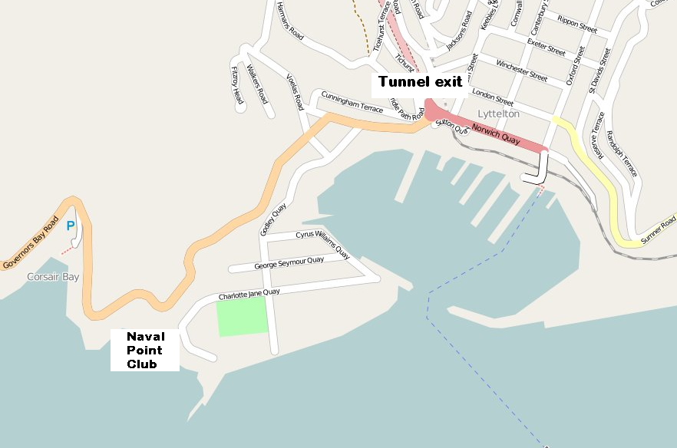

Directions:

Exit Tunnel, turn right at roundabout,

After 200m turn left, follow the road for 1km and turn right at the recreation ground, follow the road to the NPCL gate.

Attachment B

Location of Racing Area in Lyttelton Harbour

  - 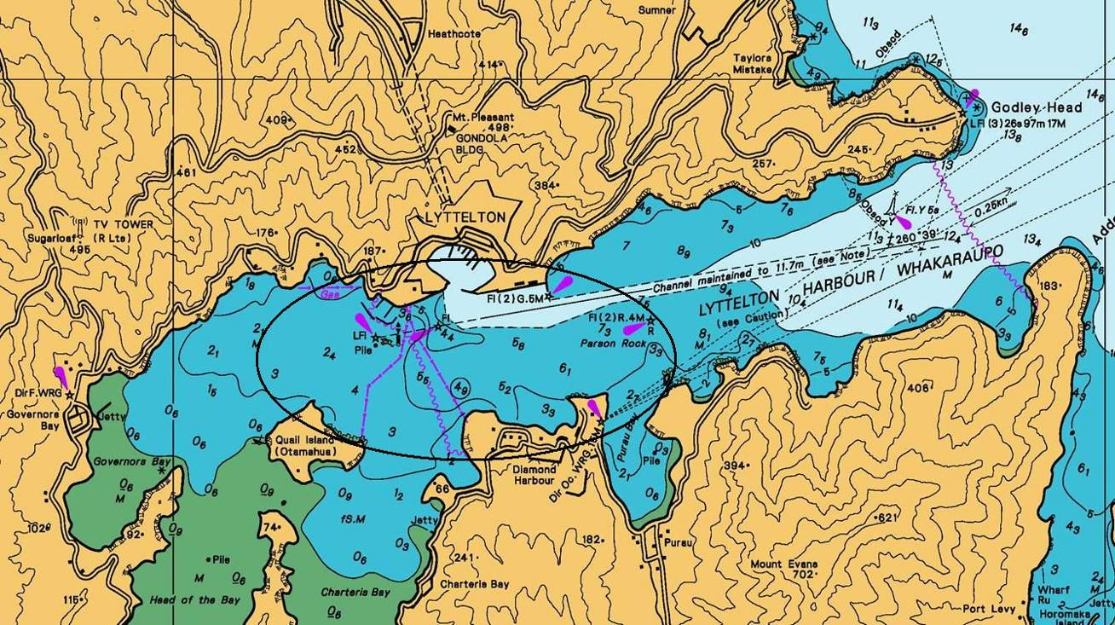
Entry Form

2019 New Zealand R Class Skiff National Championship
And 12 ^{ft.} Skiff Championship
14th February to 17th February 2019
Including the 69th Leander Trophy

Sail Number

Boat Name

12ft Skiff or R Class

Organising Authority:
Naval Point Club Lyttelton PO Box 19 733, Woolston
Christchurch 8241
Helmsperson |  | Crew
First Name |  | First Name
Surname |  | Surname
Gender Male / Female |  | Gender Male / Female
Date of Birth |  | Date of Birth
Yacht Club |  | Yacht Club
Address |  | Address
Email |  | Email
Phone – Home |  | Phone – Home
Phone – Mobile |  | Phone - Mobile
I agree to be bound by the Racing Rules of Sailing and all other rules that govern this event. I understand that yacht racing has inherent risks and dangers that are beyond the control of the organizing authority. I understand that neither the organising authority and its officers, members and servants nor other persons assisting with the conduct of the regatta accept any responsibility in respect of any injury or loss to person or property that may be sustained by reason of participation in the regatta or howsoever arising in connection with the regatta.
I agree to the use of my photograph(s) and other relevant information in any event publicity and in the ongoing promotion of New Zealand yachting. I agree to the Organising Authority and Yachting New Zealand holding the above information for the general administration and well-being of the sport, and for them to retain, use and disclose the information to affiliated organisations and any other persons or organisations that Yachting New Zealand believes will further the interests and objectives of Yachting New Zealand. I acknowledge my right to access to and correction of this information. The consent is given in accordance with the Privacy Act 1993.
Helmsperson’s Signature Parents Signature (if a sailor is under 18 years old)
Date

Enclosures (if stated as required to be presented in Notice of Race)
Entry Fee  $130 | Proof of Club Membership | Proof of Squadron Membership | Insurance Certificate
NPCL Bank Account Number 02 0864 0080191 00 Ref: Skiff (Sail Number)

Office Use
Entry Fee Paid | Cash / Cheque / Eftpos | Date | Comment

