New Zealand Youth Match Racing Nationals 2018
12th – 16th December 2018
The Organising Authority is Royal Port Nicholson Yacht Club
103 Oriental Parade, Wellington, New Zealand

NOTICE OF RACE

NB: The notation ‘[DP]’ in a rule in the Notice of Race means that the penalty for a breach of that rule may, at the discretion of the protest committee, be less than disqualification.

- RULES
  - The regatta will be governed by the rules as defined in The Racing Rules of Sailing 2017 – 2020, including Appendix C.
  - While aboard the Elliott 6 Supersports and any change over boats, a personal flotation device approved by their national governing body, shall be worn.
  - The rules for the handling of boats will apply for the event and any practice sailing.
  - The sailing instructions will consist of the instructions in RRS Appendix S, Standard Sailing Instructions, and supplementary sailing instructions that will be on the official notice board located at Wellington Ocean Sports.

- ADVERTISING
  - Boats may be required to display advertising chosen and supplied by the organising authority. If this rule is broken, World Sailing Regulation 20.9.2 applies. [DP]
  - The OA shall have the right to use any video, images and sound recorded during the event free of any charge.

- ELIGIBILITY AND ENTRY
  - Teams will be invited to participate in the event. Only skippers invited by the OA will be eligible to enter this event.

  - All competitors shall be under 23 years of age as at 16th December 2018

  - The registered skipper shall helm the boat at all times while racing, except in an emergency or excused by the OA.

  - To remain eligible, a skipper shall confirm acceptance of invitation in writing (email is acceptable) to be received by the date specified on the letter of invitation.

  - All competitors shall meet the eligibility requirements of World Sailing Eligibility Code, regulation 19.2.
  - All skippers shall obtain a World Sailing Sailor ID by registering online. Skippers shall inform the OA of their World Sailing Sailor ID at registration. Skippers can register online at www.sailing.org/isafsailor
  - To be eligible to compete in this event each entrant and crew member shall be a financial member of a club recognised by the entrant and crew member’s national authority.

Proof of affiliated club membership to be presented at registration.

  - Each competitor, entrant and crew members shall be entered on completion of registration, crew-weighing and the payment of all fees and deposits. All payments shall be made by credit card, cash, cheque or online transfer.

- FEES
  - Required fees are as follows:
A non-refundable entry fee of NZ $900 shall be paid by 1700hrs on Monday 13th November 2018.

  - Damage deposit:
An initial damage deposit of NZ $1000 shall be paid at registration, unless extended by the OA. This deposit is the maximum payable by the skipper as a result of any one incident.

In the event of deduction from the damage deposit being made, the OA may require that the deposit be restored to its original amount before the skipper will be permitted to continue the event.

Any remaining deposit at the conclusion of the event will be refunded within 10 days of the event.

- CREW (INCLUDING SKIPPER)
  - The total number of crew, including the skipper, shall be 3 or 4. All registered crew shall sail all races.
  - The maximum total crew weight, determined prior to racing shall be 262.5kg, when wearing at least shorts and a t-shirt.
  - Crew weight may be checked during the regatta. At any re-weighing the total weight is increased by 10kg. Any crew weighing in excess of this increased limit shall not be penalised, but they shall reduce their weight to the weight limit before racing again.
  - When a registered skipper is unable to continue in the event the OA may authorise an original crew member to substitute.
  - When a registered crew member is unable to continue in the event the OA may authorise a substitute, a temporary substitute or other adjustment.

- ROUND ROBIN AND FINAL SERIES
The regatta will consist the following series:
Two Round Robins
Fifth/Sixth Place Sail Off
Semi Finals (four highest scoring skippers from Round Robin Stage)
Third/Forth Place Sail Off
First/Second Place Grand Final

The OA may change the format, terminate or eliminate any round, when conditions do not permit the completion of the intended format.

- SCHEDULE
  - Registration: Wednesday 12th December from 1100hrs until 1730hrs.
  - Dates of racing: Thursday 13th – Sunday 16th December
  - Two practice sessions times will be available from 1200hrs – 1400hrs and 1500hrs- 1700hrs on Wednesday 12th December.
  - First briefing will be at 1800hrs on Wednesday 12th December.
  - On racing days, skippers briefing will be held at 0830hrs.
  - The scheduled time of the warning signal for each day is 0953hrs.
  - On the last scheduled day of racing no warning signal will be made after 1600hrs.
  - Prize giving ceremony will be held after the conclusion of racing on Sunday 16th December.
  - Unless excused by the OA, attendance at the following is mandatory:
Initial briefing for skippers and crews
Daily briefing, for skippers.
Prize giving.

- SAILING INSTRUCTIONS
The sailing instructions will be available at registration on Wednesday 12th December.

- VENUE
  - The regatta venue will be the Wellington Ocean Sports Building and the racing area will be the inner Wellington Harbour. See attachment 1.

- THE COURSES
The courses to be sailed will be as follows:

The intended course will be windward/leeward with all marks rounded to starboard and a downwind finish.

See attachment 2 for mapped sailing areas.

- BOATS AND SAILS
  - The event will be sailed in Elliot 6 Supersport Class Boats provided by the OA.
  - Four boats will be provided.
  - The following sails will be provided for each boat:
Mainsail
Jib
Symmetrical Spinnaker

  - Boats will be allocated by the draw before the first day of racing.
- SCORING
  - The scoring system is as follows:

The event is a World Sailing Grade 3 event. This grading is subject to review by world sailing. The event may be re-graded when there is clear reason to do so.

  - 5 races are required to be completed to constitute a series.

- SUPPORT BOATS
A support boat from which coaches may observe racing and communicate with their teams between matches will be provided by the OA. Individual coach boats and berthage will not be permitted. [DP]

- BERTHING
Boats shall be kept in their assigned places while they are on A pier in the Chaffers Marina. [DP]

- HAUL-OUT RESTRICTIONS
Keelboats shall not be hauled out during the regatta except with and according to the terms of prior written permission of the race committee. [DP]

- DIVING EQUIPMENT AND PLASTIC POOLS
Underwater breathing apparatus and plastic pools or their equivalent shall not be used around keelboats between the preparatory signal of the first race and the end of the regatta. [DP]

- RADIO COMMUNICATION
Except in an emergency, a boat that is racing shall not make voice or data transmissions and shall not receive voice or data communication that is not available to all boats. This restriction also applies to mobile telephones. [DP]

- PRIZES
Prizes will be given as follows:
The principal prize for first place will be the Warren “Wolfie” Williams trophy and the title of National Youth Match Racing Champion 2018. The OA may reduce a prize in the case of misconduct or refusal to comply with any reasonable request, including attendance at official functions.

- DISCLAIMER OF LIABILITY
Competitors participate in the regatta entirely at their own risk. See RRS 4, Decision to Race. The organising authority will not accept any liability for material damage or personal injury or death sustained in conjunction with or prior to, during, or after the regatta.

- FURTHER INFORMATION
For further information please contact:
Zoe Bennett
Youth Scheme Coordinator
P: 0275215955
E: youth.scheme@rpnyc.org.nz

Attachment 1.
Venue

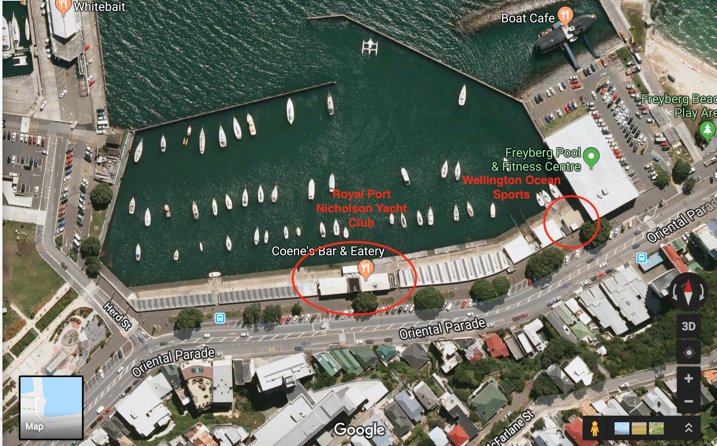
Attachment 2.
Sailing Areas.

