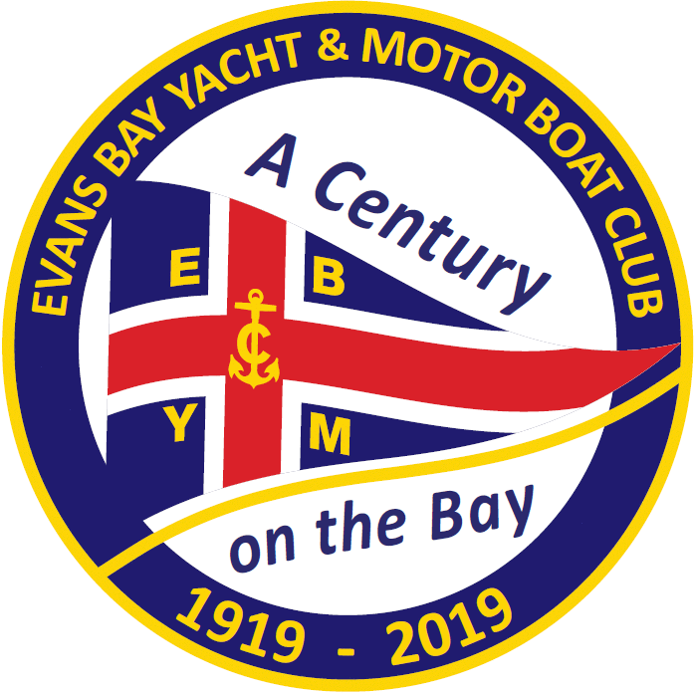

New Zealand Elliott 5.9 National Championships

1st – 4th November 2018

Notice of Race
The Organising Authority is the Evans Bay Yacht and Motor Boat Club (EBYMBC)
447 Evans Bay Parade | PO Box 14496, Kilbirnie, Wellington 6241

- Rules
  - The regatta will be governed by the rules as defined in The Racing Rules of Sailing.
  - The Yachting New Zealand Safety Regulations of Sailing Part 1 shall apply.
  - The Elliott 5.9 Class Association Rules and Safety Regulations shall apply.
  - All boats must supply and clearly display visible two-digit bow numbers with a minimum height of 350mm. The numbers to be used by each boat are those approved by the E5.9 Class Association and will generally be the last digits of the sail number – e.g. “00”. These must be positioned within 1 metre of the bow, on the port and starboard sides of the hull, above the waterline.
  - Appendix T will apply.
- Advertising
  - Boats may be required to display advertising chosen and supplied by the organising authority.
- Eligibility and Entry
  - The regatta is open to all boats of the Elliott 5.9 class and whose owner(s) are current financial members of the class association.
  - Eligible skippers may enter by completing the attached form and either
(a) sending it, together with the required fee to:
The Organising Committee
Elliott 5.9 National Championships
PO Box 14496, Kilbirnie
Wellington 6241
or

(b) emailing it to:
generalmanager@ebymbc.org.nz
and depositing the required fee into the Westpac Bank (Lambton Quay Branch)
Account number: 03-0502-0588510-00
Reference: Elliott 5.9 – Sail Number – Helms surname
Eg: Elliott 5.9 – 5737 – Smith
by Friday 12th October 2018.

  - Late entries, accompanied by the late entry fee may be accepted at the Race Committee’s discretion until 1000hours on 1st November 2018.
  - To be eligible to compete in this event each entrant and crew member shall be a financial member of a yacht club recognised by that person’s national authority. Proof of affiliated club membership shall be presented at registration.
- Fees
  - The entry fee for the regatta is $200.00
  - The late entry fee is $250.00
- Schedule
  - Registration
Thursday 1st November 2018 0900 – 1000hours EBYMBC
  - Briefing
The briefing is scheduled for 1000 hours on Thursday 1st November 2018 at EBYMBC.
  - Dates of Racing
Thursday 1st November 2018 Race Day 1 1st Warning Signal: 1125hours
Friday 2nd November 2018 Race Day 2 1st Warning Signal: 1025hours
Saturday 3rd November 2018 Race Day 3 1st Warning Signal: 1025hours
Sunday 4th November 2018 Reserve Day
  - Number of Races
(a) 12 races are scheduled for the series.
(b) 4 races are scheduled per Race Day.
(c) Up to 5 races per day may be sailed.
5.6. The Reserve Day will only be used if required to complete a series. Refer to NOR11.1.
5.7. On Sunday 4th November 2018 no warning signal will be made after 1530hrs.
- Measurement
  - All boats shall comply with RRS 78.1 at all times while racing.
  - Measurements may be taken to ensure boats meet class rules and safety requirements. A safety check may be made on any boat at any time during the event.
- Sailing Instructions
  - The Sailing Instructions will be available at the time of Registration and will be available on the EBYMBC website by 12th October 2018.
- Venue
  - Attachment A shows the location of the regatta venue.
  - The racing area is the waters known as Evans Bay and Wellington Harbour.
- Courses to be Sailed
  - The courses to be sailed will be Windward Leeward type courses.
  - The target time for each race will be 45 minutes for the leading boat.
- Penalty System
10.1 Rule 44.1 is changed so that the Two-Turns Penalty is replaced by the One-Turn Penalty.
- Scoring
  - 5 races are required to be completed to constitute a series.
  - When 5 or less races have been completed, a boat’s series score will the total of her race scores.
  - When 6 or more races have been completed, a boat’s series score will be the total of her race scores excluding her worst score.
- Launching
  - Unless otherwise directed by Organising Authority, all competing boats and equipment shall be launched and retrieved from the ramps to the south of the EBYMBC.
- Radio Communication
  - Except in an emergency, a boat that is racing shall not make voice or data transmissions and shall not receive voice or data communications that is not available to all boats. This restriction also applies to mobile telephones.
- Prizes
13.1 Elliott 5.9 Association National Trophies will be awarded.
13.2 Other Prizes may be awarded at the discretion of the Class Association or the Organising Authority.
- Disclaimer of Liability
  - Competitors participate in all races entirely at their own risk. Refer to RRS rule 4. The Organising Authority will not accept any liability for material damage or personal injury or death sustained in conjunction with, prior to, during, or after the regatta.
- Insurance
  - Each participating boat shall be insured with valid third-party liability insurance with a minimum cover of $1,000,000.00. A Certificate of Insurance is to be submitted with entry or presented at registration.

Further Information

For further information please contact:
Ryan (Rowdy) Leatham Keith Hogan
General Manager, EBYMBC Elliott 5.9 Class Association
Phone: (04) 939 4167 Phone: 021 222 5266
Email: generalmanager@ebymbc.org.nz Email: keithhogan@xtra.co.nz
Web: www.ebymbc.org.nz Web: www.e59.org.nz

Attachment A – Location of Evans Bay Yacht & Motor Boat Club

