Parts of the boat
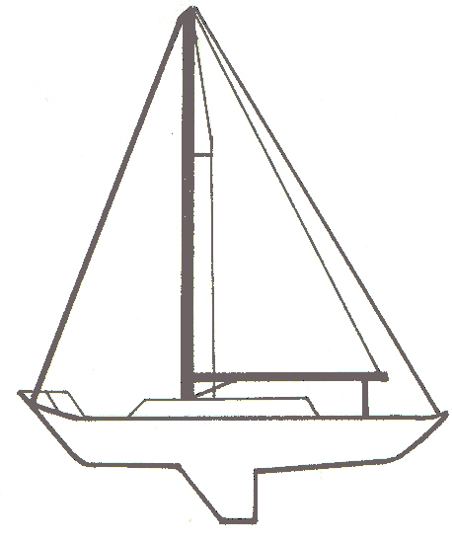
Backstay
Forestay

Boom topping lift

Spreader

Mainsheet
Pulpit

Stern
Hull
Bow

Kicker/Vang
Keel

Parts of the Sail
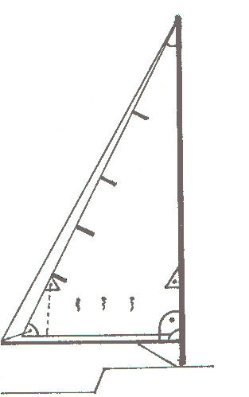

Head
Battens

Luff

Reefing eye
Reefing line
Leech

Outhaul
Tack

Vang
Clew
Boom

