APPLICATION FOR CLUB AFFILIATION 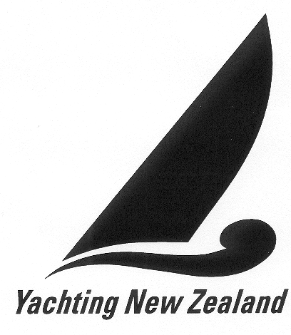

CLUB NAME _______________________________________________________________

ADDRESS__________________________________________________________________

___________________________________________________________________________

CONTACT PERSON _____________________________POSITION____________________

PHONE ________________ (Bus) ________________ (Home) _______________ (Mobile)
EMAIL _____________________________________________________________________

I do hereby make application to be admitted as a member of Yachting New Zealand and we agree to pay the dues and conform to the rules, regulations and by-laws thereof which may from time to time be in force.

We acknowledge that one of the main objects of our Club is the promotion of the sport of yachting, whether under sail or power.

Date _______________________

Signed ______________________________ (Commodore)

Signed ______________________________ (Secretary)

NOTE:
The following information is required also:

- Attached form
- A Copy of the Club Constitution, certified by the Registrar of Incorporated Societies
(b) A copy of the current Balance Sheet and Statement of Accounts
(c) A short history of the Club illustrating:
(i) Growth
(ii) Present numerical strength
- (iii) Facilities of the Club
(d) Evidence of Regional Association
__________________________________________________________________________________
Please send your completed application form to:
Yachting New Zealand
PO Box 331487, Takapuna, AUCKLAND 0740
Email: reception@yachtingnz.org.nz
Fax: (09) 360 2246

AFFILIATED YACHT CLUB INFORMATION FORM
Items with an * must be completed

* Name of Club:
* Physical Address:
* Postal Address:
* Club Telephone: |  |  | Club Fax:
* Club or Contact Email Address:
Club Web Address
* Commodore | Name:
* Commodore | Preferred contact number:
* Commodore | Email:
* Commodore | Please tick if you do not wish your details to be published on the YNZ website
* Admin Secretary | Name:
* Admin Secretary | Preferred contact number:
* Admin Secretary | Email:
* Admin Secretary | Please tick if you do not wish your details to be published on the YNZ website
* Treasurer | Name:
* Treasurer | Preferred contact number:
* Treasurer | Email:
* Treasurer | Please tick if you do not wish your details to be published on the YNZ website
Sailing Master | Name:
Sailing Master | Preferred contact number:
Sailing Master | Email:
Sailing Master | Please tick if you do not wish your details to be published on the YNZ website
Publicity Officer | Name:
Publicity Officer | Preferred contact number:
Publicity Officer | Email:
Publicity Officer | Please tick if you do not wish your details to be published on the YNZ website
Usual Sailing Waters:
Club Office Hours:
Club Social Hours:
Family Memberships:
Junior Members:
Senior Members:
Total Members:

In some instances your Club might not have one or more of the titles listed. If this applies to your Club, please allocate a person who can handle this particular role even if you don’t give them the title – this might be your Commodore or Secretary.

LEARN TO SAIL INFORMATION
Please complete this section if it is relevant to your club. This information will be published in the Learn-to-Sail area of the Yachting New Zealand website.

Do you have a Learn to Sail programme: | Yes No
Classes Sailed:
Learn to Sail programme:  Please check relevant box | Dinghies Keelboats Trailer Sailors
Do you teach the YNZ Learn to Sail Syllabus Yes No

Do you offer programmes for people with a diability Yes No

Do you
Charge members extra for learn to sail classes?
Offer classes to non-members?
Do you offer classes for (Please check as many as apply)
Children Teens
Adults Schools
Do you have club boats available Yes No
Learn To Sail / Coaching  Co-ordinator | Name:
Learn To Sail / Coaching  Co-ordinator | Telephone:
Learn To Sail / Coaching  Co-ordinator | Mobile:
Learn To Sail / Coaching  Co-ordinator | Email:
Learn To Sail / Coaching  Co-ordinator | Please tick if you do not wish your details to be published on the YNZ website

