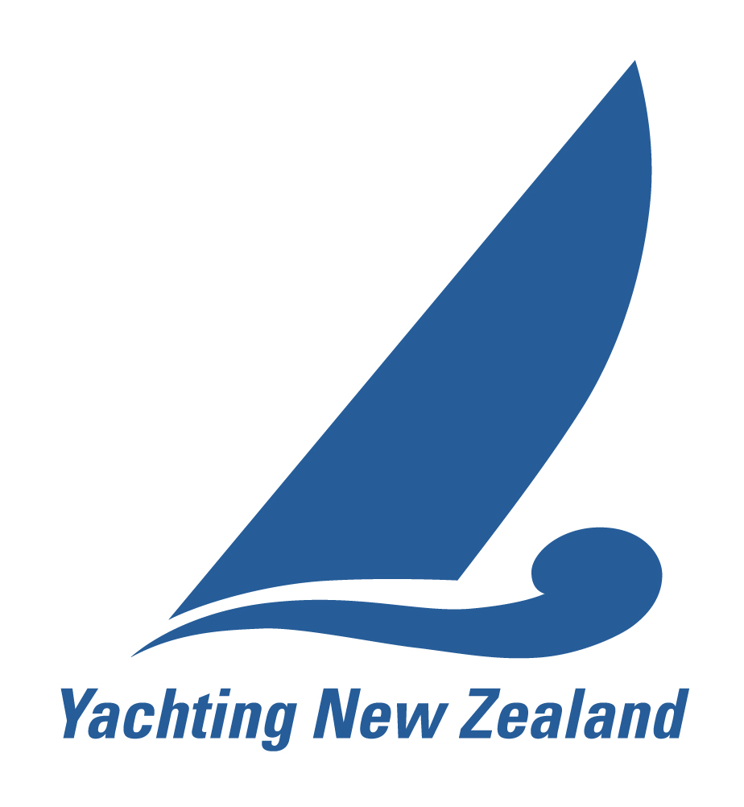
YACHTING NEW ZEALAND YOUTH SCHOLARSHIP

Application Form

1. Personal Details
Name
Address
Phone |  | Date of Birth
Yacht Club |  | Email address
Class |  | Position (delete one) | Skipper Crew
Skipper Name |  | Crew name (where app)
Name (parent/guardian) |  | Contact phone numbers (different from above)

2. Previous Results in the last nine months
Please include your top five results from national events, ranking events and any international events.
 | Year | Class | Event | Placing
1
2
3
4
5

3. Upcoming major Events between March 2018 – June 2019
Date | Event (include location) | Class | Goal for the event

4. Yachting goals between 2018 - 2020
1
2
3

5. Educational Study
Fill out this section if you are currently studying, either part time or full time at a School or Tertiary Institute. Also include details if you have enrolled for courses in Semester Two this year.

Educational Institute | Course (ie BBS, School Cert etc) | Year Course began | Years still to go (inc this year)
Subjects studying
Grades in Previous Year

6. Work Commitments
Fill out these details if you are currently working, either part time or full time, or if you are going to be working in the next six months and have the details of this employment.

Employer | Part time/Full time (include hours) | Role | Years working there/Time involved

7. If you were the recipient of this scholarship, how would receiving the Yachting New Zealand Youth Scholarship benefit your sailing goals?

8. Have you applied to any other organisations for funding for the same purpose?
(If so, please provide details: Name of funding organization, date applied, amount requested, amount received, purpose and outcome)

We declare that the information in this application is true and correct to the best of our knowledge.

Signed: Date:
(parent/guardian)

Signed: Date:
(sailor)
8. Checklist

Please tick the checklist to ensure you have completed the application process
Application form filled out
Signed by sailor and parent
Yes, I am eligible to compete at the 2018 Youth Sailing World Championships

Please send the completed form to stuart@yachtingnz.org.nz or post to Yachting New Zealand PO Box 331487, Takapuna, Auckland 0740 by 5pm Thurs 10th May. Applications received after this time will not be considered for acceptance into the Programme.

